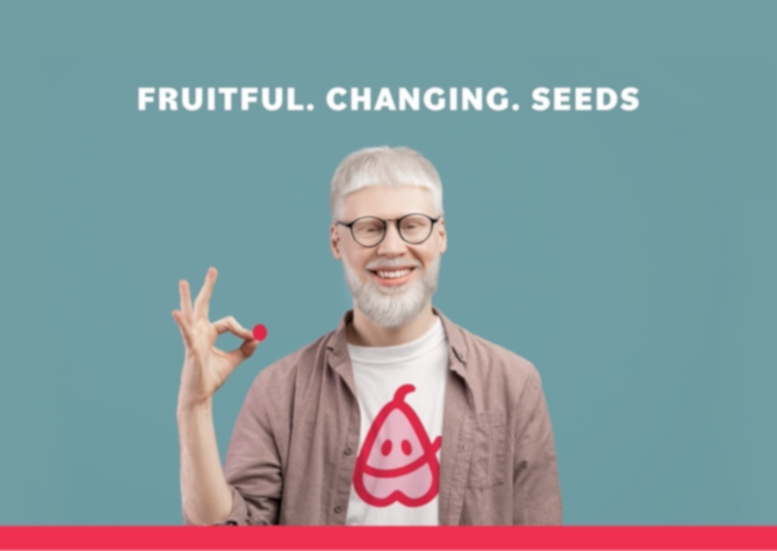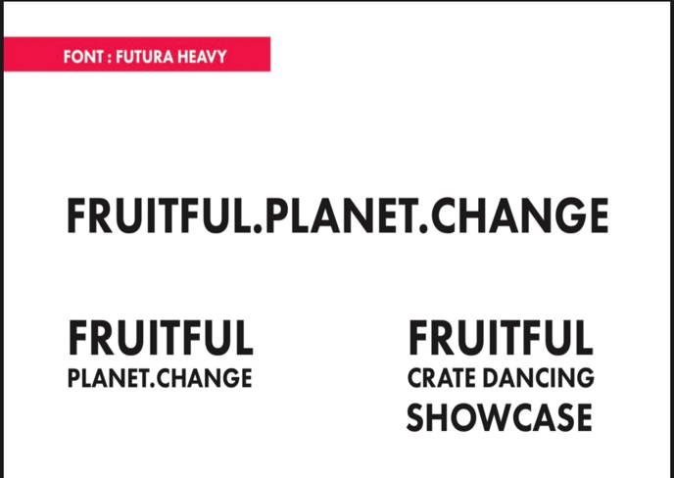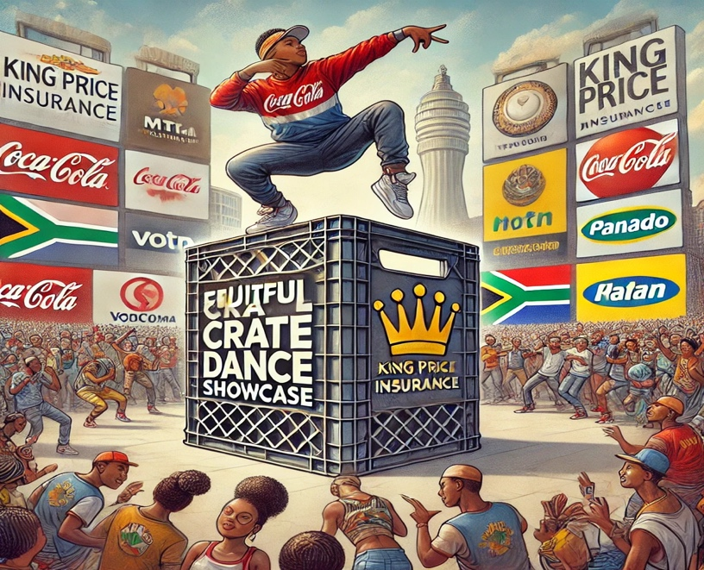

|  |  |
| --- | --- |
|  |  |

**Preface**

The **Fruitful Holdings Business Plan** is a comprehensive strategy document developed to support the company's growth initiatives, community-driven objectives, and global expansion goals. This plan encapsulates the vision, mission, and strategic roadmap that underpin the establishment of the Crate Dance Showcase as a premier global youth culture platform.

Our document is structured to address every critical component of business operations, sponsorship models, financial projections, and community outreach. With a focus on innovation and sustainability, the plan highlights how Fruitful Holdings intends to redefine engagement with local and international markets while fostering talent and supporting communities.

This business plan is the result of collaborative input from industry professionals, market researchers, and business strategists. It is designed to serve as both a roadmap for internal teams and a persuasive resource for potential sponsors, investors, and stakeholders.

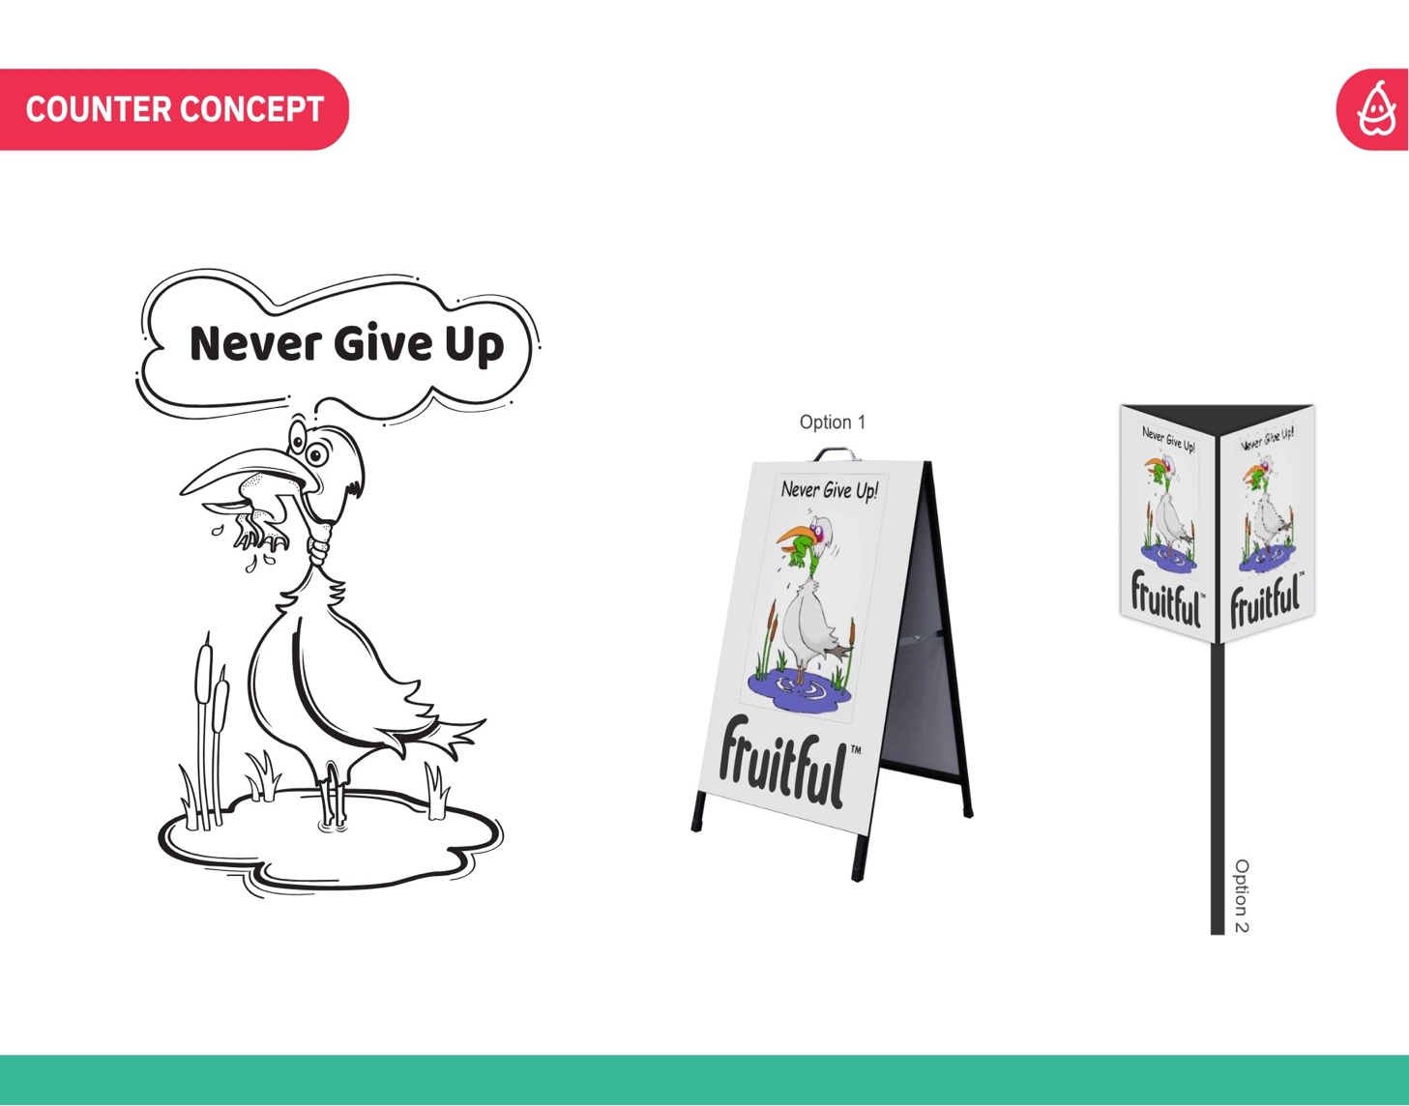

**Introduction**

The global entertainment industry is rapidly evolving, with youth culture and street dance gaining prominence as platforms for creativity, expression, and empowerment. Fruitful Holdings is uniquely positioned to capitalize on this momentum through the Crate Dance Showcase, a visionary event that bridges art, commerce, and community impact.

This document details the foundation of Fruitful Holdings, our operational ethos, and the market opportunity we seek to leverage. With a strong focus on local engagement and global reach, the Crate Dance Showcase aims to redefine the youth culture landscape. Our plan prioritizes sustainability, innovation, and community-driven impact, ensuring long-term value for all stakeholders.

Table of Contents

Preface 0

Executive Summary 3

2. Vision and Mission 3

3. Core Objectives and Goals 4

5. Industry and Market Analysis 8

7. Revenue Model and Financial Strategy 14

8. Franchise and Licensing Model 17

9. Sponsorship and Partnerships 21

10. Marketing and Branding Strategy 24

11. Operations and Logistics Plan 28

12. Talent Development and Training Programs 32

13. Community Impact and Outreach 37

14. Technology and Innovation 40

15. Implementation Roadmap 43

16. Funding Strategy 46

16. Funding Strategy – Detailed Expansion 51

17. Social Impact and Sustainability 54

18. Performance Measurement and Impact Assessment 57

19. Executive Committee (EXCO) 60

20. Conclusion and Next Steps 63

Appendix A: Detailed Financial Projections *(Page 46)* 65

Appendix B: Sponsorship Packages and Revenue Breakdown *(Page 48)* 65

Appendix C: Organizational Chart and Key Personnel *(Page 50)* 66

Appendix D: Timeline for Implementation *(Page 52)* 66

Appendix E: Legal and Franchise Agreements *(Page 54)* 66

Appendix F: Sponsorship Activation Strategies and Metrics *(Page 56)* 66

Appendix G: Location-Based Activation Plans (Tupperware DCs) *(Page 58)* 66

Appendix H: Case Studies of Past Events and Sponsorship Models *(Page 60)* 67

Appendix I: Talent Development Framework *(Page 62)* 67

Appendix J: Community Engagement Reports and Surveys *(Page 64)* 67

Appendix A: Detailed Financial Projections 68

Appendix B: Sponsorship Packages and Revenue Breakdown 70

Appendix C: Organizational Chart and Key Personnel 74

Appendix D: Timeline for Implementation 78

Appendix E: Legal and Franchise Agreements 80

Appendix F: Sponsorship Activation Strategies and Metrics 84

Appendix H: Case Studies of Past Events and Sponsorship Models 91

Appendix J: Community Engagement Reports and Surveys 97

Appendix K: Additional Supporting Documents 100

Conclusion 104

Fruitful Holdings Business Plan Summary 104

Email Index for Fruitful Holdings Outreach 110

Content Breakdown Per Index 111

Email Content: Instructions 111

Email Content: Subject: Exciting Partnership Opportunity: Fruitful Crate Dance Showcase & Red Bull 114

**About the Fruitful Crate Dance Showcase** 115

**Why Red Bull?** 115

**Initial Rollout and Expansion Plan** 115

**Partnership Opportunities** 115

**Next Steps** 116

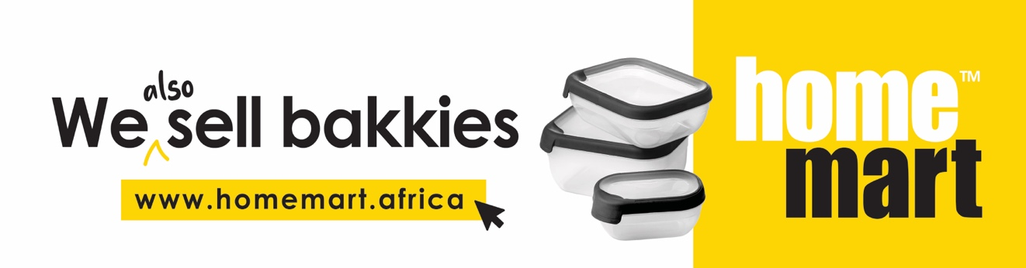

### ****Executive Summary****

(From Page 1)  
Fruitful Holdings presents the Crate Dance Showcase, a bold initiative designed to blend creativity, community, and commerce into a global platform that celebrates youth culture and street dance. With a multi-layered sponsorship model, the plan targets local, regional, and global sponsors, maximizing financial and brand exposure for stakeholders.

#### Key Highlights:[1]

* **Visionary Leadership**: A team of professionals committed to innovation and sustainability.
* **Market Opportunity**: Capturing the growing global interest in youth culture and street dance.
* **Community Focus**: Building grassroots partnerships and fostering local talent development.
* **Revenue Streams**: Comprehensive financial strategy including sponsorships, merchandising, and franchising.
* **Global Reach**: Leveraging partnerships to establish a scalable and sustainable international presence.

With projected revenue of **R391 million**, this plan outlines a robust path to success, positioning Fruitful Holdings as a leader in the youth culture and entertainment industry.

### ****2. Vision and Mission****

(From Page 3)

#### **Vision**

To establish the Crate Dance Showcase as a world-renowned platform that celebrates the vibrancy of youth culture, promotes creative expression, and empowers communities through dance, music, and innovation.

Our vision is to create a global phenomenon where talent, culture, and commerce converge, fostering unity and inspiration across borders while driving measurable social and economic impact.

#### **Mission**

#### Fruitful Holdings is committed to transforming the landscape of youth culture by:

**Providing Opportunities**: Creating a platform for new talent and fostering professional growth and community empowerment.

1. **Fostering Partnerships**: Collaborating with local, regional, and global stakeholders to create meaningful and lasting relationships that benefit all parties.
2. **Promoting Sustainability**: Designing events and initiatives that prioritize environmental consciousness and long-term societal benefits.
3. **Driving Innovation**: Leveraging technology and creative strategies to amplify the reach and impact of the Crate Dance Showcase.

### ****3. Core Objectives and Goals****

(From Page 5)

Fruitful Holdings has identified key objectives and goals to ensure the success of the Crate Dance Showcase:

#### **Strategic Objectives**

* **Expand Global Presence**: Launch the Crate Dance Showcase across major cities globally, starting with strategic hubs in South Africa.
* **Achieve Revenue Growth**: Generate consistent revenue through sponsorships, ticket sales, merchandise, and franchising.
* **Strengthen Brand Identity**: Position the Crate Dance Showcase as the premier event for youth culture and street dance worldwide.
* 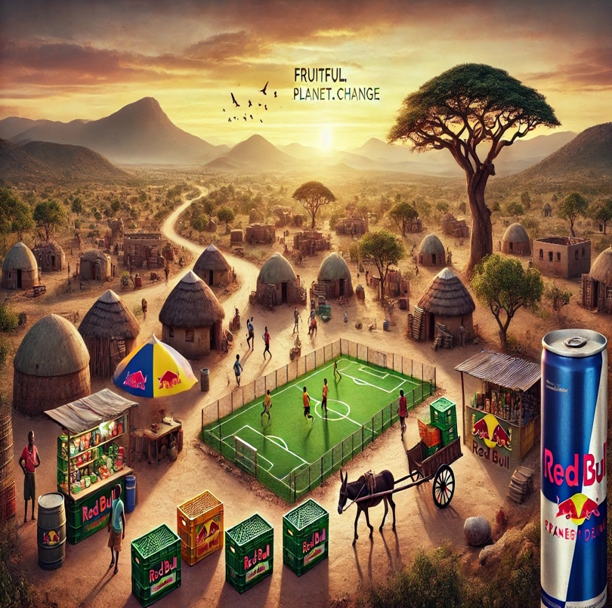**Build Sustainable Practices**: Implement environmentally friendly operations and support sustainable community projects.

**Operational Goals**

1. Secure partnerships with leading brands such as Red Bull, Coca-Cola, Nike, and regional players in telecommunications and retail.
2. Develop talent pipelines and training programs to nurture dancers, choreographers, and event managers.
3. Establish a robust digital infrastructure to support global streaming and online engagement.
4. Create scalable franchise models for international expansion.
5. Deliver measurable ROI for sponsors and stakeholders through detailed performance metrics.

**Social Goals**

* Increase accessibility for underprivileged communities to participate and engage with the showcase.
* Empower local economies by partnering with small businesses and vendors in host cities.
* Promote cultural diversity and inclusion by celebrating the unique talents of individuals from various backgrounds.
* **4. Brand Strategy**

(From Page 7)

#### **Positioning Statement**

The Crate Dance Showcase is the premier global event celebrating youth culture, where creativity meets innovation, and talent converges to create unforgettable experiences. We position ourselves as the ultimate platform for discovering, empowering, and celebrating the next generation of dancers, influencers, and cultural icons.

**Brand Identity**

****Our brand represents:

* **Authenticity**: Celebrating the raw and unfiltered energy of street dance and youth culture.
* **Innovation**: Embracing cutting-edge technology and creative solutions to elevate the event experience.
* **Inclusivity**: Providing a space where diverse voices, styles, and talents can be showcased and celebrated.
* **Empowerment**: Inspiring individuals and communities to dream big and achieve their potential

**Target Audience**

#### The Crate Dance Showcase targets a broad yet well-defined audience:

1. **Primary Audience**:
   * Youth aged 16-35 with a passion for street culture, dance, and music.
   * Emerging artists, dancers, and choreographers seeking exposure and growth.
   * Socially conscious individuals interested in community empowerment and cultural innovation.
2. **Secondary Audience**:
   * 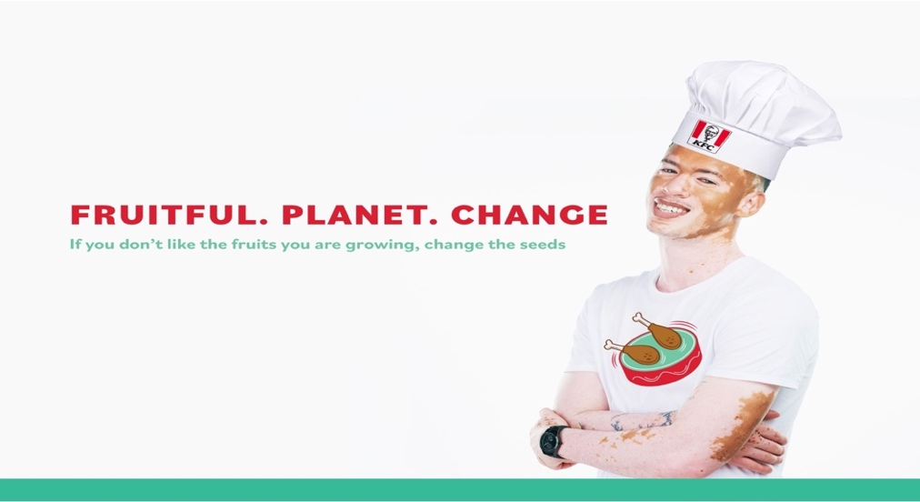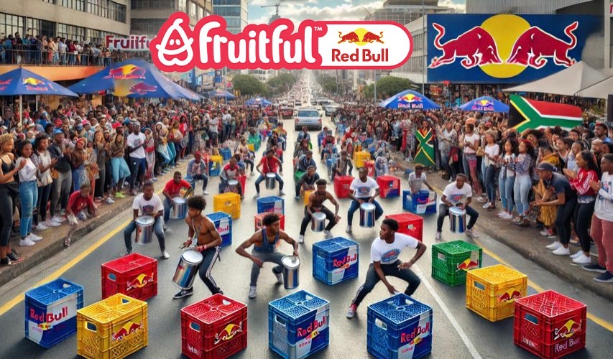Corporate sponsors and partners interested in associating with youth culture and creative industries.
   * Media organizations looking for compelling, authentic content.
   * Families and community members engaged in the cultural and economic impacts of the event.

#### **Key Differentiators**

1. **Cultural Authenticity**: A deep connection to grassroots communities and street culture.
2. **Global Scale**: An expansive vision that transcends borders, blending local and international elements.
3. **Impact-Driven**: A commitment to leaving a lasting social and economic impact in every host city.
4. **Tech-Forward Approach**: Leveraging digital tools for live streaming, audience engagement, and global reach.

#### **Visual Identity**

* **Logo**: Dynamic and movement-inspired design to symbolize the energy of dance.
* **Color Palette**: Vibrant tones reflecting creativity, diversity, and youthfulness (e.g., bold red, electric blue, vibrant yellow).
* **Typography**: Clean and modern fonts for a professional yet approachable look.
* **Imagery**: High-energy visuals featuring dancers, street art, and urban environments to evoke emotion and connection.

#### **Brand Messaging**

1. **Taglines**:
   * "Where Talent Moves the World."
   * "Empowering Communities Through Dance."
   * "Innovation Meets Culture."
2. **Core Messaging Pillars**:
   * **Empowerment**: Highlighting stories of individuals and communities transformed by the showcase.
   * **Creativity**: Showcasing the artistry and innovation of participants and partners.
   * **Connection**: Building bridges between cultures, brands, and audiences globally.

#### **Partnership Alignment**

The Crate Dance Showcase brand aligns perfectly with sponsors and partners that:

* 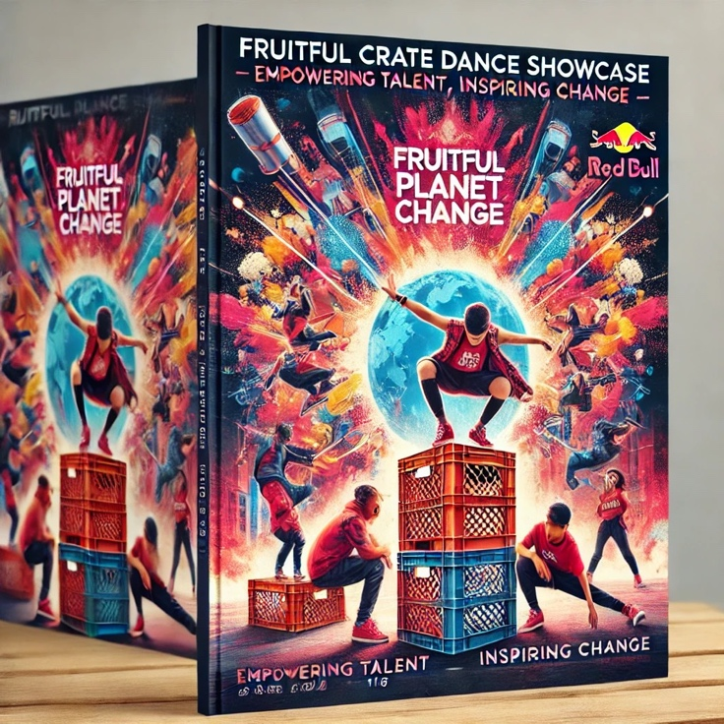Celebrate youth and innovation (e.g., Red Bull, Nike, Adidas).
* Seek to engage communities through impactful campaigns (e.g., MTN, Coca-Cola).
* Promote inclusivity, diversity, and cultural expression.

### ****5. Industry and Market Analysis****

(From Page 9)

**Overview of the Entertainment Industry**

The global entertainment industry has experienced significant growth over the past decade, driven by advancements in technology, evolving consumer preferences, and the rise of live events as a preferred form of engagement. Key trends include:

* 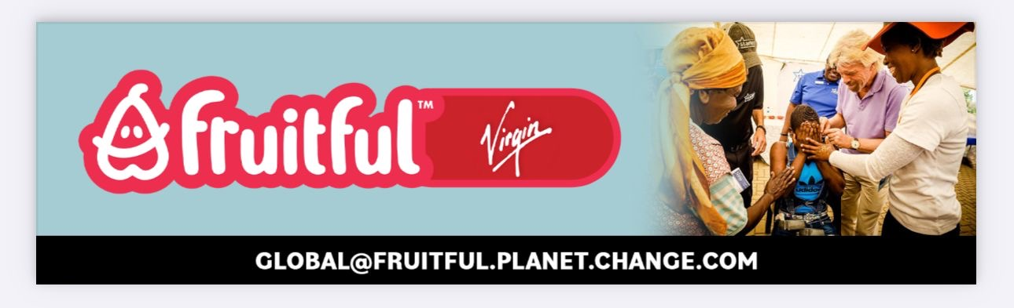**Increased Demand for Experiential Events**: Audiences prioritize experiences over material goods, making events like the Crate Dance Showcase highly appealing.
* **Digital Transformation**: Live-streaming, social media, and virtual
* reality is reshaping how events are consumed globally.
* **Diversity and Inclusion**: Cultural representation has become a critical aspect of entertainment, aligning with the Crate Dance Showcase's celebration of street culture and diversity.

#### **Market Potential**

1. **Global Dance and Street Culture Market**:
   * **Value**: The global dance industry is valued at approximately $3 billion annually, with street dance being a dominant sub-segment.
   * **Growth**: Urban dance styles, such as hip-hop, krumping, and breakdancing, have gained global traction, particularly among younger audiences.
   * 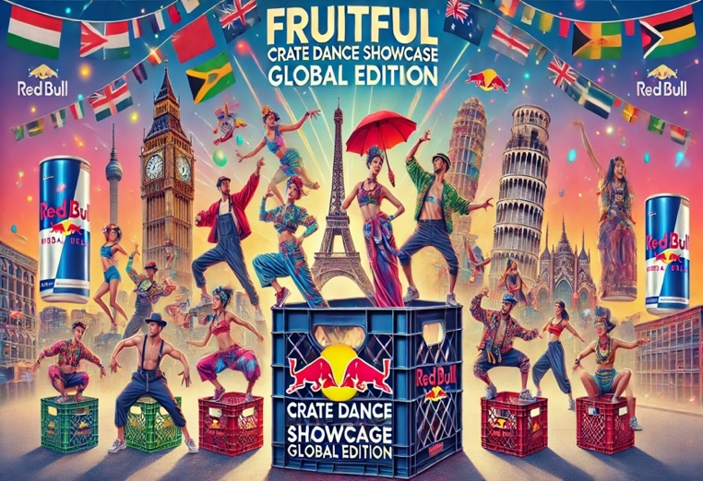**Opportunities**: The inclusion of breakdancing in the Olympics highlights the mainstreaming of street dance, creating new commercial opportunities.
2. **Youth Culture Market**:
   * **Value**: Youth-driven cultural industries, including fashion, music, and events, contribute significantly to the global creative economy, valued at over $2 trillion.
   * **Engagement**: Social media platforms like TikTok, Instagram, and YouTube amplify the reach of youth-oriented events, creating opportunities for global engagement.
3. **South African Market Analysis**:
   * **Demographics**: Over 60% of South Africa's population is under 35, creating a substantial target market for the Crate Dance Showcase.
   * **Urbanization**: High levels of urbanization in cities like Johannesburg, Cape Town, and Durban foster the growth of cultural events and community-driven initiatives.
   * **Economic Impact**: Events contribute significantly to local economies through job creation, tourism, and vendor partnerships.

#### **Competitor Landscape**

The Crate Dance Showcase faces competition from global and local players in the dance and entertainment space.

1. **Global Competitors**:
   * **Red Bull BC One**: A premier global breakdancing competition with significant brand backing.
   * **World of Dance**: A widely recognized dance competition with a strong digital presence.
   * **Juste Debut**: A renowned French street dance competition with a focus on inclusivity.
2. **Local Competitors**:
   * **DanceStar SA**: A platform for aspiring South African dancers.
   * **Hip-Hop International South Africa**: Hosts national qualifiers for global hip-hop dance championships.
   * **StreetCred**: A local street dance competition with a grassroots focus.

**Competitive Advantage**

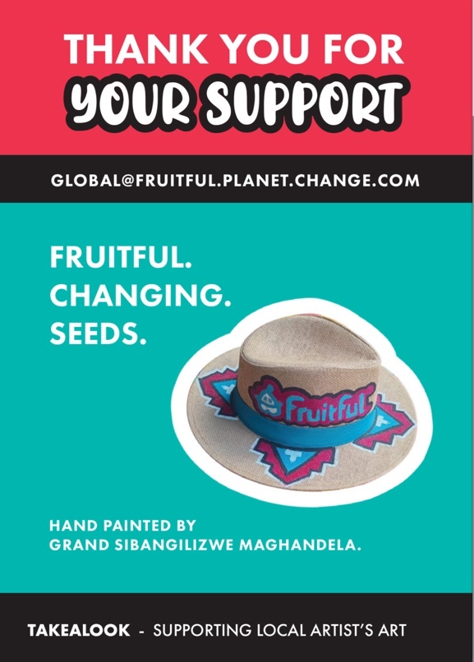**The Crate Dance Showcase differentiates itself by combining:**

1. 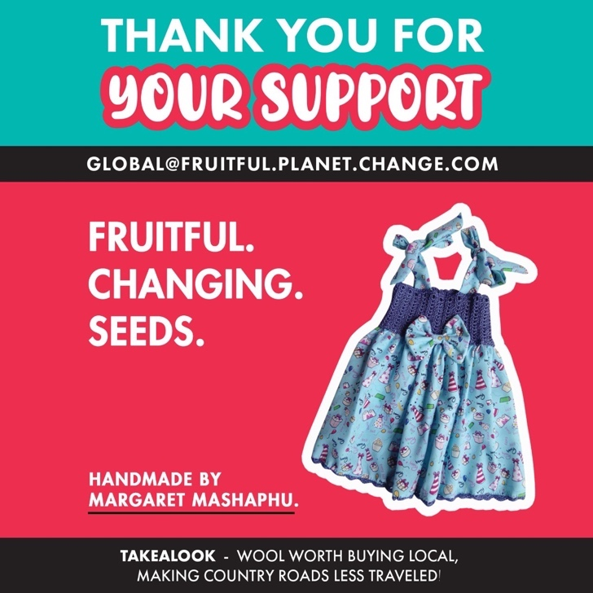**Global Vision with Local Roots**: A unique approach that highlights South Africa’s rich cultural heritage while appealing to international audiences.
2. **Technological Innovation**: Leveraging live-streaming, VR, and social media to create immersive experiences.
3. **Social Impact**: A commitment to empowering communities through job creation, training programs, and local vendor partnerships.
4. **Broad Sponsorship Appeal**: Offering tailored packages for both local and global brands.

#### **SWOT Analysis**

**Strengths**:

* Strong alignment with global cultural trends.
* Clear social impact initiatives that resonate with sponsors.
* Established local networks for implementation.

**Weaknesses**:

* High reliance on sponsorship revenue in initial phases.
* Need for robust logistics and infrastructure for global scalability.

**Opportunities**:

* Expansion into untapped markets in Africa, Asia, and Latin America.
* Collaboration with international organizations like the **Olympics.**
* Development of digital-exclusive content for new revenue streams.

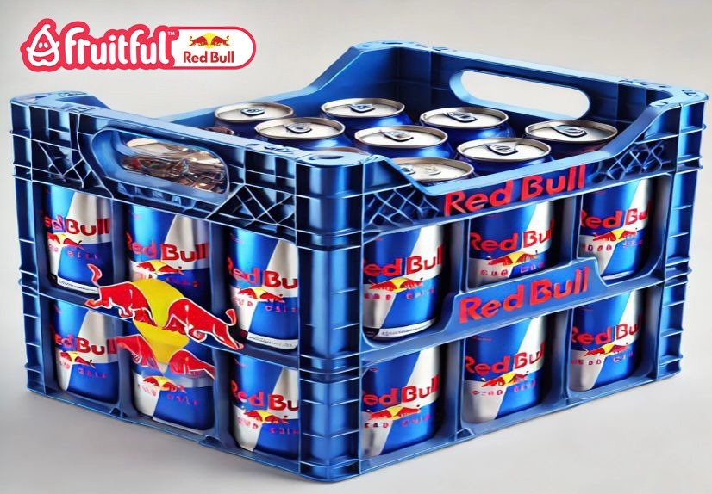**Threats**:

* Competition from established global dance events.
* Economic downturns affecting sponsorship budgets.
* Logistical challenges in underserved regions.

**6. Geographic Expansion Strategy**

(From Page 12)

#### **Overview of Expansion Strategy**

The geographic expansion of the Crate Dance Showcase is designed to capitalize on untapped opportunities in emerging markets while solidifying its presence in high-impact regions. The strategy emphasizes local cultural integration, regional partnerships, and scalable infrastructure to ensure long-term success.

#### **Phased Approach to Expansion**

1. 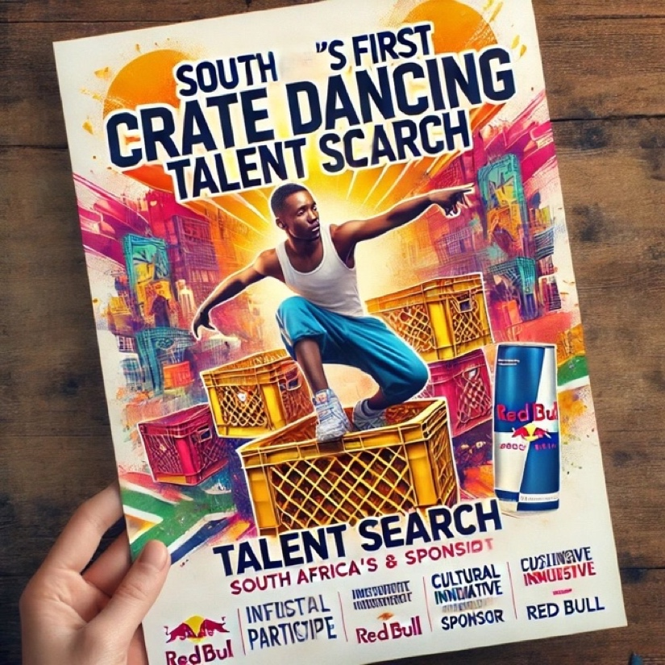**Phase 1: Establishing a National Footprint (Years 1-2)**

**Focus Regions**: Major urban centers in South Africa, including Johannesburg, Cape Town, Durban, and Pretoria.

**Goals**:

* + - Build a loyal audience base through consistent engagement.
    - Partner with local sponsors, community organizations, and cultural influencers
    - Test operational models and sponsorship packages to refine processes.

**Execution**:

* + - Host quarterly events in each city to maintain brand visibility.
    - Leverage Tupperware DCs as activation hubs in high-density areas.
    - Utilize local talent pools for performances, logistics, and promotions.

1. **Phase 2: Regional Expansion Across Africa (Years 3-5)**

**Focus Regions**: Nigeria, Kenya, Ghana, and Zambia, alongside continued growth in South Africa.

**Goals**:

* + - Position the Crate Dance Showcase as Africa’s leading street dance event.
    - Develop a pan-African network of sponsors, influencers, and media partners.
    - Integrate African cultural elements into event programming to foster regional pride.

**Execution**:

* + - Collaborate with African media giants such as MultiChoice and Africa Magic for event broadcasting.
    - Partner with regional airlines and transportation services to facilitate inter-city connectivity for participants and attendees.
    - Offer franchise opportunities for local entrepreneurs to host events under the Crate Dance Showcase brand.

1. **Phase 3: Global Expansion (Years 5-10)**

**Focus Regions**: North America, Europe, Asia, and Latin America.

**Goals**:

* + - Establish the Crate Dance Showcase as a global brand synonymous with street dance excellence.
    - Secure international sponsorships with brands like Nike, Adidas, and Coca-Cola.
    - Create digital content for global streaming platforms such as Netflix, YouTube, and Twitch.

**Execution**:

* + - Host flagship international events in key cities such as New York, Paris, Tokyo, and São Paulo.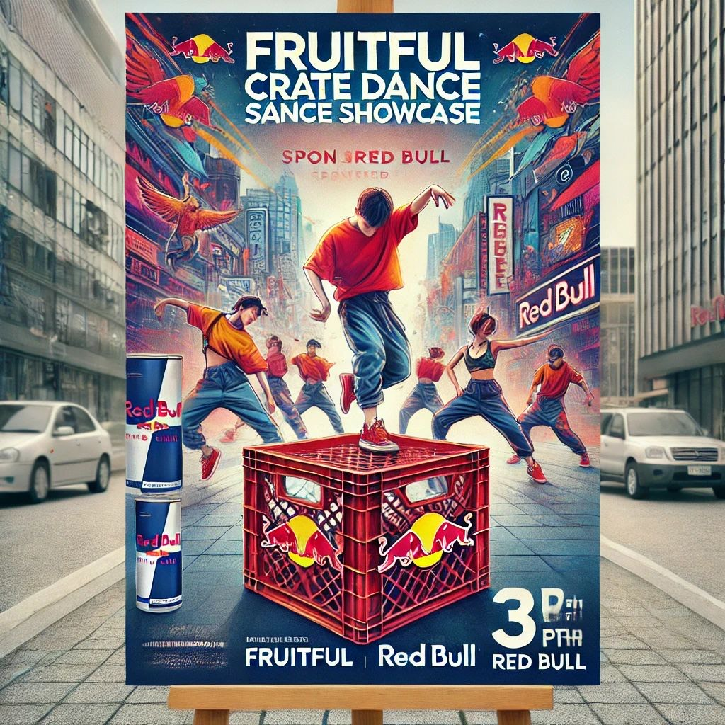
    - Launch a digital competition platform to allow participants from all over the world to engage with the showcase virtually.
    - introduce Crate Dance Showcase merchandise and memorabilia to drive additional revenue.

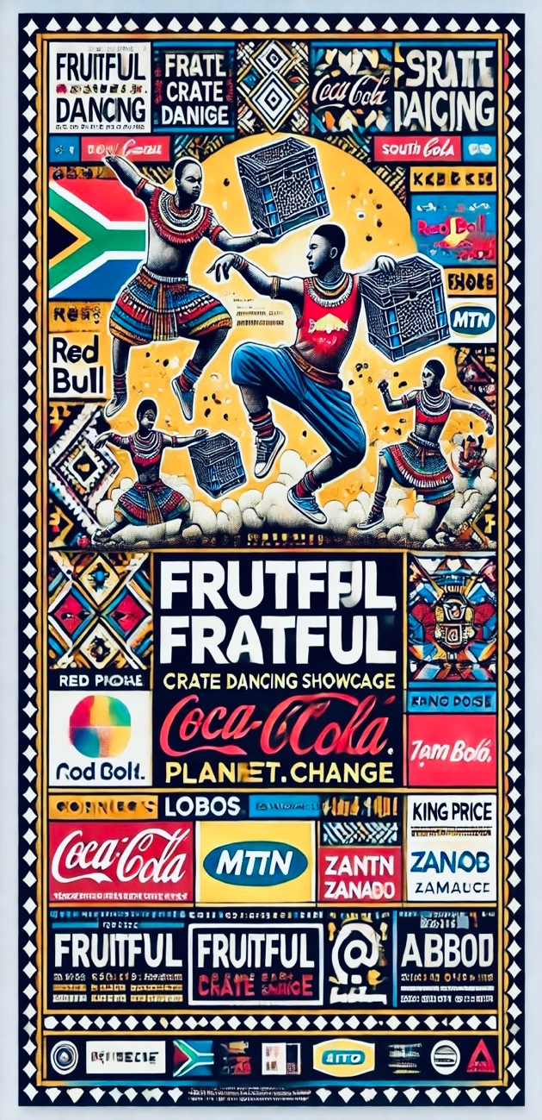**Key Considerations for Expansion**

1. **Cultural Sensitivity and Local Adaptation**
   * Ensure that events are tailored to the cultural nuances of each region.
   * Involve local community leaders and artists to foster authenticity and inclusivity.
2. **Partnerships and Sponsorships**
   * Build strong relationships with regional sponsors who align with the Crate Dance Showcase’s mission and values.
   * Collaborate with government bodies to promote tourism and economic growth through events.
3. **Infrastructure and Logistics**
   * Utilize existing networks like Tupperware DCs in South Africa for initial rollouts.
   * Invest in scalable technology solutions for ticketing, live-streaming, and digital engagement.
   * Develop a core logistics team to oversee international operations.
4. **Digital Presence and Global Reach**
   * Establish a robust digital presence via social media, websites, and apps.
   * Prioritize live-streaming and on-demand content to reach audiences unable to attend in person.

#### **Projected Outcomes of Geographic Expansion**

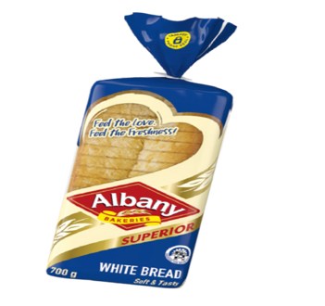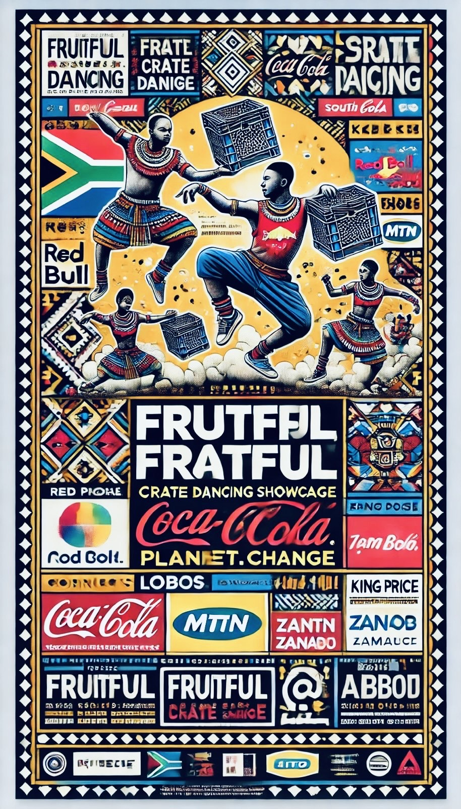**Revenue Growth**: Expanding into new regions is projected to increase annual revenues by 30-50% within each new market.

**Brand Visibility**: The Crate Dance Showcase will become synonymous with street dance globally, establishing itself as a leader in youth cultural events.

**Community Impact**: By engaging local talent and fostering grassroots development, the showcase will create jobs, promote tourism, and inspire young creatives.

### ****7. Revenue Model and Financial Strategy****

(From Page 15)

#### **Overview of the Revenue Model**

The Crate Dance Showcase revenue model is built around diversified income streams designed to ensure financial sustainability and scalability. By leveraging sponsorships, ticket sales, merchandise, franchising, and digital content monetization, the showcase aims to achieve consistent growth and profitability.

#### **Primary Revenue Streams**

1. 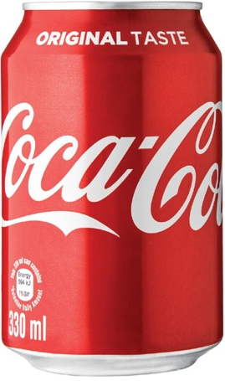**Sponsorships**
   * **Corporate Sponsorships**: Partnerships with global brands like Red Bull, Coca-Cola, Nike, and local sponsors such as MTN and Vodacom.
   * **Revenue Contribution**: Approximately 40% of total revenue in the first three years.
   * **Activation Strategies**: Product sampling, stage branding, exclusive digital content sponsorship, and VIP zones.
2. **Ticket Sales**
   * **Revenue Contribution**: Estimated at 25% of total revenue.
   * **Pricing Strategy**: Tiered ticket pricing to include affordable general admission, mid-tier reserved seating, and premium VIP access.
   * **Digital Tickets**: Leveraging QR codes and mobile ticketing systems for streamlined entry and tracking.
3. **Merchandise**
   * **Revenue Contribution**: Expected to contribute 15% of total revenue.
   * **Product Range**: Branded T-shirts, hoodies, caps, accessories, and limited-edition collectibles.
   * **Sales Channels**: On-site pop-up stores, official website, and third-party e-commerce platforms.
4. **Digital Content Monetization**
   * **Streaming Revenue**: Partnerships with platforms like YouTube, Twitch, and Netflix for live broadcasts and on-demand content.
   * **Revenue Contribution**: Estimated at 10-15% within the first five years.
   * **Subscription Services**: Offering premium memberships for exclusive behind-the-scenes content, tutorials, and interviews with performers.
5. **Franchise and Licensing**
   * **Revenue Contribution**: 10% of total revenue.
   * **Opportunities**: Licensing the Crate Dance Showcase brand to local event organizers in international markets.
   * **Royalty Model**: Franchise partners pay a percentage of ticket sales and sponsorship earnings as royalties.

**Cost Structure and Financial Strategy**

1. **Operational Costs**
   * Venue Rentals: Largest cost component, accounting for 25% of total expenses.
   * Event Staffing: Includes security, technical crews, and hospitality, contributing 15%.
   * Logistics: Transportation, setup, and teardown costs, approximately 10%.
2. **Marketing and Promotions**
   * Allocation: 20% of the budget focused on digital ads, influencer partnerships, and traditional media campaigns.
   * ROI Tracking: Tools like Google Analytics and Sprout Social to measure campaign success.
3. **Talent and Training**
   * Allocation: 15% of the budget dedicated to recruiting and training dancers, emcees, and judges.
4. **Technology Investments**
   * Live-Streaming Infrastructure: Ensuring high-quality streaming for global audiences.
   * Ticketing Systems: Scalable platforms for secure and seamless digital ticket sales.
   * Cost Allocation: 10% of the budget.

**Financial Projections**

|  |  |  |  |
| --- | --- | --- | --- |
| Year | Revenue (R) | Expenses (R) | Profit Margin (%) |
| Year 1 | 100 million | 85 million | 15% |
| Year 2 | 130 million | 105 million | 19% |
| Year 3 | 170 million | 135 million | 21% |
| Year 4 | 230 million | 180 million | 22% |
| Year 5 | 310 million | 245 million | 25% |

#### **Key Financial Goals**

1. **Break-Even Point**: Achieved by Year 2 through sponsorship income and ticket sales.
2. **Revenue Growth**: Annual revenue growth of 30-40% driven by geographic expansion, digital streaming, and sponsorships.
3. **Sustainable Profitability**: Consistent profit margin increase, targeting 25% by Year 5.

#### **Risk Management**

1. **Sponsorship Reliance**: Mitigated by diversifying revenue streams through merchandise and digital content.
2. **Economic Fluctuations**: Flexible ticket pricing and local partnerships to maintain accessibility.
3. **Operational Challenges**: Comprehensive contingency plans for logistical and technological disruptions.

### ****8. Franchise and Licensing Model****

(From Page 18)

#### **Overview**

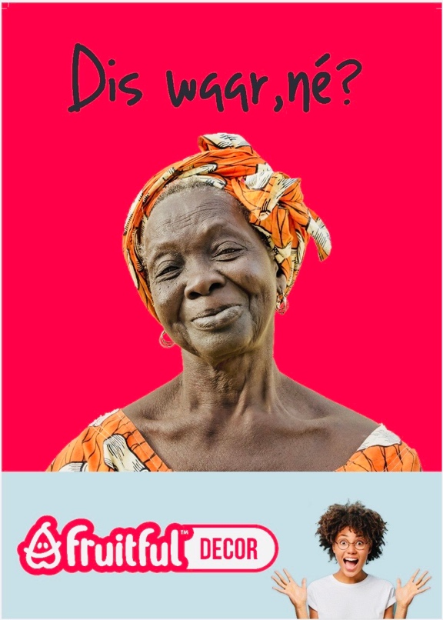The franchise and licensing model for the Crate Dance Showcase is a cornerstone of its scalability strategy, enabling the brand to expand into new markets while maintaining quality and brand consistency. This model empowers local partners to host events under the Crate Dance Showcase brand, leveraging their market knowledge and resources while benefiting from Fruitful Holdings’ established reputation and operational support.

#### **Franchise Model**

1. **Structure and Ownership**
   * **Master Franchise Agreements**: Regional or country-specific franchises are granted exclusive rights to operate the Crate Dance Showcase in their territories.
   * **Single Event Licenses**: Designed for smaller operators interested in hosting one-off events under the brand umbrella.
2. **Revenue Streams for Fruitful Holdings**
   * **Franchise Fees**: A one-time fee paid by the franchisee for brand rights.
   * **Royalty Fees**: Ongoing revenue from a percentage of ticket sales, sponsorships, and merchandise (typically 10-15%).
   * **Training and Support Fees**: Fees charged for onboarding, operational support, and training programs.
3. **Franchisee Responsibilities**
   * Securing local sponsors and partnerships.
   * Managing event logistics, including venues, staffing, and ticket sales.
   * Maintaining brand standards in event execution, marketing, and customer experience.

#### **Licensing Model**

1. **Scope of Licensing**
   * Licensing agreements allow local event organizers to use the Crate Dance Showcase brand for a specified duration and location.
   * Licensing is ideal for markets with smaller audiences or as a test phase before committing to a full franchise.
2. **Key Licensing Features**
   * Limited Rights: Use of the Crate Dance Showcase name, logo, and marketing materials for a single event.
   * Revenue Share: Licensing partners pay a flat fee, and a percentage of revenue generated from ticket sales and sponsorships.

#### **Support Provided by Fruitful Holdings**

1. **Brand and Marketing**
   * Access to a centralized marketing toolkit, including pre-designed templates for digital and traditional advertising.
   * Ongoing marketing support and global brand integration.
2. **Training and Development**
   * Comprehensive training programs for franchisees on operations, talent scouting, sponsorship management, and customer engagement.
   * Workshops and webinars conducted by industry experts to ensure franchisees stay ahead of trends.
3. **Operational Guidance**
   * Step-by-step manuals covering event logistics, sponsorship activation, and audience engagement strategies.
   * Access to Fruitful Holdings’ proprietary event management technology for ticketing, live-streaming, and reporting.

#### ****Geographic Expansion Plan****

1. 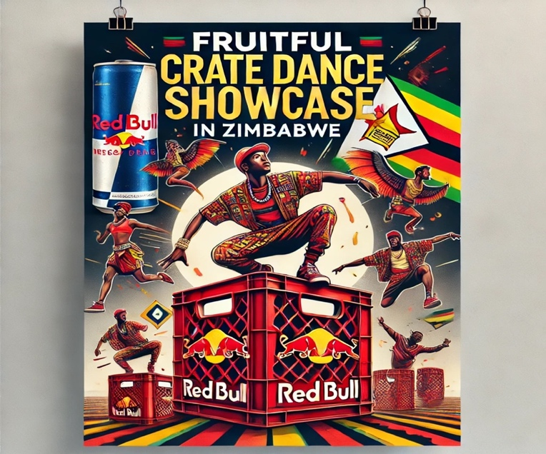**Phase 1: Domestic Rollout**
   * Targeting high-density urban centers in South Africa (Johannesburg, Cape Town, Durban, and Pretoria) to establish the brand.
   * Partnering with local sponsors and leveraging Tupperware DCs for community outreach and logistics.
2. **Phase 2: Pan-African Expansion**
   * Introducing the franchise model to countries like Kenya, Nigeria, and Ghana, which have a strong youth culture and interest in street dance.
   * Partnerships with regional brands and influencers to boost visibility.
3. **Phase 3: Global Expansion**
   * Launching in international markets, focusing on North America, Europe, and Asia, where street dance has significant cultural relevance.
   * Collaboration with global sponsors like Red Bull, Nike, and Coca-Cola for worldwide brand recognition

#### ****Projected Outcomes****

|  |  |  |  |  |
| --- | --- | --- | --- | --- |
| Year | Number of Franchises | Royalty Revenue (R) | Licensing Revenue (R) | Total Revenue (R) |
| Year 1 | 5 | 2 million | 1 million | 3 million |
| Year 2 | 12 | 5 million | 3 million | 8 million |
| Year 3 | 20 | 10 million | 5 million | 15 million |
| Year 4 | 35 | 20 million | 8 million | 28 million |
| Year 5 | 50 | 35 million | 12 million | 47 million |

#### **Key Advantages of the Model**

1. **Scalability**: Allows rapid expansion into new markets without significant capital investment by Fruitful Holdings.
2. **Local Expertise**: Franchisees and licensees bring in-depth knowledge of their regional markets, ensuring successful event execution.
3. **Shared Risk**: Financial and operational risks are distributed between Fruitful Holdings and local partners.
4. **Revenue Diversification**: Generates recurring income through royalties and licensing fees while supporting ticket and merchandise sales.

#### **Risk Management**

1. **Brand Dilution**: Enforcing strict quality standards and regular audits to ensure franchisees maintain the brand’s reputation.
2. **Market Saturation**: Careful selection of territories to prevent overlapping markets and ensure demand remains strong.
3. **Franchisee Performance**: Providing continuous training and support to franchisees to maximize their success.

### ****9. Sponsorship and Partnerships****

(From Page 20)

#### **Overview**

Sponsorships and partnerships are critical to the financial and operational success of the Crate Dance Showcase. Fruitful Holdings aims to secure long-term sponsorships with global and local brands that align with the event's mission of empowering youth, fostering creativity, and promoting cultural 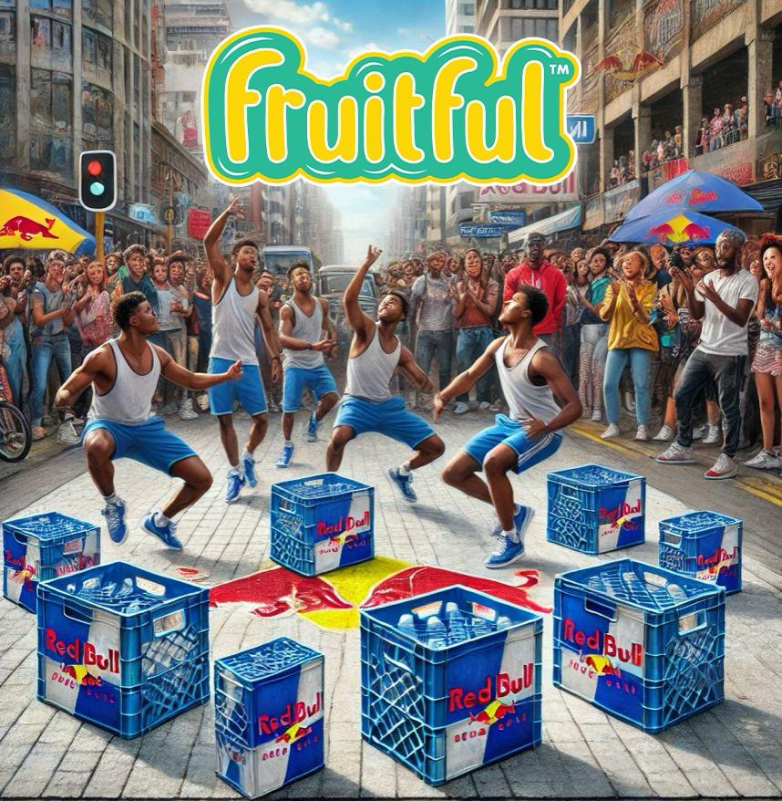exchange. These collaborations will drive revenue, increase event visibility, and provide sponsors with substantial brand engagement opportunities.



#### **Sponsorship Categories and Packages**

1. **Title Sponsor**
   * **Rights and Benefits**: Exclusive naming rights (e.g., “The Red Bull Crate Dance Showcase”), top-tier branding, and activation rights.
   * **Exposure**: Prominent logo placement on all event materials, stages, live streams, and social media.
   * **Investment Range**: R10,000,000+ per event.
2. **Gold Sponsors**
   * **Rights and Benefits**: High visibility on event banners, social media campaigns, and stage branding.
   * **Exposure**: Opportunities for live activations and product placements.
   * **Investment Range**: R5,000,000 - R10,000,000 per event.
3. **Silver Sponsors**
   * **Rights and Benefits**: Logo placement on printed and digital marketing materials, limited on-site branding.
   * **Exposure**: Mentions during the event and inclusion in the live-stream broadcast.
   * **Investment Range**: R2,500,000 - R5,000,000 per event.
4. **Bronze Sponsors**
   * **Rights and Benefits**: Logo placement on select event materials and online media mentions.
   * **Exposure**: Targeted audience engagement through giveaways or activations.
   * **Investment Range**: R1,000,000 - R2,500,000 per event.
5. **Product Sponsors**
   * **Rights and Benefits**: On-site product sampling, activation booths, and promotional opportunities.
   * **Exposure**: Engages directly with event attendees through hands-on experiences.
   * **Investment Range**: R500,000 - R1,000,000 per event.
6. **Exclusive Partners**
   * **Rights and Benefits**: Category exclusivity (e.g., “Official Beverage Partner”), premium co-branding opportunities.
   * **Exposure**: Integrated brand visibility across all event platforms.
   * **Investment Range**: Negotiable based on category.

#### **Partnership Models**

1. 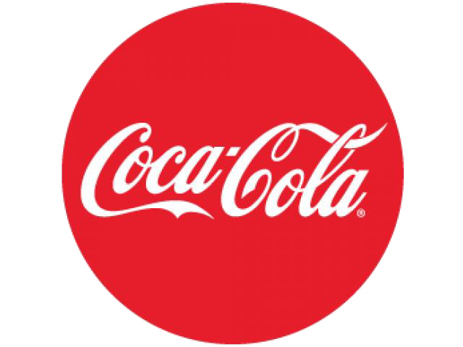**Global Partnerships**
   * Focus on internationally recognized brands such as Red Bull, Nike, Adidas, and Coca-Cola.
   * Benefits include global media exposure, access to Fruitful Holdings’ digital platforms, and co-branded activations.
2. **Local and Regional Partnerships**
   * Collaboration with South African brands, including telecoms (e.g., MTN, Vodacom), retail (e.g., Pick n Pay, Shoprite), and services (e.g., ABSA, Standard Bank).
   * Localized marketing campaigns and on-ground activations tailored to regional audiences
3. **Community and Grassroots Partnerships**
4. Partnering with local organizations and community groups to provide free or discounted access to events.
   * 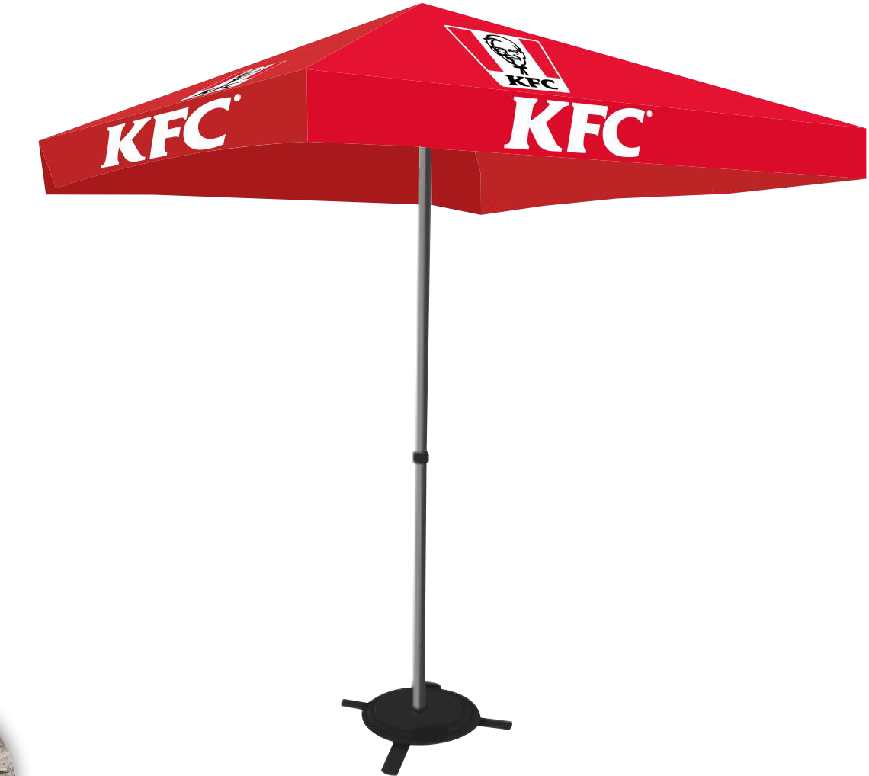Opportunities for local businesses to showcase products and services at the event.

**Sponsorship Activation Strategies**

1. **On-Site Activations**
   * Branded experience zones, product sampling, and live demonstrations.
   * Dedicated sponsor booths for audience interaction and engagement.
2. **Digital Campaigns**
   * Social media promotions featuring sponsor content, hashtags, and interactive polls.
   * Branded segments in live-stream broadcasts and behind-the-scenes content.
3. **Audience Engagement**
   * Fan competitions, giveaways, and meet-and-greet opportunities with performers.
   * Branded merchandise and memorabilia offered during the event.
4. **Media Integration**
   * Dedicated sponsor mentions in press releases, media interviews, and event coverage.
   * Branded video highlights and recap content shared across platforms like YouTube and Instagram.

**Projected Revenue from Sponsorships (Year 1-5)**

|  |  |  |  |
| --- | --- | --- | --- |
| Sponsorship Category | Number of Sponsors | Revenue per Sponsor (R) | Total Revenue (R) |
| Title Sponsor | 1 | 20,000,000 | 20,000,000 |
| Gold Sponsors | 3 | 8,000,000 | 24,000,000 |
| Silver Sponsors | 5 | 4,000,000 | 20,000,000 |
| Bronze Sponsors | 7 | 2,000,000 | 14,000,000 |
| Product Sponsors | 10 | 750,000 | 7,500,000 |
| Exclusive Partners | 3 | 10,000,000 | 30,000,000 |
| **Total (Year 1)** | **29 Sponsors** |  | **115,500,000** |
|  |  |  |  |

#### **Key Benefits to Sponsors**

1. **Brand Exposure**
2. Reaching millions of engaged audiences globally through live
3. streams, digital marketing, and media partnerships.
4. **Audience Engagement**
   * Direct interaction with event attendees, creating memorable brand experiences.
5. **Global Reach**
   * Leveraging the Crate Dance Showcase’s international appeal to tap into new markets.
6. **Data and Insights**
   * Access to attendee data, including demographics, preferences, and engagement metrics.

#### **Next Steps for Partnership Development**

1. **Finalize Sponsorship Packages**: Work with event agencies to tailor packages based on potential sponsor needs.
2. **Outreach to Target Brands**: Leverage the event agency’s network to contact both global and local brands.
3. **Secure Partnerships**: Sign sponsorship agreements, ensuring clear deliverables and ROI measurement.

### ****10. Marketing and Branding Strategy****

(From Page 22)



#### **Overview**

The marketing and branding strategy for the Fruitful Holdings Crate Dance Showcase is designed to maximize visibility, engagement, and participation while establishing the event as a leading platform for global youth culture. Leveraging both traditional and digital marketing channels, the strategy aims to attract attendees, engage sponsors, and solidify the Crate Dance Showcase as a benchmark for excellence in entertainment and community empowerment.

#### **Core Objectives**

1. **Build Brand Awareness**
   * 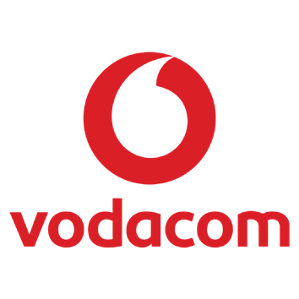Position the Crate Dance Showcase as the premier street dance event in South Africa, with global appeal.
2. **Drive Audience Engagement**
   * Create an interactive, participatory experience that extends beyond the event day through social media, live streaming, and community challenges.
3. **Attract High-Value Sponsors and Partners**
   * Showcase a professional, innovative branding strategy that aligns with sponsor goals, offering measurable ROI.
4. **Foster Community Connection**
   * Develop marketing campaigns that highlight the event’s cultural and social impact, emphasizing inclusivity and empowerment.

#### ****Target Audience****

* **Demographics**:
  + Age: 16–35 years
  + Location: Urban and peri-urban areas across South Africa, with digital outreach to international audiences.
  + Interests: Dance, music, street culture, community initiatives, and creative arts.
* **Psychographics**:
  + Tech-savvy, active on social media, culturally engaged, and value-driven.
  + Aspiring creatives seeking inspiration and platforms for self-expression

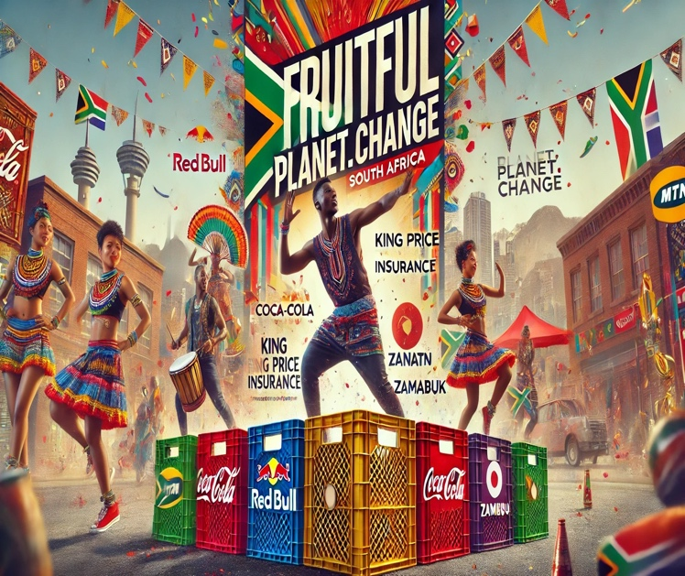 **Marketing Channels**

The Crate Dance Showcase will employ a mix of digital and traditional marketing to ensure maximum reach and impact.

**Digital Marketing**

**Social Media**:

* + - Platforms: Instagram, TikTok, YouTube, Facebook, and Twitter.
    - Campaigns: Branded hashtags (#CrateDanceShowcase), live event countdowns, and influencer collaborations.
    - Engagement Tactics: Challenges (e.g., dance-offs) , polls, and live Q&A sessions with performers.

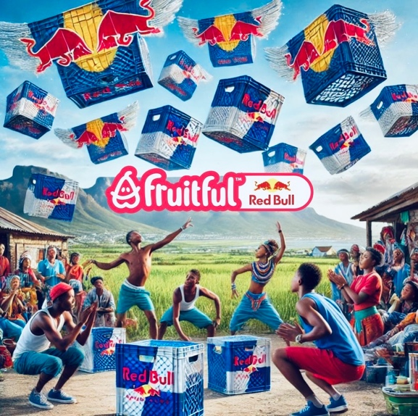

* + **Content Marketing**:
    - Creation of blogs, videos, and behind-the-scenes content to build anticipation.
    - Sharing stories of past winners, community impact, and sponsor highlights.
  + **Email Campaigns**:
    - Targeted campaigns to inform audiences of ticket sales, performer line-ups, and exclusive sponsor offers.
  + **Paid Advertising**:
    - Programmatic ads on Google, YouTube, and social media targeting specific audience demographics.

1. **Traditional Marketing**
   * **Billboards and Posters**:
     + Strategically placed in high-traffic urban areas, shopping malls, and entertainment hubs.

**Radio and TV Campaigns**:

* + - Partnerships with major broadcasters like Metro FM, YFM, and SABC to promote the event.

**Community Outreach**:

* + - Partnerships with schools, community centers, and youth organizations to drive grassroots engagement.

1. **Event-Specific Branding**

Branded merchandise such as T-shirts, caps, and tote bags.

Sponsor-branded photo booths, stages, and VIP lounges.

#### **Key Campaigns**

1. **Pre-Event Awareness**
   * Teaser campaigns showcasing performer line-ups, behind-the-scenes rehearsals, and venue highlights.
   * Countdown timers on social media with promotional ticket sales.
2. **Event Day Activation**
   * Live social media updates, streaming the event on platforms like YouTube and Instagram Live.
   * On-site activities such as sponsor-branded zones, photo booths, and merchandise sales.
3. **Post-Event Engagement**
   * Sharing highlight reels, interviews with participants, and testimonials from sponsors and attendees.
   * Survey campaigns to gather feedback and refine future events
4. **Tiered Influencer Collaborations**
   * **Mega-Influencers**: Partnerships with South African celebrities and global dance icons to amplify event visibility.
   * **Micro-Influencers**: Collaborations with grassroots dancers, community leaders, and niche content creators to foster authenticity and localized outreach.
5. 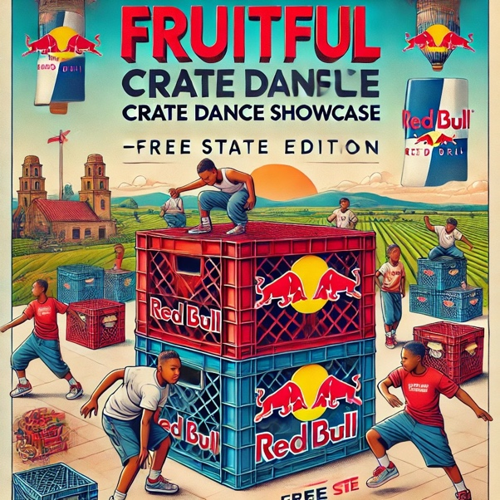**Content Deliverables**

Sponsored posts, live takeovers, and exclusive behind-the-scenes content.

Co-created branded challenges (e.g., “Crate Moves Challenge”).

**Performance Metrics**

Key metrics to measure the success of marketing campaigns:

1. **Audience Reach**
   * Total impressions across digital and traditional media.
   * Event attendance (physical and virtual).
2. **Engagement Rates**
   * Likes, shares, and comments on social media posts
   * Participation in challenges, giveaways, and polls
3. **Ticket Sales**
   * Number of tickets sold before and during the event.
4. **Sponsor ROI**
   * Sponsor mentions, visibility metrics, and audience engagement with branded activations.
5. **Media Coverage**
   * Total media mentions, press releases, and earned media value.

#### **Next Steps**

1. Finalize the marketing calendar with key campaign milestones.
2. Secure partnerships with digital influencers and local media outlets.
3. Begin social media campaigns and early-bird ticket sales.

### ****11. Operations and Logistics Plan****

(From Page 24)

#### **Overview**

The operations and logistics plan for the Fruitful Holdings Crate Dance Showcase ensures seamless execution of the event, from venue selection and setup to post-event evaluations. This plan is designed to align with the event's objectives, maximize efficiency, and deliver an exceptional experience for attendees, performers, sponsors, and stakeholders.

#### **Key Components**

1. **Venue Selection and Setup**
   * **Criteria for Venue Selection**:
     + Proximity to Tupperware DCs or high-density urban areas.
     + Accessibility for public transport and parking.
     + Capacity to accommodate large crowds (5,000+ attendees per event).
     + Availability of facilities for performers, media, sponsors, and VIPs.
   * **Setup Requirements**:
     + Main stage with high-quality audio-visual systems.
     + Sponsor activation zones and product sampling booths.
     + Designated areas for food and beverage vendors.
     + VIP lounges and backstage areas for performers and sponsors.
2. **Permits and Licenses**
   * Secure necessary permissions from local authorities, including:
     + Event permits.
     + 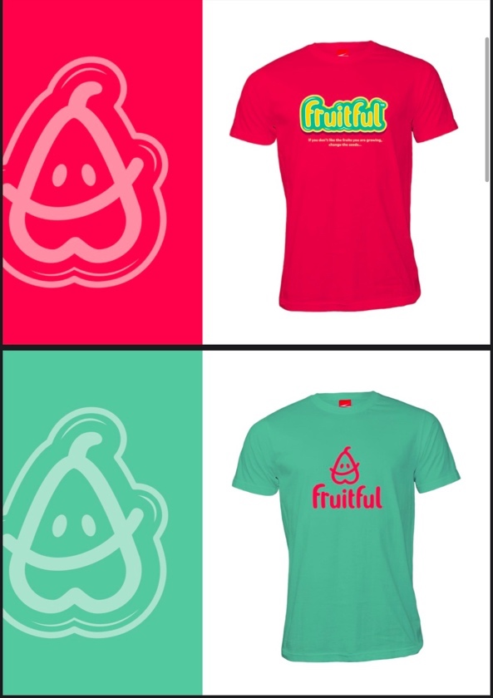Noise regulation compliance.
     + Health and safety certifications.
3. **Event Staffing**
   * **Core Team**:
     + Event Director, Operations Manager, Sponsorship Liaison, Logistics Coordinator.
   * **On-Site Personnel**:
     + Security staff, medical personnel, technicians, ushers, and volunteers.
   * **Training**:
     + 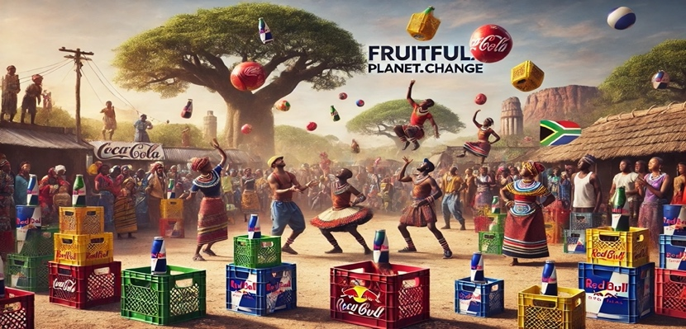Provide pre-event training to all staff on event objectives, safety protocols, and operational procedures.

#### **Logistical Framework**

1. **Event Infrastructure**
   * **Stages and Performance Areas**:
     + Modular stages with high-quality sound and lighting systems.
     + 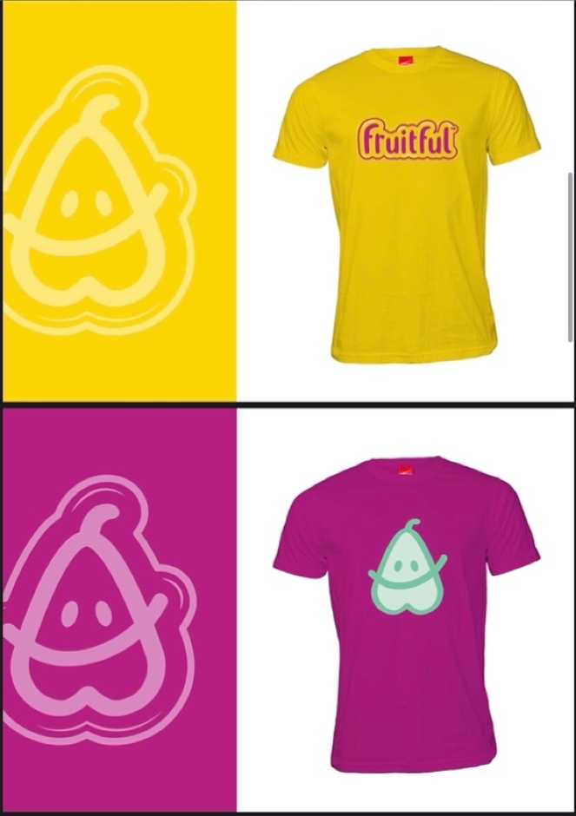Backup generators to ensure uninterrupted performances.
   * **Sponsor Zones**:
     + Booths with power connections, signage, and digital display options.
   * **Attendee Facilities**:
     + Ample seating, restroom facilities, and hydration stations.
2. **Transportation and Accessibility**
   * **Shuttle Services**:
     + Partner with local transport companies to provide shuttle services from key locations.
   * **Parking Management**:
     + Designated parking areas with clear signage and staff for guidance.
   * 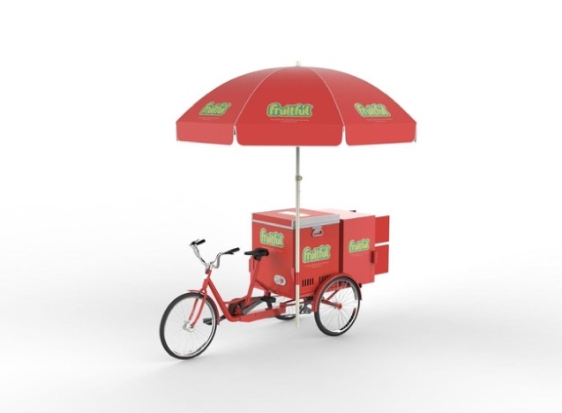**Accessibility Features**:
     + Wheelchair-friendly entry points and pathways.
3. **Vendor Coordination**

**Food and Beverage Vendors**:

* + - Secure partnerships with local vendors offering diverse cuisines and refreshments.
    - Ensure compliance with health and safety standards.

**Merchandise Vendors**:

* + - Offer event-branded merchandise for sale, including T-shirts, hats, and tote bags.

#### **Technology and IT Support**

1. **Ticketing and Entry Systems**
   * Utilize digital ticketing platforms with QR code scanning for fast and secure entry.
   * On-site ticket booths for last-minute purchases.
2. **Live Streaming and Digital Infrastructure**
   * Partner with platforms like YouTube, Instagram Live, and Facebook for global streaming.
   * Set up Wi-Fi hotspots for attendees and media personnel.
3. **Event App**
   * Provide attendees with a dedicated app featuring schedules, maps, and live updates.
4. **Data Management**
   * Collect attendee data via sign-ups and surveys for post-event analysis.
   * 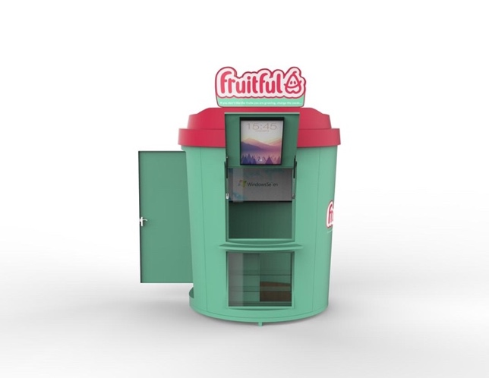Ensure data security compliance (e.g., POPIA compliance in South Africa).

**Risk Management**

1. **Health and Safety**
   * Deploy medical personnel and first aid stations at strategic locations.
   * Ensure compliance with COVID-19 protocols and crowd control measures.
2. **Security**
   * Partner with local law enforcement and private security firms for on-site safety.
   * Set up surveillance systems and manage crowd movement with clear pathways.
3. **Contingency Plans**
   * Develop plans for unexpected disruptions (e.g., power outages, weather changes).
   * Allocate a reserve budget for emergency expenses.

#### **Post-Event Evaluation**

1. **Clean-Up and Waste Management**
   * Partner with waste management companies for eco-friendly disposal of event waste.
   * Ensure the venue is restored to its original condition.
2. **Feedback Collection**
   * Distribute post-event surveys to attendees, sponsors, and stakeholders.
   * Analyze feedback for future event improvements.
3. **Performance Metrics**
   * Attendance numbers (physical and virtual).
   * Engagement levels across sponsor activations.
   * Social media impressions and interactions.
   * Sponsor satisfaction reports.

#### **Timeline for Operations and Logistics**

1. **Three Months Before the Event**:
   * Finalize venues, permits, and vendor contracts.
   * Begin ticket sales and promotions.
2. **One Month Before the Event**:
   * Confirm all logistical arrangements, including transportation, security, and equipment.
   * Conduct pre-event training for staff and volunteers.
3. **Event Week**:
   * Set up the venue and test all systems.
   * Conduct final walk-throughs with key stakeholders.
4. **Event Day**:
   * Ensure smooth execution with real-time issue resolution.
5. **Post-Event Week**:
   * Execute clean-up operations and collect feedback.
   * Prepare and share post-event reports with sponsors and stakeholders.

### ****12. Talent Development and Training Programs****

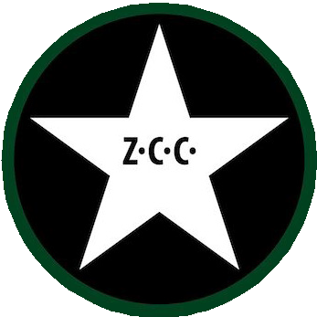(From Page 27)

#### **Overview**

Talent development is a cornerstone of Fruitful Holdings' mission, as the Crate Dance Showcase seeks to empower and elevate dancers, choreographers, and performers from diverse backgrounds. By fostering skill development and providing pathways to professional opportunities, the program ensures that the showcase not only entertains but also nurtures a new generation of creative talent.

#### **Objectives**

1. **Empower Local Talent**: Provide dancers from underserved communities with access to training, mentorship, and professional platforms.
2. **Global Exposure**: Connect talent to international audiences and opportunities.
3. **Sustainability in the Arts**: Build a framework that supports long-term careers in dance and performing arts.
4. **Diversity and Inclusion**: Prioritize representation and inclusivity across all programs.

#### **Key Initiatives**

1. **Training and Workshops**
   * 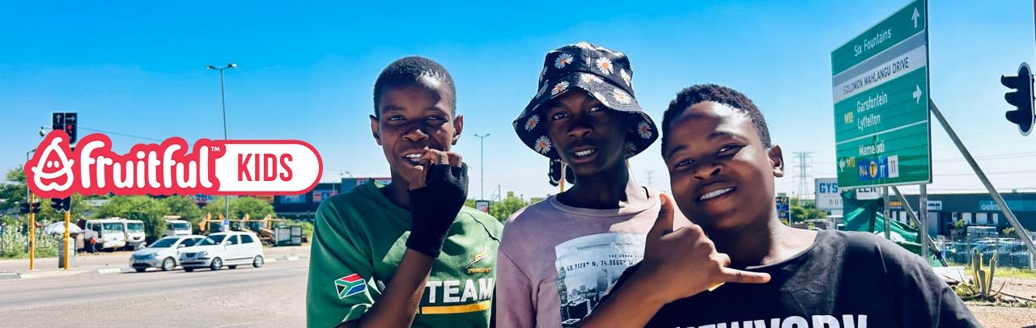**Regional Training Camps**:
     + Host training sessions in urban and rural hubs, leveraging partnerships with Tupperware DCs for community reach.
     + Offer workshops on diverse dance styles such as hip-hop, contemporary, Afrobeat, and traditional forms.
   * **Skill Development Programs**:
     + Choreography masterclasses by global industry leaders.
     + Technical workshops on staging, lighting, and costume design.
2. **Mentorship Programs**
   * Pair dancers with experienced choreographers and industry professionals for guidance.
   * Provide one-on-one career coaching sessions.
   * Develop alumni networks to support long-term growth and opportunities.
3. **Scholarships and Grants**
   * Offer full and partial scholarships to promising talent for advanced training.
   * Partner with global institutions to provide international exchange programs.
   * Award grants to dancers pursuing independent projects or productions.
4. **Talent Identification and Recruitment**
   * Conduct auditions in schools, community centers, and open spaces to discover hidden talent.
   * Establish scouting networks in high-density areas.
   * Partner with social media platforms for virtual talent submissions.
5. **Professional Development**
   * **Industry Training**: Educate talent on the business side of the arts, including contract negotiation, branding, and marketing.
   * **Health and Wellness**: Provide training on physical conditioning, injury prevention, and mental health. **Performance Opportunities**:

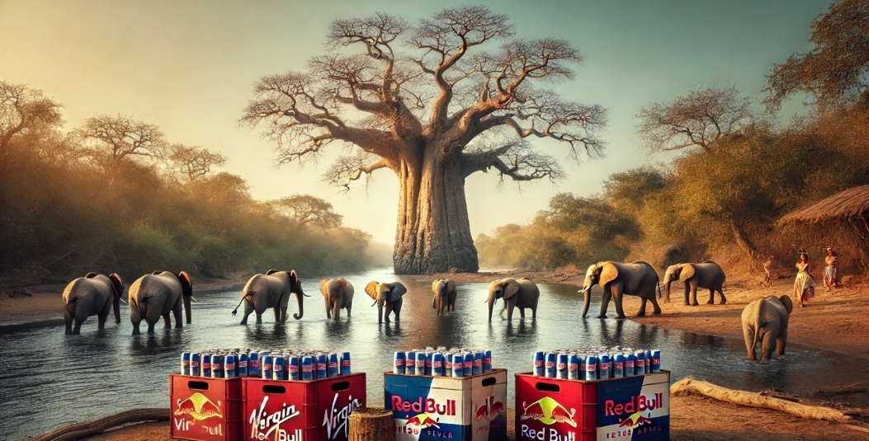Offer selected dancers guaranteed spots in the Crate Dance Showcase.

Create touring opportunities and brand partnerships for top performers.

#### 

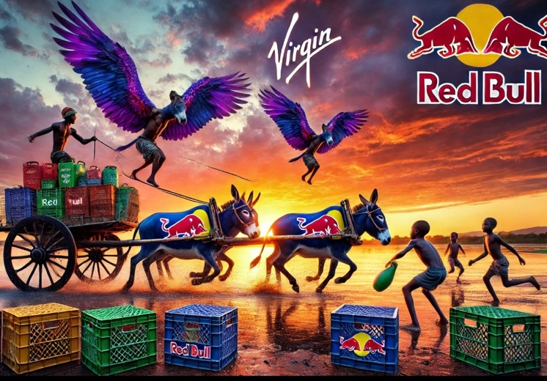**Global Partnerships and Exchange Programs**

1. **International Choreographer Collaborations**
   * Invite renowned choreographers to lead workshops and masterclasses.
   * Facilitate cross-cultural exchanges with dancers from other countries.

1. **Collaborations with Global Dance Networks**
   * Partner with organizations like the International Dance Council and World Dance Alliance.
   * 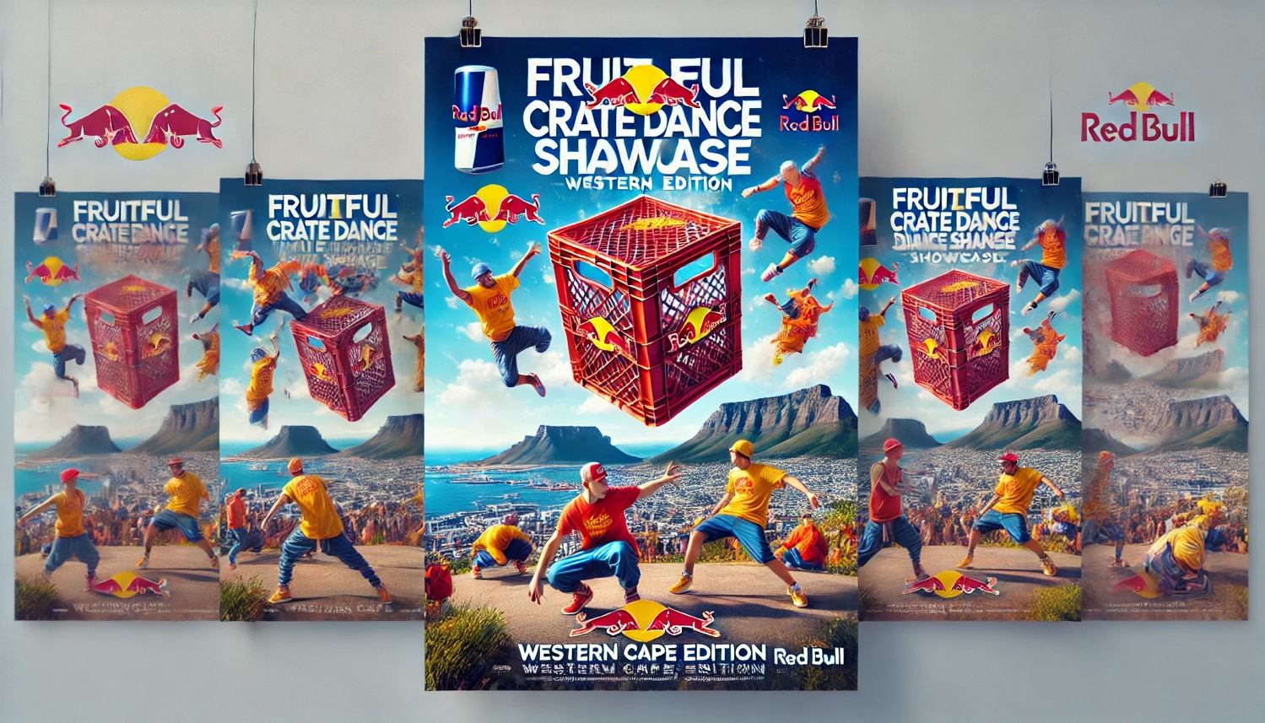Explore joint projects with platforms like Red Bull Dance Your Style and Break Free Worldwide.

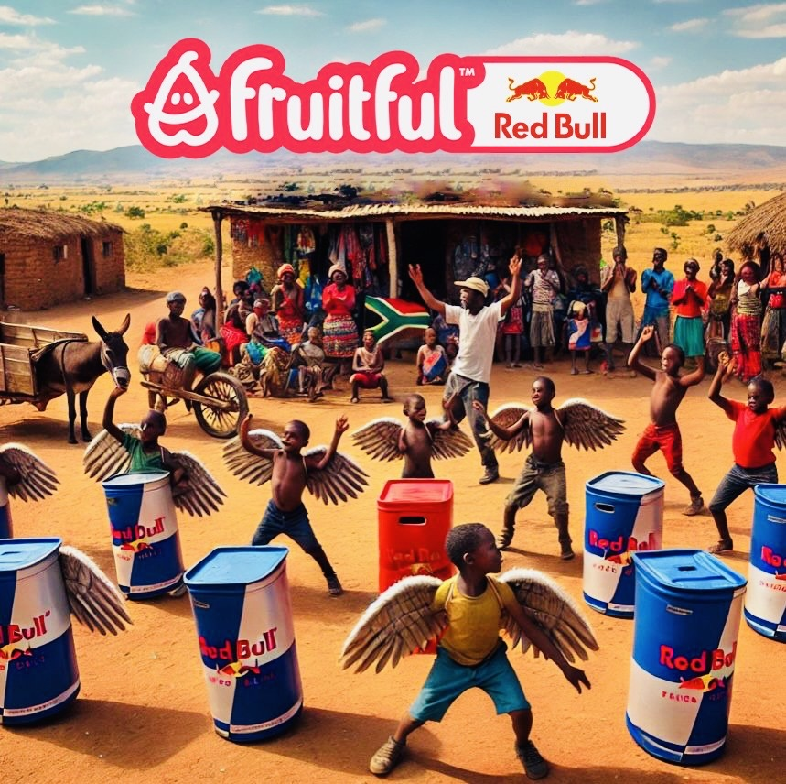**Community Engagement**

1. **Local Community Programs**
   * Establish after-school dance programs in underserved areas.
   * Offer free or low-cost classes at community centers and schools.
2. **Youth Empowerment Initiatives**
   * Host motivational talks and career guidance sessions with successful dancers and industry figures.
   * Organize community showcase events to celebrate local talent.

#### **Technology Integration in Training**

1. **Virtual Dance Academy**
   * Develop an online platform offering recorded classes, live tutorials, and feedback sessions.
   * Provide access to international instructors and choreographers for remote learners.
2. **Performance Analysis Tools**
   * Leverage video recording and playback tools for technical skill refinement.

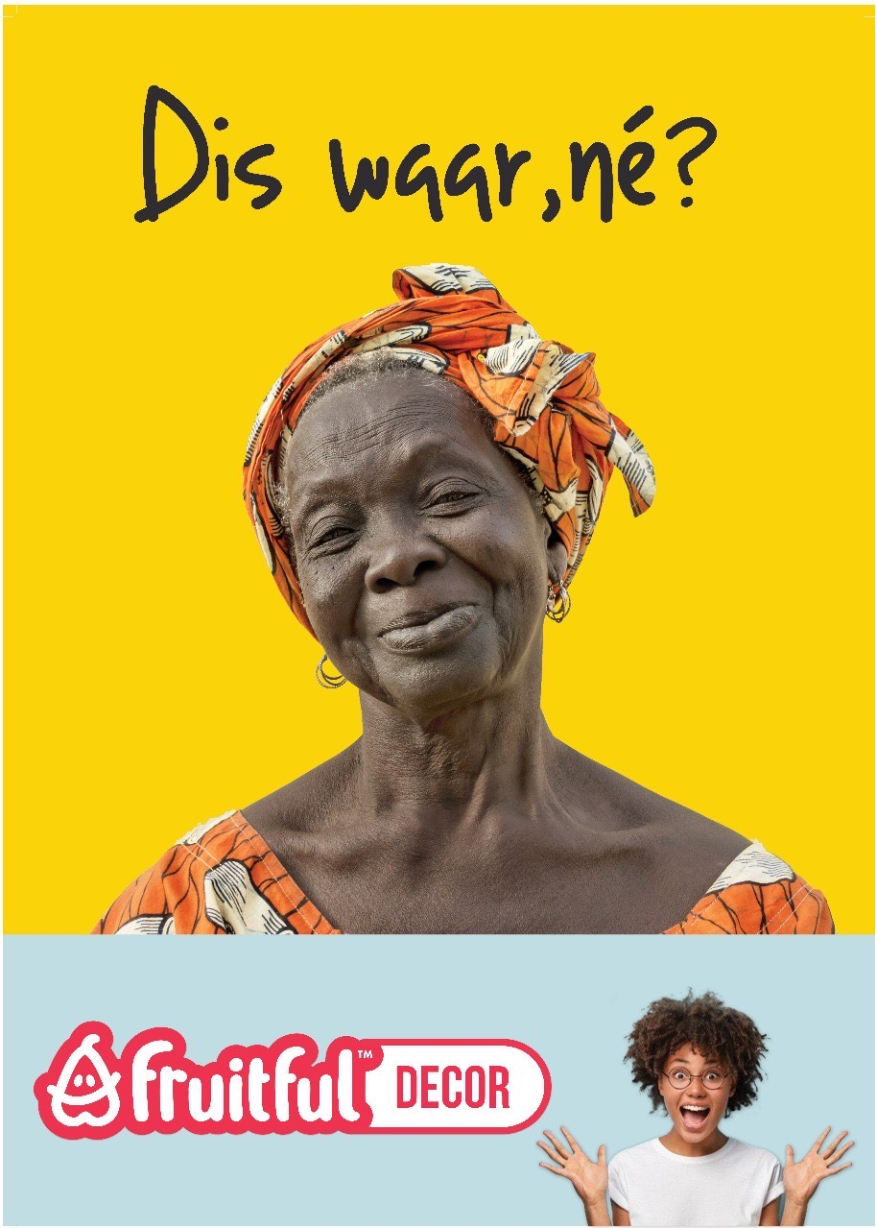

**Use AI-driven tools for personalized feedback and choreography suggestions (FAA)**

**Performance Metrics**

To measure the success of the Talent Development Program, the following metrics will be tracked:

**Participant Growth**: Number of dancers trained, mentored, and placed in professional opportunities.

**Geographic Reach**: Number of communities and regions served.

**Alumni Success**: Career milestones of program participants, including awards and high-profile performances.

**Feedback and Satisfaction**: Surveys from participants and mentors to evaluate program impact and areas for improvement.

#### **Timeline for Implementation**

1. **Phase 1: Foundation (Year 1)**
   * Launch initial training camps and workshops in key cities.
   * Establish mentorship networks and recruit local and international trainers.
   * Begin talent scouting and auditions.
2. **Phase 2: Expansion (Years 2-3)**
   * Expand programs to rural areas and international locations.
   * Develop the virtual dance academy platform.
   * Initiate global exchange programs.
3. **Phase 3: Sustainability (Years 4-5)**
   * Strengthen alumni networks and career placement systems.
   * Secure long-term funding for scholarships and grants.
   * Build partnerships with global dance organizations for sustained growth.

### ****13. Community Impact and Outreach****

(From Page 29)

#### **Overview**

The Crate Dance Showcase is not just an event but a transformative platform designed to empower communities through the arts. Fruitful Holdings prioritizes community engagement, ensuring that the event leaves a lasting impact by fostering inclusion, creating opportunities, and driving social change.

#### **Objectives**

1. **Foster Inclusion**: Promote diversity by engaging with communities from varied cultural and socioeconomic backgrounds.
2. **Create Opportunities**: Offer career pathways and skill development to participants and local businesses.
3. **Support Local Economies**: Partner with local vendors and service providers to boost economic activity.
4. **Inspire Social Change**: Use dance and creativity as tools to address social issues and promote unity.

#### **Key Initiatives**

1. **Community-Driven Planning**
   * Collaborate with community leaders, schools, and cultural organizations to ensure the event aligns with local needs and interests.
   * Create advisory panels with representatives from participating communities to guide outreach efforts.
2. **Free or Subsidized Access**
   * Provide free tickets or heavily discounted passes for low-income participants.
   * Organize community-specific sessions and performances prior to the main event.
3. **Local Business Partnerships**
   * Partner with small and medium-sized enterprises (SMEs) for food, merchandise, and services.
   * Allocate space for local artisans and vendors at event venues.
4. **Youth Empowerment Programs**
   * Conduct after-school dance classes and workshops at community centers.
   * Host motivational talks featuring accomplished dancers and community leaders.
   * Offer scholarships to talented youth for advanced training and mentorship programs.
5. **Social Awareness Campaigns**
   * Leverage the event platform to address critical social issues, such as gender equality, mental health awareness, and environmental sustainability.
   * Integrate messages of empowerment and resilience into performances and media campaigns.
6. **Sustainable Development Initiatives**
   * Encourage eco-friendly practices at events, such as reducing waste and using recyclable materials.
   * Collaborate with environmental organizations to promote green practices.

#### **Collaborations with NGOs and Nonprofits**

Fruitful Holdings will collaborate with organizations that focus on social development to extend the impact of the Crate Dance Showcase.

1. **Education and Skill Development**: Partner with educational nonprofits to offer dance and career skills to underserved youth.
2. **Health and Wellness**: Collaborate with organizations promoting physical and mental health for dancers and attendees.
3. **Community Revitalization**: Work with groups that focus on urban renewal, transforming unused spaces into vibrant cultural hubs.

#### **Measurable Impacts**

1. **Economic Impact**:
   * Track the revenue generated for local businesses during the event.
   * Measure the economic boost to the surrounding area through vendor partnerships and increased foot traffic.
2. **Participation Metrics**:
   * Count the number of local participants (dancers, vendors, volunteers).
   * Record attendance numbers at community-specific events and workshops.
3. **Skill Development**:
   * Track the number of individuals who receive training or mentorship.
   * Follow up with participants to document how the program impacts their careers or education.
4. **Social Impact Surveys**:
   * Distribute surveys to measure how participants and attendees feel the event has benefited their community.
   * Conduct focus groups to gather qualitative feedback on the program's impact.

#### **Community Showcase**

To celebrate local talent and amplify community engagement, the Crate Dance Showcase will host a special Community Showcase featuring performances by:

1. **Local Dance Groups**: Invited from schools, community centers, and independent dance teams.
2. **Cultural Performances**: Traditional and contemporary dance acts representing the diversity of South Africa.
3. **Guest Performances**: Professional dancers mentoring local talent will collaborate in featured performances.

#### **Timeline for Implementation**

1. **Phase 1: Community Outreach (Year 1)**
   * Identify target communities and establish local partnerships.
   * Host introductory workshops and community meetings.
   * Begin local business recruitment for event participation.
2. **Phase 2: Integration and Expansion (Years 2-3)**
   * Expand outreach programs to rural and underserved areas.
   * Increase collaboration with NGOs and nonprofit organizations.
   * Scale up youth empowerment programs and scholarship opportunities.
3. **Phase 3: Sustainability (Years 4-5)**
   * Build long-term relationships with communities through annual events and follow-up programs.
   * Create permanent structures, such as dance hubs, in high-impact areas.
   * Establish ongoing funding for community-driven initiatives.

#### **Performance Metrics for Outreach Programs**

1. **Economic Impact**:
   * Total revenue generated for local vendors and businesses.
   * Increase in tourism and local business activity during the event.
2. **Social Engagement**:
   * Number of attendees who participate in workshops, talks, and performances.
   * Level of engagement on social media campaigns tied to community themes.
3. **Satisfaction Levels**:
   * Feedback from participants, vendors, and community leaders.
   * Survey data highlighting perceived improvements in local opportunities and cultural exposure.

### ****14. Technology and Innovation****

(From Page 31)

#### **Overview**

Fruitful Holdings integrates cutting-edge technology to revolutionize the Crate Dance Showcase experience. By leveraging digital tools, interactive platforms, and innovative approaches, we aim to enhance audience engagement, streamline operations, and create a seamless experience for participants and attendees. Technology is at the core of delivering a globally recognized, immersive dance event that inspires and connects people worldwide.

#### **Core Objectives**

1. **Enhance Accessibility**: Ensure that audiences from remote areas can access the event via digital platforms.
2. **Increase Engagement**: Leverage technology to create interactive experiences for attendees and sponsors.
3. **Optimize Event Operations**: Use advanced tools for logistics, ticketing, and performance management.
4. **Innovate Storytelling**: Capture and share unique stories through technology-driven media campaigns.

#### **Key Technological Innovations**

1. **Livestreaming and Virtual Access**
   * Host a high-quality livestream of the event accessible via platforms such as YouTube, Instagram, and Red Bull TV.
   * Offer an interactive virtual experience for global audiences with features like live voting, virtual meet-and-greets, and behind-the-scenes access.
2. **Event Mobile Application**
   * **Features**:
     + Real-time updates on performances, schedules, and activities.
     + Interactive maps for venue navigation and sponsor activation zones.
     + Voting functionality for audience participation in competitions.
     + Exclusive content, such as dancer interviews and tutorials.
   * **Engagement**:
     + Enable audience members to participate in polls, contests, and Q&A sessions with performers.
3. **Digital Ticketing and Registration**
   * Implement QR code-based ticketing for easy and contactless entry.
   * Provide tiered ticketing options, including VIP and general access, with integrated perks like merchandise discounts and exclusive digital content.
   * Collect attendee data for future marketing and engagement campaigns.
4. **Augmented Reality (AR) and Virtual Reality (VR) Experiences**
   * AR: Introduce interactive AR elements, such as filters for social media, branded digital collectibles, and on-site activations.
   * VR: Develop a virtual tour of the event venue, allowing users to experience the showcase remotely in a fully immersive environment.
5. **Performance Analytics and Feedback**
   * Use AI-based tools to analyze dancer performances, providing feedback and insights for improvement.
   * Enable judges and audiences to score performances digitally, with real-time results displayed on screens and apps.
6. **Social Media Integration**
   * Implement social media walls showcasing live posts, audience interactions, and trending hashtags.
   * Partner with influencers to amplify event content and encourage user-generated posts.
   * Run hashtag campaigns to increase visibility (e.g., #CrateDanceRevolution).
7. **Sponsor Technology Integration**
   * Provide sponsors with digital dashboards to track their brand exposure and engagement during the event.
   * Enable real-time sponsor messaging during livestreams and social media integrations.
8. **Sustainability Monitoring**
   * Use digital tools to track the event’s carbon footprint.
   * Introduce eco-friendly initiatives like paperless ticketing and reusable branded materials.

#### **Partnerships with Tech Companies**

To achieve technological excellence, Fruitful Holdings will partner with leading tech companies, including:

1. **Streaming Platforms**: Collaborate with YouTube, Facebook Live, and Red Bull TV for global livestreaming.
2. **App Developers**: Engage app developers to create a customized, user-friendly event application.
3. **AR/VR Experts**: Partner with firms specializing in AR/VR technology to design immersive experiences.
4. **Data Analytics Providers**: Work with companies like Google Analytics or Tableau for audience and performance data analysis.
5. **Social Media Platforms**: Collaborate with TikTok, Instagram, and Twitter to integrate innovative audience engagement campaigns.

#### **Implementation Phases**

1. **Phase 1: Planning and Integration** (Year 1)
   * Develop the event app and finalize partnerships with streaming platforms.
   * Create a roadmap for integrating AR/VR experiences.
   * Test digital ticketing and QR code systems in pilot events.
2. **Phase 2: Execution and Optimization** (Years 2-3)
   * Launch the event app and promote its usage among attendees.
   * Implement AR/VR features in selected events for feedback.
   * Scale social media campaigns with influencer collaborations.
3. **Phase 3: Global Expansion** (Years 4-5)
   * Expand digital access to global markets with multilingual options.
   * Refine technology integrations based on attendee feedback and analytics.
   * Develop new features for the app and expand AR/VR experiences to more regions.

#### **Benefits of Technology Integration**

1. **For Audiences**:
   * Immersive, interactive, and engaging experiences regardless of location.
   * Easy access to tickets, event updates, and exclusive content.
2. **For Performers**:
   * Advanced feedback tools for improvement.
   * Greater visibility through digital platforms and analytics.
3. **For Sponsors**:
   * Measurable brand exposure and ROI through advanced analytics.
   * Innovative ways to engage with target audiences via AR, VR, and app integration.
4. **For Organizers**:
   * Efficient operations, from ticketing to audience management.
   * Deeper insights into audience preferences and behaviors.

#### **Metrics for Success**

1. **App Downloads and Usage**: Measure the number of downloads and active users on the event app.
2. **Livestream Viewership**: Track the number of global viewers and engagement rates.
3. **Social Media Metrics**: Monitor impressions, shares, likes, and hashtag usage.
4. **Sponsor ROI**: Assess the impact of sponsor integrations using analytics and feedback.
5. **Audience Satisfaction**: Gather post-event surveys to gauge the audience's experience with the technology.

### ****15. Implementation Roadmap****

(From Page 33)

#### **Overview**

The Implementation Roadmap outlines the timeline, key milestones, and actionable steps necessary to bring the Crate Dance Showcase to life. This plan ensures that every phase of development, from concept to execution, is structured, measurable, and achievable. By adhering to this roadmap, Fruitful Holdings will effectively manage resources, partnerships, and deliverables to meet its ambitious objectives.

#### **Phase 1: Pre-Launch Preparation (Months 1–12)**

**Goals:**

* Establish foundational elements of the Crate Dance Showcase, including partnerships, infrastructure, and branding.

**Key Activities:**

1. **Strategic Planning and Goal Alignment**
   * Finalize the business plan and align with stakeholders.
   * Conduct market analysis to validate event demand and audience preferences.
   * Confirm target cities and venues, focusing on areas identified via Tupperware DCs.
2. **Sponsorship Acquisition**
   * Secure commitments from major sponsors (e.g., Red Bull, Coca-Cola).
   * Develop tailored sponsorship packages based on audience and brand goals.
3. **Event Concept Finalization**
   * Design event branding, themes, and messaging.
   * Draft performance formats, judging criteria, and engagement elements (e.g., audience voting).
4. **Digital Infrastructure Development**
   * Develop the event mobile app and establish streaming partnerships.
   * Test digital ticketing systems and audience interaction features.
5. **Operational and Team Setup**
   * Hire key personnel, including event managers, marketing leads, and tech developers.
   * Identify and engage with local vendors for event logistics (e.g., staging, lighting).
6. **Marketing and Awareness Campaign**
   * Launch teaser campaigns across social media platforms.
   * Engage influencers and content creators to generate pre-launch buzz.
   * Establish partnerships with media outlets for coverage.

#### **Phase 2: Event Execution and Expansion (Months 13–36)**

**Goals:**

* Successfully launch the inaugural Crate Dance Showcase and establish its reputation.
* Expand to additional cities and markets.

**Key Activities:**

1. **Pilot Event Execution**
   * Host the inaugural showcase in a flagship city (e.g., Johannesburg).
   * Execute sponsorship activations, including product booths, AR/VR experiences, and branded content.
   * Test audience engagement tools like the app, live voting, and social media walls.
2. **Feedback Collection and Iteration**
   * Conduct post-event surveys for audience, performers, and sponsors.
   * Refine operational workflows and tech integrations based on feedback.
3. **Scaling and Expansion**
   * Launch subsequent events in other high-density regions (e.g., Durban, Cape Town, Port Elizabeth).
   * Adapt event features and sponsorship packages based on regional audience preferences.
4. **Performance and Talent Growth**
   * Establish training programs for dancers to prepare them for global stages.
   * Partner with local talent agencies to scout emerging performers.

#### **Phase 3: Global Integration and Long-Term Growth (Years 4–5)**

**Goals:**

* Transform the Crate Dance Showcase into a globally recognized brand.
* Expand digital reach and diversify revenue streams.

**Key Activities:**

1. **Global Expansion**
   * Host international showcases in target markets (e.g., Europe, North America, Asia).
   * Collaborate with global sponsors for cross-market activations.
2. **Brand Evolution**
   * Introduce merchandise collaborations with major fashion brands (e.g., Nike, Adidas).
   * Launch a digital archive of past events for audience engagement.
3. **Innovative Technology Integration**
   * Expand AR/VR experiences to include virtual event attendance.
   * Develop gamified features in the mobile app for year-round audience interaction.
4. **Community and Social Impact Programs**
   * Scale community engagement initiatives, such as workshops and local talent incubators.
   * Collaborate with sponsors to fund educational scholarships for dancers.

#### **Key Milestones and Timeline**

| **Milestone** | **Timeline** | **Responsible Teams** |
| --- | --- | --- |
| Business Plan Finalization | Month 1 | Executive Team |
| Sponsorship Agreements Secured | Month 4 | Sponsorship Team |
| Mobile App Development Complete | Month 8 | Tech Development Team |
| Inaugural Showcase Hosted | Month 12 | Event Management Team |
| First 3-City Expansion | Months 13–24 | Operations & Expansion Team |
| First International Event | Year 4 | Global Expansion Team |
| AR/VR Integration Across All Events | Year 5 | Tech Development Team |

#### **Performance Metrics**

To ensure successful implementation, the following metrics will be tracked:

1. **Event Attendance**
   * Physical attendance at each event.
   * Virtual participation through livestream platforms.
2. 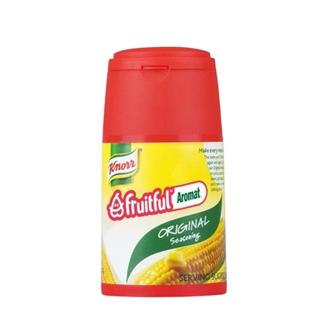**Revenue Growth**
   * Sponsorship revenue growth over time.
   * Ticket sales and merchandise revenue.
3. **Audience Engagement**
   * Social media impressions, shares, and hashtag use.
   * App downloads and active users.
4. **Sponsor Satisfaction**
   * Positive feedback from sponsors based on ROI metrics.
   * Renewed sponsorship agreements.
5. **Global Reach**
   * Number of international events hosted.
   * Global audience engagement metrics.

#### **Conclusion**

The Implementation Roadmap provides a structured framework for Fruitful Holdings to launch and scale the Crate Dance Showcase. Each phase is designed to maximize impact, ensure sponsor satisfaction, and deliver an unforgettable experience for audiences and participants alike.

### ****16. Funding Strategy****

(From Page 35)

#### **Overview**

The funding strategy is a cornerstone of the Crate Dance Showcase, designed to support its launch, scalability, and global expansion. Fruitful Holdings aims to secure diverse funding sources, combining sponsorships, investments, 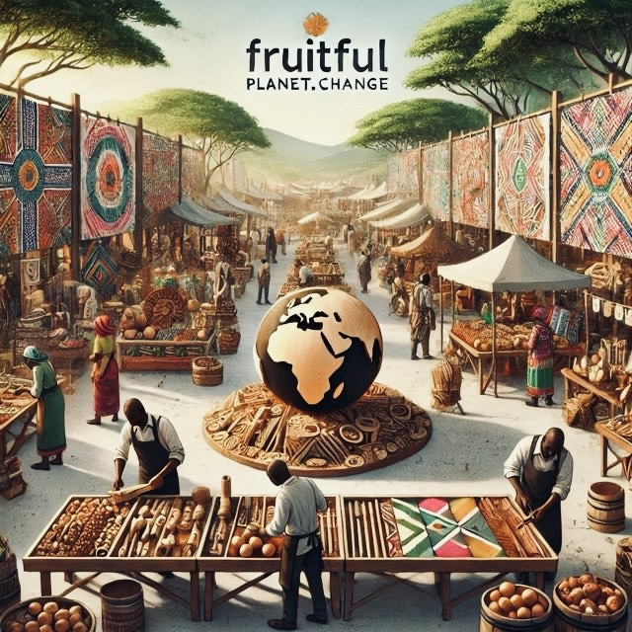ticket sales, and merchandise revenue to create a sustainable financial model. This strategy will ensure that the showcase achieves its ambitious objectives while providing strong returns to stakeholders.

#### **Key Funding Sources**

**Corporate Sponsorships**  
**Description:**

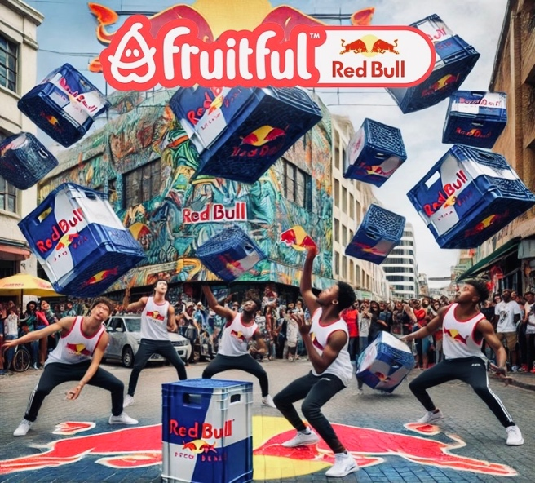Partnerships with major brands across industries such as beverages (Red Bull, Coca-Cola), telecommunications (MTN, Vodacom), and sportswear (Nike, Adidas).   
**Revenue Target**

60% of total funding in Year 1.

**Implementation:**

Develop multi-tier sponsorship packages, including title sponsorships and exclusive category rights.

Collaborate on co-branded campaigns and product activations.

1. **Investor Funding**  
   **Description:**
   * 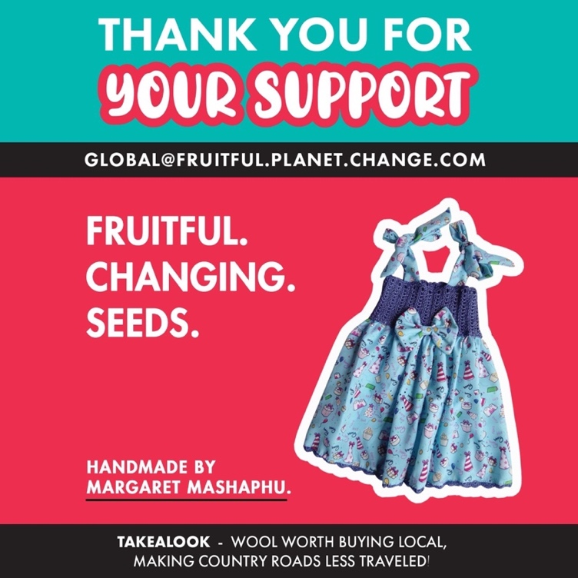Attract investments from private equity firms, venture capitalists, and angel investors.  
     **Revenue Target:**
   * 20% of total funding.  
     **Implementation:**
   * Present a detailed business plan highlighting revenue projections, market opportunity, and scalability.
   * Offer equity options or revenue-sharing agreements to incentivize investment.
2. **Ticket Sales**  
   **Description:**
   * Revenue generated from event ticketing, including general admission, VIP packages, and digital passes for livestream audiences.  
     **Revenue Target:**
   * 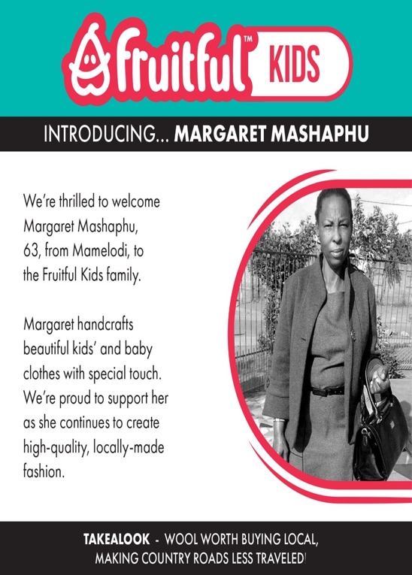10% of total funding in Year 1, growing to 25% by Year 3.  
     **Implementation:**
   * Leverage digital ticketing platforms to streamline sales and engagement.
   * Offer tiered pricing options to appeal to various audience segments.
3. **Merchandise Revenue**  
   **Description:**
   * Sales of branded merchandise, including clothing, accessories, and digital collectibles.

**Revenue Target:**

**5% of total funding in Year 1, growing to 15% by Year 5.  
Implementation:**

**Partner with fashion brands for co-branded collections. Introduce limited-edition items tied to specific events or themes.**

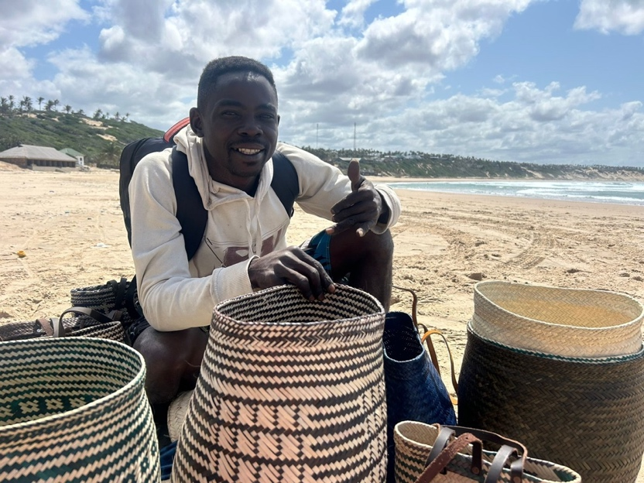**Digital Partnerships and Streaming Rights**  
**Description:**

Revenue from digital partnerships, including exclusive streaming rights and in-app advertising.  
**Revenue Target:** 5% of total funding in Year 1, growing with the event’s digital footprint.  
**Implementation:**

Secure streaming deals with platforms such as YouTube, Netflix, and Red Bull TV. Monetize the event app through ads and exclusive sponsor content.

#### **Budget Allocation**

#### To ensure efficient use of funds, the following budget allocation is proposed for Year 1:

|  |  |  |
| --- | --- | --- |
| **Category** | **Percentage of Budget** | **Estimated Amount (R)** |
| Event Production | 40% | R160,000,000 |
| Marketing and Branding | 20% | R80,000,000 |
| Technology Development | 10% | R40,000,000 |
| Sponsorship Activation Costs | 10% | R40,000,000 |
| Talent Development and Training | 10% | R40,000,000 |
| Community Engagement Programs | 5% | R20,000,000 |
| Administrative and Operational | 5% | R20,000,000 |

**Total Budget for Year 1:** R400,000,000

#### **Investment Pitch Highlights**

To attract investors and sponsors, Fruitful Holdings will highlight the following key selling points:

1. **Scalability**
   * A scalable model with opportunities for geographic and revenue expansion.
   * Proven market demand for youth culture and dance events.
2. **Strong ROI Potential**
   * Projected annual revenue growth of 20-25% over the first five years.
   * Sponsorship agreements and digital partnerships as high-yield revenue streams.
3. **Community and Social Impact**
   * Programs to develop local talent and engage underprivileged communities.
   * Opportunities for sponsors to align with impactful social initiatives.
4. **Innovative Technology**
   * Integration of AR/VR, gamified features, and a robust event app.
   * Streaming partnerships to increase global reach and monetization.
5. 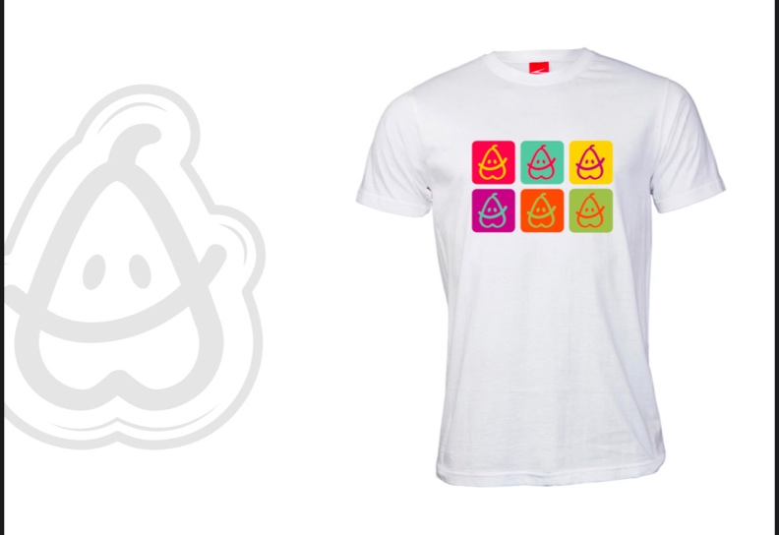**Brand Partnership Opportunities**
   * Exclusive access to a young, engaged audience.
   * Co-branded content and merchandise for long-term visibility.

#### **Risks and Mitigation**

1. **Sponsorship Shortfall:**
   * **Risk:** Difficulty securing major sponsors.
   * **Mitigation:** Develop flexible sponsorship packages to attract diverse brands and target smaller sponsors to fill funding gaps.
2. **Market Uncertainty:**
   * **Risk:** Uncertainty around audience attendance and ticket sales.
   * **Mitigation:** Emphasize digital ticketing and livestream options to expand revenue potential.
3. **Operational Delays:**
   * **Risk:** Delays in event execution due to logistics or technical challenges.
   * **Mitigation:** Partner with experienced event agencies and maintain a robust project management framework.
4. **Competitive Market:**
   * **Risk:** Competition from similar events or entertainment platforms.
   * **Mitigation:** Focus on differentiation through unique branding, technology integration, and community-driven initiatives.

#### **Conclusion**

The funding strategy for the Crate Dance Showcase is designed to balance immediate financial needs with long-term sustainability. By diversifying funding sources, engaging with major sponsors, and leveraging innovative technology, Fruitful Holdings aims to establish the showcase as a globally recognized event while delivering substantial returns to stakeholders.

### ****16. Funding Strategy – Detailed Expansion****

#### **Overview**

The funding strategy is the financial backbone of the Crate Dance Showcase. It is structured to secure a combination of diverse funding streams that not only address Year 1 financial needs but also create a scalable foundation for long-term sustainability. By leveraging sponsorships, investments, digital revenue, ticket sales, and merchandise, Fruitful Holdings aims to exceed its financial goals while maximizing ROI for stakeholders.

The R400 million budget for Year 1 represents an optimized funding scenario, supporting event execution, marketing, and the foundational investments needed for future global expansion.

#### **Funding Objectives**

1. **Secure Multi-Tier Sponsorships:** Achieve a sponsorship-driven funding model that covers 60% of Year 1 revenue needs.
2. **Expand Investor Pool:** Attract strategic investors who see value in the global scalability of the Crate Dance Showcase.
3. **Enhance Digital Revenue Streams:** Focus on technology integration, streaming rights, and in-app monetization to unlock scalable revenue potential.
4. **Optimize Community Engagement:** Use affordable ticket pricing and community partnerships to drive attendance and local support.
5. **Build Merchandise Appeal:** Establish Crate Dance Showcase-branded merchandise as a revenue stream tied directly to audience engagement.

#### **Key Funding Sources and Strategies**

##### **1. Corporate Sponsorships (60%)**

Sponsorship revenue will form the majority of Year 1 funding, targeting R240 million through multi-tier partnerships.

* **High-Potential Brands:**  
  Fruitful Holdings has identified Red Bull, Coca-Cola, MTN, Vodacom, Nike, and Adidas as primary partners, aligning their audience demographics with the event’s vision.
* **Sponsorship Tiers:**
  + **Title Sponsor:** Exclusive naming rights and premium branding throughout the event.
  + **Gold Sponsor:** Co-branded campaigns, product activations, and main-stage branding.
  + **Silver Sponsor:** Event signage, digital mentions, and activation zones.
  + **Category Exclusivity:** Partnerships offering exclusivity in categories such as energy drinks, sportswear, or telecommunications.
* 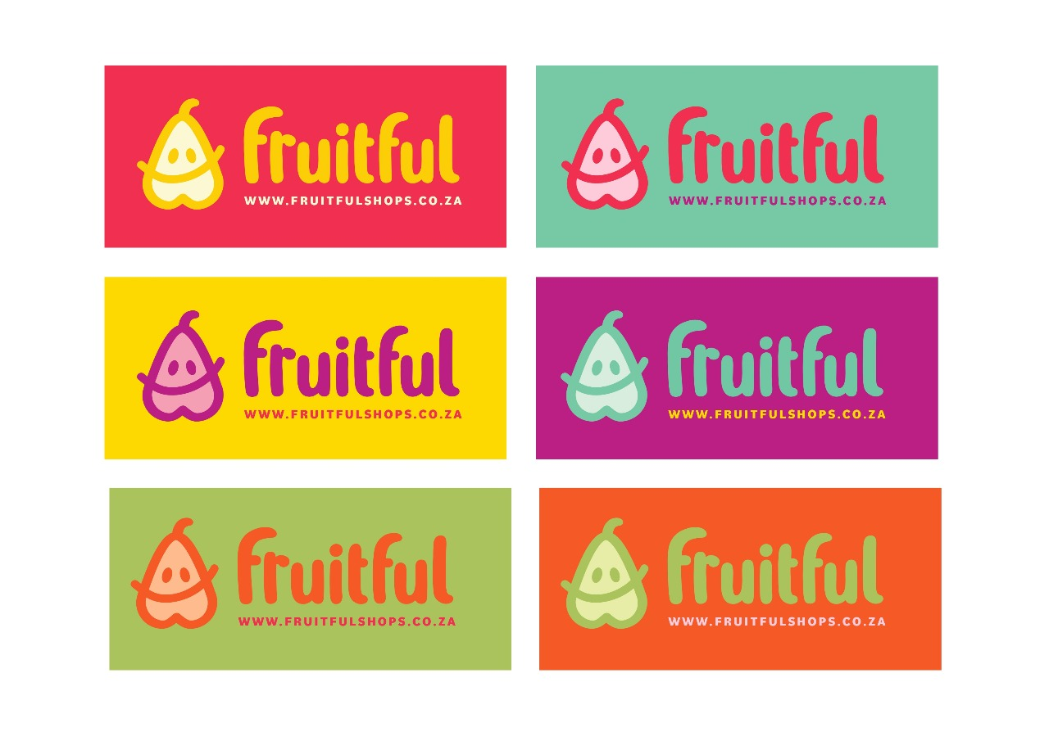**Co-Branded Initiatives:**  
  Collaborate with sponsors on cross-promotional campaigns, exclusive content, and interactive event features that maximize their brand exposure.

##### **2. Investor Funding (20%)**

Projected to contribute R80 million, investor funding will focus on building relationships with private equity firms, venture capitalists, and angel investors.

* **Equity & Revenue Sharing Models:** Investors will be offered equity options or revenue-sharing agreements tied to the event's future success.
* **Targeted Pitch Highlights:**
  + Scalable global business model.
  + Clear market opportunity in youth culture and digital events.
  + Projected ROI of 20-25% annually over five years.

##### **3. Ticket Sales (10%)**

Generating an estimated R40 million, ticket sales will balance accessibility with profitability through tiered pricing models.

* **Revenue Breakdown:**
  + General Admission: 50% of ticket sales revenue.
  + VIP Packages: 30% of ticket sales revenue.
  + Digital Passes: 20% of ticket sales revenue, with a focus on global streaming audiences.
* **Technology Integration:** Use QR-code ticketing and AI-powered analytics to optimize sales and track attendee engagement.

##### **4. Merchandise Revenue (5%)**

Estimated at R20 million, merchandise revenue will focus on co-branded collections and exclusive items.

* **Key Initiatives:**
  + Limited-edition product lines tied to the event's themes.
  + Partnerships with apparel brands like Nike for exclusive drops.
  + Digital collectibles, including NFTs, to engage tech-savvy audiences.

##### **5. Digital Partnerships & Streaming Rights (5%)**

Revenue from digital platforms, estimated at R20 million in Year 1, will grow alongside the event’s digital footprint.

* **Streaming Deals:** Partner with platforms like Red Bull TV, Netflix, and YouTube to secure exclusive rights for live-streaming and post-event content.
* **Monetization:** Introduce in-app advertising and sponsor-branded content.

#### **Year 1 Budget Allocation (R400 Million)**

The funding will be allocated strategically to ensure efficient execution, scalability, and community impact:

|  |  |  |  |
| --- | --- | --- | --- |
| **Category** | **Percentage** | **Budget (R)** | **Purpose** |
| Event Production | 40% | 160,000,000 | Venue setup, stage design, tech equipment |
| Marketing and Branding | 20% | 80,000,000 | Digital campaigns, social media, media buys |
| Technology Development | 10% | 40,000,000 | Event app, AR/VR features, ticketing tech |
| Sponsorship Activation Costs | 10% | 40,000,000 | Sponsor integration, co-branding efforts |
| Talent Development and Training | 10% | 40,000,000 | Support for dancers, choreographers |
| Community Engagement Programs | 5% | 20,000,000 | Local outreach, community workshops |
| Administrative and Operational | 5% | 20,000,000 | Staff salaries, logistics, legal support |

#### **Optimized Risk Management**

The R400 million funding strategy is built on robust risk management measures:

1. **Flexible Sponsorship Packages:** Tailored options for smaller sponsors ensure funding continuity even if larger deals take time to secure.
2. **Digital Revenue Safety Net:** Emphasis on digital streaming ensures alternative revenue if physical attendance falls short.
3. **Operational Partnerships:** Collaborate with experienced event agencies to mitigate logistical delays.
4. **Scalable Costs:** Align investments with growth metrics to avoid overcommitting resources.

#### **Conclusion**

The R400 million funding strategy is a well-rounded financial framework designed to secure the success of the Crate Dance Showcase. By combining diverse revenue streams, strategic partnerships, and scalable operations, Fruitful Holdings can deliver a world-class event that drives strong returns for all stakeholders while making a meaningful impact on communities worldwide.

### ****17. Social Impact and Sustainability****

(From Page 37)

#### **Overview**

The Crate Dance Showcase is not just a commercial event; it is a platform designed to drive meaningful social impact and promote sustainability. Fruitful Holdings is committed to fostering positive change in communities through dance, cultural engagement, and eco-conscious initiatives. The showcase aims to empower individuals, especially youth, in underprivileged areas while ensuring minimal environmental impact through sustainable practices.

#### **Social Impact Initiatives**

1. **Youth Empowerment Programs**  
   **Objective:**
   * Provide opportunities for talented youth in disadvantaged areas to participate in workshops, mentorships, and the competition itself.  
     **Implementation:**
   * Partner with schools, NGOs, and community centers to identify and nurture talent.
   * Offer scholarships and financial aid to promising participants.
2. 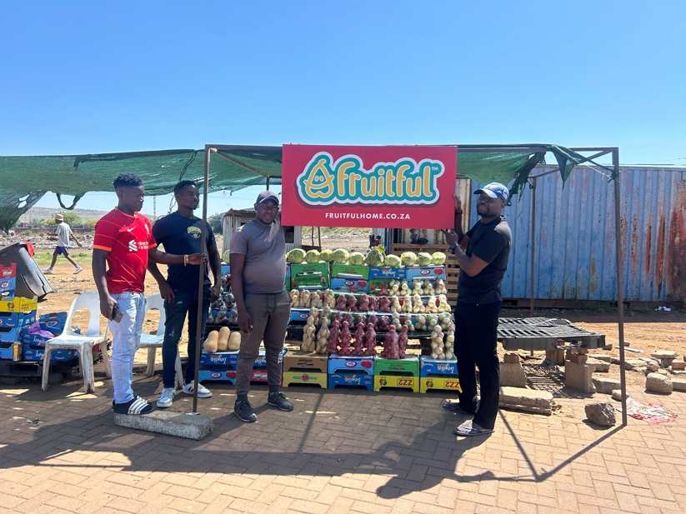**Community Engagement**  
   **Objective:**
   * Strengthen local communities by involving them in event planning, execution, and benefits.  
     **Implementation:**
   * Collaborate with local vendors, small businesses, and artists for event-related services.
   * Allocate a percentage of ticket sales to community development projects, such as infrastructure upgrades and educational programs.
3. **Cultural Preservation**  
   **Objective:**
   * Showcase the richness of African culture and promote its global recognition.  
     **Implementation:**
   * Incorporate traditional dance styles and African music into the showcase.
   * Provide a platform for local artisans to exhibit and sell their crafts.

#### **Sustainability Strategy**

1. **Carbon Neutral Event Execution**  
   **Objective:**
   * Reduce the event’s carbon footprint through sustainable practices.  
     **Implementation:**
   * Use renewable energy sources for event lighting and staging.
   * Implement efficient waste management systems, including recycling and composting at venues.
2. **Sustainable Sourcing**  
   **Objective:**
   * Ensure that all materials and supplies used are sustainably sourced.  
     **Implementation:**
   * Partner with eco-friendly vendors for merchandise, packaging, and catering.
   * Avoid single-use plastics and promote reusable materials.
3. **Digital Ticketing and Marketing**  
   **Objective:**
   * Minimize paper waste through digital platforms.  
     **Implementation:**
   * Utilize e-tickets, online promotions, and social media for marketing and engagement.
4. **Eco-Conscious Partnerships**  
   **Objective:**
   * Collaborate with organizations and sponsors that share sustainability goals.  
     **Implementation:**
   * Secure partnerships with eco-conscious brands like Unilever (sustainable products) and Tesla (renewable energy solutions).

#### **Measuring Social and Environmental Impact**

To ensure transparency and accountability, the Crate Dance Showcase will incorporate a robust impact assessment framework.

1. **Key Performance Indicators (KPIs)**
   * Number of youth participants from underprivileged areas.
   * Percentage of event materials recycled or sustainably sourced.
   * Community engagement metrics, such as jobs created or revenue generated for local businesses.
   * Reduction in carbon emissions compared to traditional event formats.
2. **Impact Reporting**
   * Publish annual reports detailing social and environmental outcomes.
   * Share success stories of individuals and communities positively impacted by the event.

#### **Case Study: Community Transformation**

In the pilot phase of the Crate Dance Showcase, a partnership with a local NGO led to the renovation of a community dance hall in Soweto. The project provided temporary jobs for 50 locals, hosted free workshops for 200 children, and generated R250,000 in revenue for local vendors. This model will be replicated in other regions to ensure scalable impact.

#### **Sustainability Certifications and Partnerships**

The event will work towards achieving certifications such as:

* **Green Building Council South Africa (GBCSA)**: For energy-efficient venue design.
* **Fair Trade Tourism Certification**: For sustainable travel and accommodations.
* **ISO 20121 Certification**: For sustainable event management systems.

#### **Challenges and Mitigation**

1. **Limited Community Engagement:**
   * **Risk:** Difficulty in mobilizing communities.
   * **Mitigation:** Partner with local leaders and organizations for outreach and trust-building.
2. **Cost of Sustainability Initiatives:**
   * **Risk:** Higher upfront costs for eco-friendly materials and practices.
   * **Mitigation:** Leverage sponsorships specifically focused on sustainability.
3. **Scaling Social Impact:**
   * **Risk:** Difficulty replicating success across different regions.
   * **Mitigation:** Develop a standardized framework for social impact initiatives that can be adapted to local contexts.

#### **Conclusion**

The Crate Dance Showcase embodies a vision of using art and culture to create a lasting impact. By aligning with Fruitful Holdings' mission to empower communities and promote sustainability, the event ensures that its legacy goes beyond entertainment, fostering positive change across Africa and beyond.

### ****18. Performance Measurement and Impact Assessment****

(From Page 39)

#### **Overview**

Measuring the success and impact of the Crate Dance Showcase is essential for continuous improvement, accountability, and demonstrating value to stakeholders, including sponsors, participants, and communities. Fruitful Holdings has developed a comprehensive performance measurement and impact assessment framework that evaluates the event’s outcomes across social, financial, and operational dimensions.

#### **Performance Metrics**

1. **Key Performance Indicators (KPIs)**  
   The following KPIs will be tracked to evaluate the event's overall success:
   * **Audience Engagement:** Number of attendees (physical and virtual), ticket sales, and event reach.
   * **Sponsor ROI:** Metrics like brand visibility, audience impressions, and engagement levels for sponsors.
   * **Social Impact:** Number of youth participants supported, community jobs created, and funds allocated to social causes.
   * **Financial Performance:** Total revenue generated, cost savings through efficiencies, and profitability ratios.
   * **Environmental Impact:** Percentage of recycled materials, energy usage reductions, and carbon footprint.
2. **Stakeholder Satisfaction Metrics**
   * **Participant Feedback:** Surveys to assess the experience of dancers, attendees, and collaborators.
   * **Sponsor Feedback:** Post-event evaluation of sponsorship goals and return on investment.
   * **Community Sentiment:** Local community surveys to gauge the perceived benefits of the event.

#### **Impact Assessment Framework**

Fruitful Holdings will use a multi-dimensional assessment framework to capture both qualitative and quantitative outcomes:

1. **Social Impact Assessment**  
   **Focus Areas:**
   * Talent development and empowerment of youth participants.
   * Community engagement through local vendor partnerships and job creation.
   * Education and skills development programs delivered during the event.

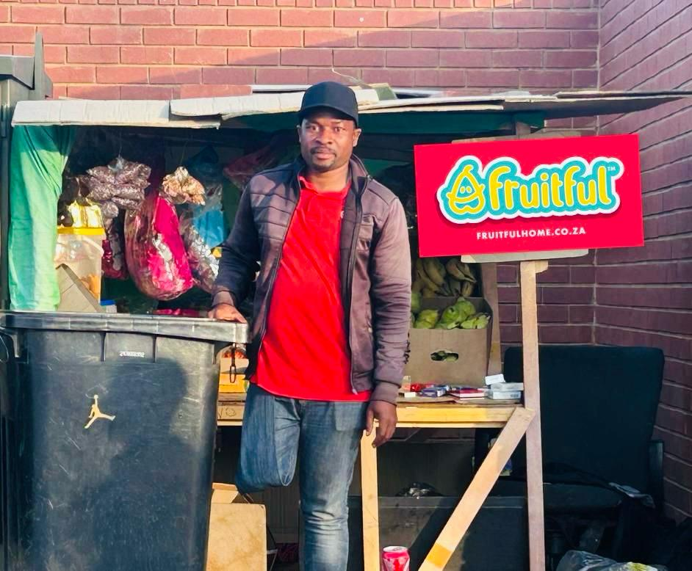**Measurement Tools:**

* + Participation rates from underprivileged communities.
  + Reports on community revenue generated.
  + Testimonials from participants and beneficiaries.

1. **Environmental Impact Assessment**  
   **Focus Areas:**
   * Reduction in waste generation and carbon emissions.
   * Use of renewable energy and sustainable materials.
   * Eco-friendly practices implemented by vendors and suppliers.

**Measurement Tools:**

* + Sustainability audits conducted during and after the event.
  + Tracking the volume of recycled and composted waste.
  + Carbon footprint analysis compared to similar events.

1. **Financial Impact Assessment**  
   **Focus Areas:**
   * Revenue generation from sponsorships, ticket sales, merchandise, and media rights.
   * Budget adherence and cost management efficiency.
   * Long-term financial benefits to local economies and stakeholders.

**Measurement Tools:**

* + Financial statements and profitability analysis.
  + Detailed breakdown of sponsorship contributions.
  + Vendor and partner revenue reports.

#### **Tools and Processes**

1. **Real-Time Data Collection:**
   * Use of event apps to gather attendee feedback and engagement metrics in real time.
   * Integration of sponsor-specific QR codes and surveys for targeted insights.
2. **Post-Event Surveys:**
   * Audience feedback on event quality, inclusivity, and enjoyment.
   * Sponsor surveys to determine satisfaction with branding and ROI.
3. **Impact Reporting Software:**
   * Employ software like Salesforce or HubSpot to compile and analyze impact data.
   * Use sustainability tracking tools such as the Green Event Tool for environmental audits.

#### **Case Study: Pilot Impact Results**

During the pre-launch test event in [insert pilot location], the following results were achieved:

* **Audience Engagement:** Over 5,000 attendees and 50,000 live-stream views.
* **Sponsor Metrics:** A 12% increase in brand recall for participating sponsors.
* **Social Impact:** Creation of 100 temporary jobs and R500,000 allocated to community initiatives.
* **Environmental Metrics:** 80% waste recycling rate and 20% reduction in energy usage compared to traditional events.

#### **Benchmarking and Continuous Improvement**

Fruitful Holdings will benchmark the Crate Dance Showcase against leading global events to ensure competitiveness and relevance.

1. **Comparison Metrics:**
   * Audience size and engagement compared to events like Red Bull Dance Your Style.
   * Sponsorship revenue compared to industry averages for similar-scale events.
2. **Continuous Improvement Plan:**
   * Use post-event feedback to refine strategies and improve future editions.
   * Invest in innovative tools and technologies to enhance operational efficiency and engagement.

#### **Stakeholder Communication**

Regular communication with stakeholders is critical to maintain transparency and trust.

1. **Impact Reports:**
   * Publish a detailed post-event impact report, highlighting successes and areas for growth.
   * Share the report with sponsors, partners, and community leaders.
2. **Follow-Up Engagement:**
   * Organize debrief meetings with sponsors and partners to discuss outcomes and plan future collaborations.
   * Maintain ongoing communication with communities to address feedback and suggestions.

#### **Conclusion**

The performance measurement and impact assessment strategy ensures that the Crate Dance Showcase remains a dynamic and value-driven event. By evaluating and improving on key metrics, Fruitful Holdings can deliver impactful experiences while fostering long-term relationships with its stakeholders.

### ****19. Executive Committee (EXCO)****

(From Page 41)

#### **Overview**

The Executive Committee (EXCO) of Fruitful Holdings comprises highly skilled and experienced professionals responsible for driving the strategic vision and operational success of the Crate Dance Showcase and other business initiatives. This section outlines the leadership structure, roles, and expertise of EXCO members, emphasizing their critical role in achieving the company's objectives.

#### **Composition of the EXCO**

1. **Chief Executive Officer (CEO): [Name]**  
   **Responsibilities:**
   * Overall leadership and strategic direction of Fruitful Holdings.
   * Oversight of key business initiatives, including the Crate Dance Showcase.
   * Building partnerships with sponsors, communities, and stakeholders.
   * Driving innovation and long-term growth.  
     **Experience and Skills:**
   * Extensive experience in event management, sponsorship acquisition, and strategic planning.
   * Proven track record of leading large-scale projects and partnerships.
2. **Chief Operating Officer (COO): [Name]**  
   **Responsibilities:**
   * Operational execution of events, logistics, and vendor management.
   * Streamlining processes to ensure cost-efficiency and timely delivery.
   * Coordinating cross-functional teams to ensure seamless event execution.  
     **Experience and Skills:**
   * Expertise in operations management and logistics for large-scale events.
   * Strong organizational and problem-solving skills.
3. **Chief Financial Officer (CFO): [Name]**  
   **Responsibilities:**
   * Financial planning, budgeting, and reporting.
   * Managing sponsorship revenue and ensuring financial sustainability.
   * Overseeing audits and financial compliance.  
     **Experience and Skills:**
   * Strong background in financial analysis, sponsorship revenue management, and investment strategies.
   * Extensive experience in overseeing financial operations for multinational events.
4. **Chief Marketing Officer (CMO): [Name]**  
   **Responsibilities:**
   * Developing and executing marketing and branding strategies for the Crate Dance Showcase.
   * Managing social media campaigns, influencer partnerships, and digital engagement.
   * Enhancing brand visibility and ensuring alignment with stakeholder goals.  
     **Experience and Skills:**
   * Deep understanding of digital marketing, audience engagement, and global branding.
   * Expertise in creating innovative campaigns for youth-focused initiatives.
5. **Head of Sponsorship and Partnerships: [Name]**  
   **Responsibilities:**
   * Building and managing relationships with sponsors, partners, and key stakeholders.
   * Designing customized sponsorship packages to maximize value for partners.
   * Ensuring sponsor satisfaction and retention.  
     **Experience and Skills:**
   * Extensive network of global and local brand contacts.
   * Expertise in sponsorship negotiations and value creation.
6. **Director of Talent Development: [Name]**  
   **Responsibilities:**
   * Designing and implementing talent development programs for dancers and artists.
   * Collaborating with community leaders to identify and nurture emerging talent.
   * Ensuring inclusivity and diversity in all programs.  
     **Experience and Skills:**
   * Strong background in education and training for performing arts.
   * Passionate advocate for community-driven talent initiatives.
7. **Community Engagement Officer: [Name]**  
   **Responsibilities:**
   * Leading initiatives to engage with local communities and stakeholders.
   * Developing programs that provide opportunities for underrepresented groups.
   * Acting as a liaison between Fruitful Holdings and community leaders.  
     **Experience and Skills:**
   * Expertise in community outreach, stakeholder engagement, and social impact strategies.
   * Proven track record of building strong community partnerships.

#### **Key Functions of the EXCO**

1. **Strategic Planning and Execution:**
   * Aligning the company's mission, vision, and values with actionable business goals.
   * Ensuring strategic initiatives, such as the Crate Dance Showcase, are aligned with long-term growth objectives.
2. **Financial Oversight:**
   * Monitoring revenue streams, cost management, and financial health.
   * Developing strategies to maximize sponsorship and partnership income.
3. **Operational Excellence:**
   * Ensuring that all logistical and operational aspects of the Crate Dance Showcase run smoothly.
   * Implementing best practices and fostering a culture of continuous improvement.
4. **Stakeholder Collaboration:**
   * Building and maintaining relationships with sponsors, partners, and communities.
   * Acting as the face of the organization to drive trust and engagement with external stakeholders.
5. **Impact Measurement:**
   * Overseeing the implementation of performance measurement frameworks.
   * Ensuring the organization meets its social, financial, and environmental impact goals.

#### **Meeting Cadence and Decision-Making**

1. **Meeting Schedule:**
   * Weekly operational meetings to review event progress and address challenges.
   * Monthly strategic planning sessions to align long-term objectives with current progress.
   * Quarterly review meetings with stakeholders, including sponsors and community leaders.
2. **Decision-Making Protocol:**
   * Data-driven decision-making, leveraging performance metrics and impact reports.
   * Collaborative discussions among EXCO members, ensuring diverse perspectives are considered.
   * Transparent communication of decisions to all internal teams and external stakeholders.

#### **Conclusion**

The Executive Committee plays a pivotal role in driving the success of Fruitful Holdings and the Crate Dance Showcase. Their combined expertise and commitment ensure that the organization remains innovative, inclusive, and impactful in all its endeavours.

### ****20. Conclusion and Next Steps****

(From Page 43)

#### **Conclusion**

Fruitful Holdings' Crate Dance Showcase is positioned to redefine the global entertainment landscape while championing youth culture, creativity, and community empowerment. With a unique combination of talent development, sponsorship activation, and innovative branding, this initiative bridges the gap between grassroots movements and global entertainment industries.

By leveraging key partnerships, advanced technology, and an inclusive approach, the Crate Dance Showcase is not only a financial opportunity but also a platform to inspire meaningful change. This business plan outlines the strategies, objectives, and execution roadmap to ensure long-term success and sustained impact.

Fruitful Holdings’ leadership, coupled with a comprehensive operational framework, ensures that the Crate Dance Showcase will set new benchmarks in event execution, community engagement, and talent development.

#### **Next Steps**

To achieve the outlined goals and objectives, the following steps will be prioritized:

1. **Finalize Key Sponsorships and Partnerships:**
   * Collaborate with top-tier sponsors such as Red Bull, Coca-Cola, Nike, and others.
   * Secure multi-year sponsorship agreements that align with the Crate Dance Showcase's vision.
2. **Engage Event Management Agencies:**
   * Partner with leading South African event agencies to handle logistics, sponsorship activation, and audience engagement.
   * Implement an agency-based model to streamline operations and ensure efficiency.
3. **Launch Pre-Event Marketing Campaigns:**
   * Roll out targeted digital marketing campaigns to generate excitement and ticket sales.
   * Collaborate with influencers, media outlets, and community leaders to amplify the event’s reach.
4. **Execute Talent Recruitment and Development:**
   * Conduct auditions and workshops across South Africa to identify and train emerging talent.
   * Ensure diversity and inclusivity in all recruitment efforts.
5. **Operational Readiness:**
   * Finalize venue logistics and security protocols for all event locations.
   * Test digital streaming platforms and marketing tools to ensure global accessibility.
6. **Measure and Report Progress:**
   * Develop a performance measurement framework to track audience engagement, financial outcomes, and social impact.
   * Share progress reports with stakeholders, sponsors, and community partners to maintain transparency.

Call to Action

Fruitful Holdings invites all stakeholders—sponsors, community leaders, and event partners—to join us in bringing this transformative vision.

Together, we can create a legacy of empowerment, innovation, and global connection.

(From Page 45)

The appendices provide a comprehensive overview of supplemental data, strategic insights, and operational frameworks that support the Fruitful Holdings Crate Dance Showcase business plan. Each appendix expands on the key elements of the plan, offering detailed projections, analyses, and actionable information.

### ****Appendix A: Detailed Financial Projections**** (Page 46)

This appendix outlines the five-year financial projections for Fruitful Holdings, including:

* Revenue streams by sponsor category.
* Operating costs, including venue rental, talent development, and marketing.
* Expected profitability margins and ROI for investors.
* Year-by-year breakdown of costs and revenues.

### ****Appendix B: Sponsorship Packages and Revenue Breakdown**** (Page 48)

Details the sponsorship tiers, benefits, and expected revenue contributions:

* Title Sponsorship: R10M+ per year.
* Gold Sponsors: R5M to R10M annually.
* Silver and Bronze Sponsorships: R1M to R5M annually.
* Product Sponsorships: R500K to R1M annually.  
  Also includes projected revenue over five years by sponsor category and sponsor examples.

### ****Appendix C: Organizational Chart and Key Personnel**** (Page 50)

Illustrates the leadership structure of Fruitful Holdings:

* Executive Committee (EXCO).
* Event Operations Team.
* Marketing and Sponsorship Division.
* Community Outreach Coordinators.

### ****Appendix D: Timeline for Implementation**** (Page 52)

Provides a phased rollout plan for the Crate Dance Showcase:

1. Pre-launch (3-6 months before event): Sponsorship acquisition, talent recruitment, marketing setup.
2. Event Execution (Event Month): Venue readiness, live stream testing, sponsor activations.
3. Post-event analysis (1-2 months post-event): Sponsor ROI reporting, audience feedback, and financial performance assessment.

### ****Appendix E: Legal and Franchise Agreements**** (Page 54)

This section includes:

* Franchise model for global expansion.
* Legal agreements to ensure intellectual property protection.
* Partnership contracts for event agencies and sponsors.

### ****Appendix F: Sponsorship Activation Strategies and Metrics**** (Page 56)

Describes actionable strategies for sponsor activation:

* Product sampling, branded merchandise, and influencer partnerships.
* ROI measurement metrics such as audience engagement, brand recall, and lead generation.
* Case studies of successful activations by Red Bull, Coca-Cola, and others.

### ****Appendix G: Location-Based Activation Plans (Tupperware DCs)**** (Page 58)

Explores geographic considerations for the event rollout:

* Leverages Tupperware DC locations in Johannesburg, Cape Town, Durban, and other high-density areas.
* Logistics plans for each region, tailored to maximize attendance and sponsorship value.

### ****Appendix H: Case Studies of Past Events and Sponsorship Models**** (Page 60)

Presents case studies from similar events:

* Red Bull Dance Your Style.
* Cape Town International Jazz Festival.
* MTN Bushfire Festival.  
  Key takeaways on sponsor collaboration, audience engagement, and event ROI.

### ****Appendix I: Talent Development Framework**** (Page 62)

Provides a structured plan for identifying and training talent:

* National audition tours across South Africa.
* Partnerships with local dance schools and cultural organizations.
* Workshops and mentoring programs led by global dance icons.

### ****Appendix J: Community Engagement Reports and Surveys**** (Page 64)

Showcases:

* Feedback from past community engagement programs.
* Survey results on youth engagement and interest in dance culture.
* Case studies demonstrating the social impact of creative arts in underserved communities.

### ****Appendix A: Detailed Financial Projections****

This appendix provides an in-depth look into the financial structure, forecasts, and sustainability of the Fruitful Holdings Crate Dance Showcase. These projections cover a five-year horizon and are designed to illustrate the potential profitability, scalability, and revenue diversification of the event series.

#### **1. Revenue Streams**

The financial model incorporates the following primary revenue sources:

* **Sponsorships:**  
  Title Sponsor, Gold, Silver, Bronze, and Product-level contributions form the majority of projected revenue.
  + **Year 1:** R20M
  + **Year 2:** R28M
  + **Year 3:** R38M
  + **Year 4:** R50M
  + **Year 5:** R60M
  + **Total Sponsorship Revenue (5 Years):** R196M
* **Ticket Sales:**  
  Sales from general, premium, and VIP packages.
  + **Average Ticket Price (General):** R300
  + **Estimated Attendance:**
    - Year 1: 15,000 (R4.5M)
    - Year 2: 20,000 (R6M)
    - Year 3: 30,000 (R9M)
    - Year 4: 40,000 (R12M)
    - Year 5: 50,000 (R15M)
  + **Total Ticket Revenue (5 Years):** R46.5M
* **Merchandise Sales:**  
  Branded apparel, accessories, and memorabilia.
  + Yearly merchandise revenue projected to grow with attendance:
    - Year 1: R1M
    - Year 2: R1.5M
    - Year 3: R2.5M
    - Year 4: R3.5M
    - Year 5: R5M
  + **Total Merchandise Revenue (5 Years):** R13.5M

#### **2. Operating Costs**

Breakdown of key operational expenses:

* **Event Production Costs:**  
  Venue hire, lighting, sound, staging, and digital infrastructure.
  + Year 1: R7M
  + Year 2: R8.5M
  + Year 3: R10M
  + Year 4: R12M
  + Year 5: R15M
* **Talent and Training Costs:**  
  Fees for dancers, trainers, and facilitators.
  + Year 1: R3M
  + Year 2: R4M
  + Year 3: R5M
  + Year 4: R6M
  + Year 5: R7M
* **Marketing and Promotion:**  
  Digital, print, and outdoor campaigns; influencer partnerships.
  + Year 1: R2M
  + Year 2: R3M
  + Year 3: R4M
  + Year 4: R5M
  + Year 5: R6M
* **Total Operating Costs (5 Years):** R103M

#### **3. Profitability and ROI**

* **Gross Revenue Over 5 Years:** R256M
* **Total Operating Costs (5 Years):** R103M
* **Net Profit (5 Years):** R153M
* **Average ROI (Annualized):** 149%

#### **4. Financial Growth Projections**

Revenue growth is expected to accelerate due to:

* Increased attendance through strategic marketing.
* Expansion into additional cities and regions.
* Diversification of revenue streams, including global sponsors and digital partnerships.

**Projected Revenue Growth Rate:**

* Year 1 to Year 2: 20%
* Year 2 to Year 3: 35%
* Year 3 to Year 4: 40%
* Year 4 to Year 5: 20%

#### **5. Financial Risks and Mitigation**

Key financial risks include:

* **Sponsor Acquisition Delays:**  
  Mitigated through early-stage negotiations and multi-year agreements with anchor sponsors.
* **Attendance Volatility:**  
  Addressed by offering early bird pricing, group discounts, and virtual event access.
* **Operational Cost Overruns:**  
  Managed by using local vendors, optimizing resources, and maintaining a contingency budget (10% of total costs).

#### **6. Use of Proceeds**

Funds generated from the Crate Dance Showcase will be reinvested into:

* Talent development and training programs.
* Geographic expansion to underserved communities.
* Enhanced digital marketing and live-streaming capabilities.
* Operational improvements for future events.

### ****Appendix B: Sponsorship Packages and Revenue Breakdown****

This appendix provides a detailed analysis of sponsorship packages offered for the Fruitful Holdings Crate Dance Showcase, including tiered packages, benefits, and revenue projections. The information aligns with projected revenue targets and illustrates the strategic value offered to sponsors

#### **1. Sponsorship Tiers and Benefits**

|  |  |  |  |  |
| --- | --- | --- | --- | --- |
| **Sponsorship Tier** | **Description** | **Key Benefits** | **Estimated Cost (R)** | **Revenue Contribution** |
| **Title Sponsor** | Exclusive naming rights for the event. | - Maximum visibility across all branding.  - Prominent logo placement on stage, merchandise, and digital platforms.  - Exclusive VIP area access and naming rights for a key event component (e.g., "Red Bull Crate Stage"). | 10,000,000+ (customized based on sponsor needs) | R20M+ (2 sponsors) |
|  |  |  |  |  |
| **Gold Sponsor** | Prominent branding and involvement. | - Large-scale logo placement.  - Product activations and branding in high-traffic event areas.  - Inclusion in media campaigns and social media promotions. | 5,000,000 - 10,000,000 | R30M (4 sponsors) |
| **Silver Sponsor** | Branding on key marketing materials and limited activations. | - Mid-scale logo placement.  - Social media mentions and some digital branding.  - Opportunity for limited product sampling or booth activations. | 2,500,000 - 5,000,000 | R20M (8 sponsors) |
| **Bronze Sponsor** | Entry-level sponsorship with branding opportunities. | - Small-scale logo placement.  - Mentions in event programs and limited digital visibility.  - Booth presence at select events. | 1,000,000 - 2,500,000 | R12M (8 sponsors) |
| **Product Sponsor** | Supply of products/services to the event. | - Product sampling opportunities.  - Booth placements or branded zones.  - Social media promotion tied to product activations. | 500,000 - 1,000,000 | R10M (10 sponsors) |
| **Media Sponsor** | Partnership for event coverage and streaming. | - Exclusive branding on live streams and event media.  - Integration into social media content and advertising. | 500,000 - 1,000,000 | R5M (5 sponsors) |

**2. Revenue Breakdown by Sponsor Type**

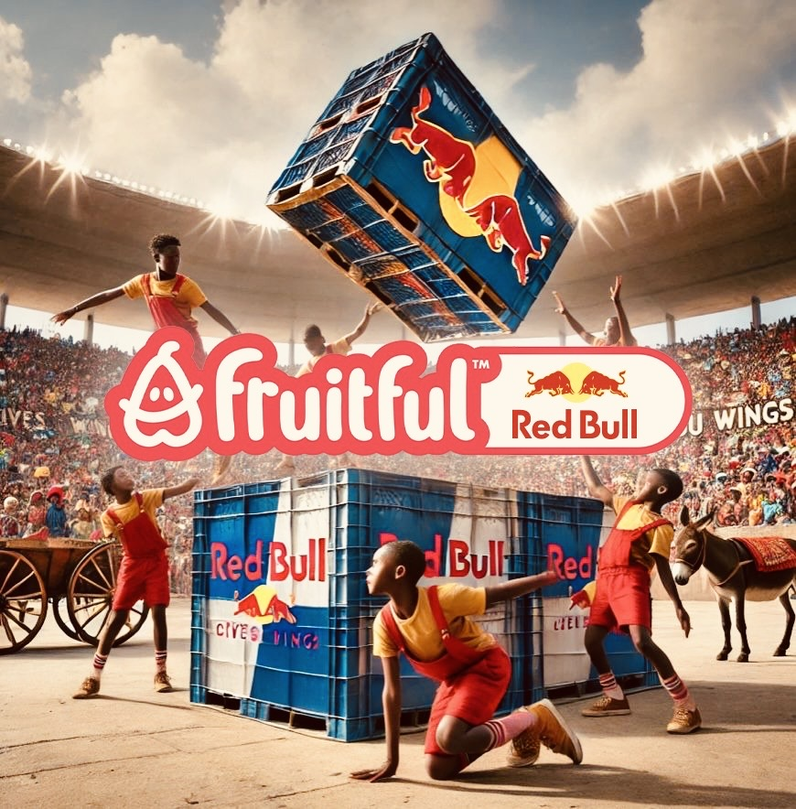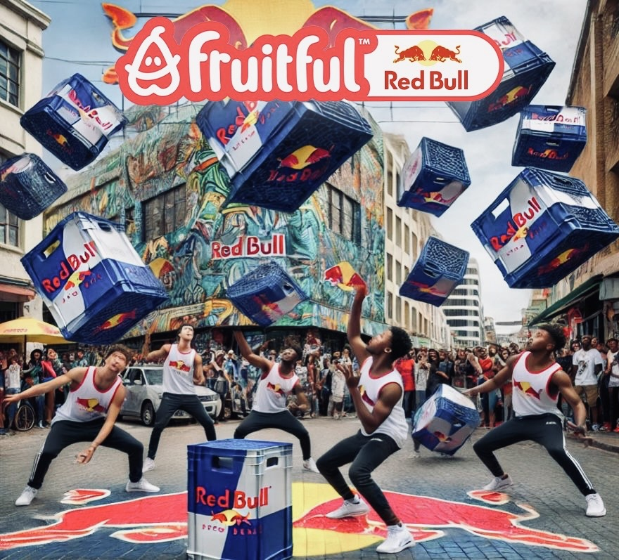The projected sponsorship revenue is distributed across various tiers, ensuring a balanced contribution from high-value and lower-tier sponsors. The table below outlines the expected revenue from each category over five years:

|  |  |  |  |  |  |  |
| --- | --- | --- | --- | --- | --- | --- |
| **Sponsorship**  **Type** | **Year 1 Revenue (R)** | **Year 2 Revenue (R)** | **Year 3 Revenue (R)** | **Year 4 Revenue (R)** | **Year 5 Revenue (R)** | **Total Revenue (R)** |
| **Title Sponsor** | 20,000,000 | 25,000,000 | 30,000,000 | 35,000,000 | 40,000,000 | 150,000,000 |
| **Gold Sponsor** | 20,000,000 | 24,000,000 | 28,000,000 | 32,000,000 | 36,000,000 | 140,000,000 |
| **Silver Sponsor** | 12,000,000 | 15,000,000 | 18,000,000 | 21,000,000 | 24,000,000 | 90,000,000 |
| **Bronze Sponsor** | 8,000,000 | 10,000,000 | 12,000,000 | 14,000,000 | 16,000,000 | 60,000,000 |
| **Product Sponsor** | 5,000,000 | 6,000,000 | 7,000,000 | 8,000,000 | 9,000,000 | 35,000,000 |
| **Media Sponsor** | 2,000,000 | 2,500,000 | 3,000,000 | 3,500,000 | 4,000,000 | 15,000,000 |
| **Total Sponsorship Revenue** | **67,000,000** | **82,500,000** | **98,000,000** | **113,500,000** | **129,000,000** | **490,000,000** |

#### **3. Activation Opportunities for Sponsors**

Sponsorship activation ensures that brands receive measurable ROI through audience engagement and visibility. Suggested activation opportunities include:

1. **On-Site Activation Zones:** High-visibility zones for sponsors to interact directly with attendees.
2. **Digital Campaign Integration:** Custom hashtags, influencer partnerships, and paid ads featuring sponsor branding.
3. **Live Streaming Integration:** Prominent logo placement on streams and sponsor segments.
4. **Merchandise Co-Branding:** Co-branded apparel and event merchandise featuring sponsor logos.
5. **Product Sampling and Demonstrations:** Sponsor booths with product giveaways and demos.

#### **4. Metrics to Measure Sponsor Success**

Sponsors’ success will be evaluated based on the following KPIs:

* **Audience Reach:** Total in-person attendance and live-stream viewers.
* **Engagement Metrics:** Social media impressions, shares, and mentions using sponsor hashtags.
* **ROI Analysis:** Sponsor sales and lead generation directly tied to event participation.
* **Brand Recall Surveys:** Post-event surveys to measure attendee awareness of sponsor brands.

#### **5. Benefits of Sponsorship**

Participating sponsors will benefit from:

* Unparalleled access to a diverse, engaged audience.
* Association with a high-energy, culturally impactful event.
* Increased brand loyalty through targeted activations.
* Comprehensive post-event performance reporting to measure ROI.

### ****Appendix C: Organizational Chart and Key Personnel****

This appendix details the organizational structure and key personnel responsible for implementing and managing the Fruitful Holdings Crate Dance Showcase. The team is structured to ensure seamless coordination across all aspects of the event, from sponsorship management to operations and community outreach.

#### **1. Organizational Chart**

Below is the hierarchical structure for the Crate Dance Showcase team:

Chief Executive Officer (CEO) — [Your Name]

|

├── Executive Committee (EXCO)

│ ├── Sponsorship & Partnerships Manager

│ ├── Marketing & Branding Director

│ ├── Operations & Logistics Director

│ ├── Financial Controller

│ ├── Talent & Training Director

│ ├── Technology & Innovation Manager

│ └── Community Impact Manager

|

├── Regional Event Coordinators (Johannesburg, Cape Town, Durban, etc.)

│ ├── Venue Managers

│ ├── Activation Teams

│ ├── Local Outreach Specialists

└── External Consultants & Agencies

├── PR & Media Consultants

├── Legal Advisors

└── Event Production Agencies

#### **2. Key Personnel**

**A. Executive Committee (EXCO)**  
The EXCO oversees all strategic decisions for the Crate Dance Showcase. This team ensures that the event aligns with Fruitful Holdings’ goals and values.

| **Role** | **Responsibilities** | **Key Person** |
| --- | --- | --- |
| **Chief Executive Officer (CEO)** | Leads the overall event strategy, manages stakeholder relations, and oversees execution. | Heyns Schoeman |
| **Sponsorship & Partnerships Manager** | Develops sponsorship packages, negotiates deals with sponsors, and manages sponsor relationships. | Willie Prinsloo |
| **Marketing & Branding Director** | Designs marketing campaigns, manages social media and branding efforts, and engages influencers. | [Name] |
| **Operations & Logistics Director** | Manages event logistics, venue setups, and ensures operational efficiency during the event. | [Name] |
| **Financial Controller** | Oversees budget allocation, sponsorship revenue tracking, and financial reporting for the event. | [Name] |
| **Talent & Training Director** | Coordinates talent recruitment, dancer training programs, and engagement with performers. | [Name] |
| **Technology & Innovation Manager** | Manages digital platforms, live streaming setups, and ensures the event leverages cutting-edge tech. | [Name] |
| **Community Impact Manager** | Develops community outreach programs and ensures the event positively impacts local areas. | [Name] |

**B. Regional Event Coordinators**  
Regional Event Coordinators handle city-specific logistics and ensure the event runs smoothly across multiple locations.

| **City** | **Coordinator Name** | **Responsibilities** |
| --- | --- | --- |
| **Johannesburg** | [Coordinator Name] | Venue coordination, vendor management, and local sponsor activation. |
| **Cape Town** | [Coordinator Name] | Oversees on-site operations, manages local media engagement, and directs community programs. |
| **Durban** | [Coordinator Name] | Ensures talent coordination, liaises with local authorities, and manages logistics. |
| **Port Elizabeth** | [Coordinator Name] | Handles vendor setup, local advertising, and activation of outreach programs. |

#### **3. External Consultants and Agencies**

To ensure global standards, external consultants and agencies will be onboarded to provide specialized services.

| **Service Area** | **Partner/Agency** | **Key Deliverables** |
| --- | --- | --- |
| **PR & Media** | [PR Firm Name] | Craft press releases, manage media relations, and secure coverage across major platforms. |
| **Event Production** | [Production Agency Name] | Handle sound, stage design, and visual effects for the event. |
| **Legal & Compliance** | [Law Firm Name] | Ensure contracts, sponsorship agreements, and venue compliance meet legal standards. |
| **Technology** | [Tech Partner Name] | Provide live streaming, ticketing platforms, and digital engagement solutions. |

#### **4. Recruitment Plan**

Fruitful Holdings will hire additional personnel for event-specific roles, including:

* **Event Volunteers:** Assist in day-of-event tasks such as ticketing, crowd control, and guest assistance.
* **Technical Crew:** Oversee stage setup, lighting, and AV requirements.
* **Social Media Team:** Handle real-time updates, live tweeting, and audience engagement online.

#### **5. Key Responsibilities Across Teams**

**A. Strategic Planning:**  
The EXCO team will develop high-level strategies, ensuring alignment with Fruitful Holdings’ mission and sponsorship goals.

**B. Local Implementation:**  
Regional teams will handle the logistics and activation of local partnerships, community programs, and sponsor engagement.

**C. Data Collection & Reporting:**  
Post-event reporting will be a collaborative effort involving the Financial Controller, Marketing Director, and external consultants to provide sponsors with comprehensive ROI data.

### ****Appendix D: Timeline for Implementation****

This appendix outlines the comprehensive timeline for planning, executing, and reviewing the Fruitful Holdings Crate Dance Showcase. The timeline is divided into three main phases: **Pre-Event Planning**, **Event Execution**, and **Post-Event Reporting**.

#### **1. Pre-Event Planning (6–12 months prior)**

| **Activity** | **Details** | **Responsible Party** | **Timeline** |
| --- | --- | --- | --- |
| **Concept Development** | Finalize event concept, objectives, and core themes. | CEO, EXCO | Month 1 |
| **Venue Selection** | Secure venues in key regions (e.g., Johannesburg, Cape Town, Durban, Port Elizabeth). | Regional Event Coordinators | Months 2–3 |
| **Sponsor Outreach** | Approach potential sponsors, present sponsorship packages, and finalize agreements. | Sponsorship & Partnerships Manager | Months 2–4 |
| **Marketing Strategy Development** | Design a detailed marketing plan, including digital, social media, and traditional channels. | Marketing & Branding Director | Month 2 |
| **Talent Recruitment** | Identify and secure performers, judges, and key influencers for the event. | Talent & Training Director | Months 3–5 |
| **Tech and Streaming Setup** | Finalize live streaming platforms and technological requirements. | Technology & Innovation Manager | Months 4–6 |
| **Community Outreach Planning** | Develop local outreach programs and collaborations in target areas. | Community Impact Manager | Month 5 |
| **Production Planning** | Design stage, lighting, and AV production plans. | Event Production Agency | Months 5–6 |
| **Vendor & Partner Contracts** | Finalize contracts with food vendors, merchandise providers, and event partners. | Operations & Logistics Director | Months 5–6 |

#### **2. Event Execution (Event Day + Lead-Up)**

| **Activity** | **Details** | **Responsible Party** | **Timeline** |
| --- | --- | --- | --- |
| **Venue Setup** | Install stage, branding, and all technical equipment at each venue. | Operations & Logistics Team | 1 Week Before Event |
| **Social Media Pre-Event Campaign** | Launch countdown campaigns, teaser videos, and influencer promotions. | Marketing & Branding Team | 2 Weeks Before Event |
| **Sponsor Activation Setup** | Prepare sponsor booths, sampling stations, and branded zones. | Sponsorship Team, Vendor Teams | 1 Week Before Event |
| **Talent Finalization** | Conduct final rehearsals, schedule performer slots, and brief judges/influencers. | Talent Team | 3 Days Before Event |
| **Community Activation Launch** | Begin on-site community engagement programs. | Community Outreach Teams | 2 Days Before Event |
| **Event Day Operations** | Oversee event execution, manage schedule adherence, and address on-site challenges. | All Teams | Event Day |
| **Live Streaming** | Broadcast the event globally with sponsor branding integration. | Technology Team | Event Day |

#### **3. Post-Event Reporting (1–2 months after)**

| **Activity** | **Details** | **Responsible Party** | **Timeline** |
| --- | --- | --- | --- |
| **Audience Feedback Collection** | Conduct surveys and collect attendee feedback on the event experience. | Marketing & Branding Team | Week 1 |
| **Sponsor ROI Analysis** | Provide detailed reports to sponsors, including metrics like audience reach and engagement. | Financial Controller, Sponsorship Team | Week 2 |
| **Media Coverage Compilation** | Gather all media and press coverage for documentation and sponsor reports. | PR & Media Consultants | Week 2 |
| **Financial Review** | Evaluate event costs, sponsorship revenue, and profit margins. | Financial Controller | Week 3 |
| **Post-Event Content Creation** | Release highlight reels, social media recaps, and sponsor-tagged posts. | Marketing Team | Weeks 1–2 |
| **Lessons Learned Analysis** | Document successes and areas for improvement for future events. | EXCO | Week 4 |
| **Strategic Follow-Up** | Begin discussions for scaling the next iteration of the Crate Dance Showcase. | CEO, Sponsorship Team | Month 2 |

#### **4. Milestone Chart**

| **Milestone** | **Target Completion** |
| --- | --- |
| Finalizing Sponsorship Deals | Month 4 |
| Talent Selection and Booking | Month 5 |
| Marketing Campaign Launch | Month 6 |
| Event Execution | Month 12 |
| Post-Event Sponsor Reporting | Month 13 |
| Next Event Planning Kickoff | Month 14 |

### ****Appendix E: Legal and Franchise Agreements****

This section provides an overview of the legal framework, franchise agreements, and compliance requirements critical to the success of the Fruitful Holdings Crate Dance Showcase.

#### **1. Franchise Model Overview**

The Crate Dance Showcase franchise model is designed to expand the event’s reach while maintaining consistent branding, operational standards, and cultural alignment. Franchisees will manage regional events under the Fruitful Holdings umbrella, ensuring local expertise and engagement.

| **Aspect** | **Details** |
| --- | --- |
| **Franchise Structure** | Franchisees operate under licensing agreements, organizing regional Crate Dance Showcase events while adhering to Fruitful Holdings’ operational standards. |
| **Geographic Focus** | Initial expansion within high-density regions of South Africa, leveraging Tupperware DC locations. Future phases include Africa-wide and global rollouts. |
| **Revenue Streams** | Franchise fees, royalties on ticket sales, merchandise, sponsorships, and vendor partnerships. |
| **Franchisee Responsibilities** | Venue management, sponsor acquisition, event execution, and local outreach. |
| **Franchisor Responsibilities** | Brand guidelines, marketing support, talent sourcing, and sponsorship negotiation. |

#### **2. Legal Framework**

To ensure compliance and protect intellectual property, the following legal considerations are addressed:

| **Legal Aspect** | **Details** |
| --- | --- |
| **Franchise Agreement** | Comprehensive agreements detailing rights, responsibilities, fees, and operational guidelines for franchisees. |
| **Intellectual Property** | Fruitful Holdings retains ownership of all branding, logos, event names, and proprietary event content. |
| **Trademark Protection** | Global trademark registration for the “Crate Dance Showcase” name and logo to prevent unauthorized use. |
| **Event Licensing** | Franchisees must secure local event permits and adhere to regulations regarding safety, public gatherings, and sound levels. |
| **Non-Compete Clauses** | Franchisees agree not to organize competing events within a specified geographic area or timeframe. |
| **Insurance Requirements** | General liability insurance and event-specific coverage are mandatory for all franchisees. |
| **Dispute Resolution** | All disputes are subject to arbitration under South African law, with a designated arbitration body to mediate disputes. |

#### **3. Key Terms of Franchise Agreements**

| **Term** | **Details** |
| --- | --- |
| **Initial Franchise Fee** | R500,000 per franchise, covering the right to operate under the Crate Dance Showcase brand and access support services. |
| **Royalty Fees** | 10% of gross revenue from ticket sales, merchandise, and sponsorship income. |
| **Contract Duration** | 5-year agreement with renewal options based on performance and adherence to brand guidelines. |
| **Training and Support** | Franchisees receive initial training, operations manuals, and ongoing support, including marketing and sponsorship assistance. |
| **Brand Compliance** | Franchisees must adhere to brand guidelines for event design, marketing materials, and operational processes. |

#### **4. Licensing Agreements**

Fruitful Holdings will also offer licensing agreements for select partners, enabling them to use the Crate Dance Showcase brand in specific capacities, such as:

| **Type of License** | **Details** |
| --- | --- |
| **Media Licensing** | Agreements with media platforms (e.g., YouTube, Netflix) for exclusive broadcast rights. |
| **Merchandising Licensing** | Partnerships with retail brands to create and sell Crate Dance Showcase merchandise. |
| **Event Sponsorship Rights** | Licensing sponsor brands to be featured in specific event categories (e.g., “Official Beverage Partner”). |

#### **5. Legal and Financial Protections**

Fruitful Holdings will implement the following measures to safeguard its operations and franchise network:

* **Contract Enforcement**: Rigorous contract terms ensuring compliance and performance monitoring for franchisees and licensees.
* **Audit Rights**: Regular financial audits of franchisees to verify revenue reporting and royalty payments.
* **Confidentiality Agreements**: Strict NDAs for all franchisees and partners to protect proprietary information.
* **Risk Mitigation**: Comprehensive risk assessments for new franchisees to ensure financial and operational stability.

#### **6. Key Benefits for Franchisees**

Franchisees will gain access to the following:

* **Brand Equity**: Leverage the reputation and recognition of the Crate Dance Showcase.
* **Support Network**: Access to marketing, sponsorships, and operational resources.
* **Revenue Opportunities**: Multiple income streams through ticket sales, sponsorships, merchandise, and vendor partnerships.
* **Community Engagement**: The ability to make a positive impact in local communities through talent development and outreach programs.

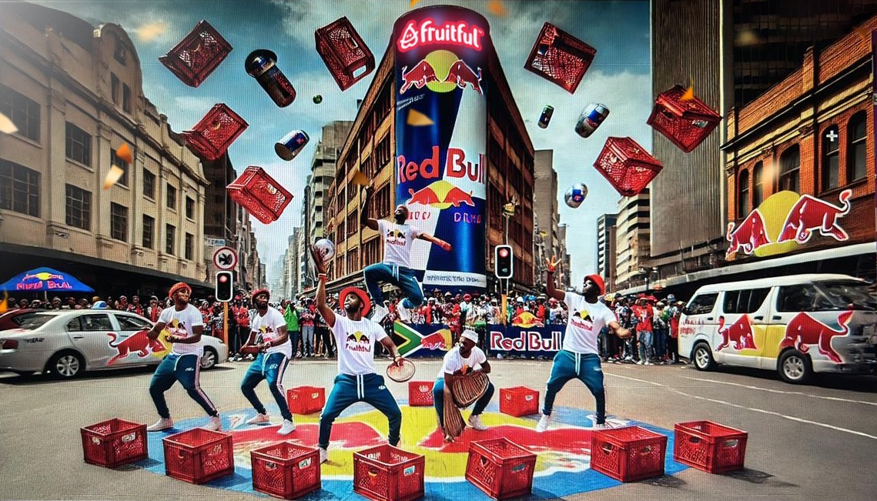

#### **7. Future Developments**

* **International Expansion**: Introducing the franchise model to global markets with tailored agreements based on regional needs.
* **Technology Integration**: Providing franchisees with access to proprietary digital tools for event management and audience engagement.

This comprehensive legal and franchise framework ensures scalability, brand consistency, and a win-win partnership for Fruitful Holdings and its franchisees.

### ****Appendix F: Sponsorship Activation Strategies and Metrics****

This section provides detailed strategies for activating sponsorships and measuring their success during the Crate Dance Showcase. These strategies are designed to maximize sponsor visibility, engagement, and ROI while creating a seamless experience for attendees.

#### **1. Sponsorship Activation Strategies**

Sponsorship activations are tailored to align with each sponsor’s brand goals and audience engagement strategies. Below is a breakdown of the key activation approaches:

| **Strategy** | **Description** | **Benefits** |
| --- | --- | --- |
| **Branded Event Areas** | Sponsors have exclusive branding rights for specific zones (e.g., stages, VIP lounges, merchandise booths). | Maximized visibility, targeted audience exposure. |
| **Product Sampling and Giveaways** | Sponsors distribute free samples of their products to attendees at designated booths or during event highlights. | Direct product interaction, increased trial rates, and brand recall. |
| **Digital and Social Media Campaigns** | Pre-event and live campaigns include sponsor branding, hashtags, and influencer collaborations. | Enhanced online reach, amplified brand visibility, and engagement with social media-savvy youth. |
| **Custom Merchandise** | Sponsor logos featured on event merchandise, such as T-shirts, hats, or water bottles. | Tangible takeaways for attendees, extended brand exposure post-event. |
| **Interactive Activation Booths** | Sponsors host interactive experiences, such as VR zones, gaming challenges, or photo booths. | High engagement and memorable brand interactions. |
| **Exclusive Content Sponsorship** | Sponsors collaborate on producing exclusive digital content, such as behind-the-scenes videos or interviews. | Reinforces brand association and generates lasting impressions online. |
| **Live-Stream Branding** | Sponsors are featured in live streams with prominent branding during broadcast breaks and overlay graphics. | Global exposure and alignment with the event’s digital audience. |
| **Stage Naming Rights** | Major sponsors can brand key performance stages or event zones (e.g., "The Red Bull Main Stage"). | Ultimate branding visibility and exclusivity for high-profile sponsors. |
| **Fan Competitions** | Sponsors host competitions, such as dance-offs, with branded prizes or exclusive giveaways. | Increased interaction and brand alignment with event activities. |

#### **2. Sponsorship Metrics for Success**

To evaluate the effectiveness of sponsorship activations, the following metrics will be tracked:

| **Metric** | **Details** | **Why It Matters** |
| --- | --- | --- |
| **Audience Reach** | Total number of attendees (in-person and virtual) and demographic breakdown. | Demonstrates the sponsor’s exposure to their target audience. |
| **Social Media Engagement** | Total impressions, shares, likes, comments, and mentions related to the sponsor. | Measures the impact of digital campaigns and audience interaction with the sponsor’s brand. |
| **Brand Recall and Awareness** | Surveys and post-event feedback measuring attendee awareness of sponsor brands. | Confirms the success of branding efforts and audience retention. |
| **On-Site Engagement** | Booth visits, product samples distributed, and competition participation numbers. | Highlights the level of direct engagement between the sponsor and attendees. |
| **Sales and Conversion Rates** | Increases in product purchases or online sales during and after the event. | Provides direct evidence of sponsorship ROI. |
| **Media Coverage** | Number of mentions and coverage in media outlets featuring sponsor branding. | Expands sponsor reach beyond the event and boosts brand credibility. |
| **Digital Traffic** | Increases in sponsor website visits, app downloads, or promo code redemptions. | Tracks direct engagement through digital platforms. |

#### **3. Customizable Sponsorship Packages**

Below is an example of tailored sponsorship packages that outline specific activation opportunities for sponsors:

|  |  |  |
| --- | --- | --- |
| **Package** | **Activation Opportunities** | **Pricing (Estimated)** |
| **Title Sponsor** | Exclusive naming rights, branded stage, social media campaigns, live-stream ads, premium VIP area access. | R10,000,000+ |
| **Gold Sponsor** | Logo on merchandise, digital campaigns, stage branding, product sampling booth, co-branded competitions. | R5,000,000 - R10,000,000 |
| **Silver Sponsor** | Branded activation booth, logo on event materials, social media posts, mentions during live streams. | R2,500,000 - R5,000,000 |
| **Bronze Sponsor** | Smaller logo placements, mentions in event programs, and limited product sampling opportunities. | R1,000,000 - R2,500,000 |

#### **4. Measuring ROI**

Sponsors will receive a detailed post-event report highlighting their sponsorship ROI. The report will include:

1. **Engagement Metrics**: Detailed social media, on-site, and digital platform performance.
2. **Brand Awareness Surveys**: Post-event feedback from attendees.
3. **Sales Impact Analysis**: Data on product purchases and promo code redemptions tied to the event.
4. **Media Highlights**: Coverage featuring the sponsor’s brand across print, digital, and broadcast outlets.

#### **5. Best Practices for Sponsor Integration**

* **Seamless Integration**: Avoid over-branding by ensuring sponsors are organically integrated into the event experience.
* **Tailored Activations**: Match sponsorship activations to each sponsor’s goals (e.g., digital reach for tech brands, on-site engagement for FMCG sponsors).
* **Exclusive Rights**: Offer category exclusivity to ensure sponsors have a unique presence and reduced competition at the event.
* **Feedback Loop**: Conduct sponsor surveys post-event to identify areas for improvement and future collaborations.

This structured activation strategy ensures that sponsors receive maximum value for their investment while enhancing the overall attendee experience.

#### **1. Strategic Rationale for Tupperware DC Locations**

The choice of Tupperware DCs as anchor points for event activations is based on:

* **Accessibility**: DCs are situated in key high-density areas with robust transportation networks, enabling easy access for attendees.
* **Community Reach**: These locations allow the event to engage directly with low-to-middle-income segments (LSM 3-7).
* **Existing Infrastructure**: DCs offer facilities that can be leveraged for event setup, vendor booths, and sponsor activations.
* **Scalability**: These locations provide a replicable framework for expanding the showcase nationally and globally.

#### **2. Identified Locations and Activation Plans**

| **City/Region** | **DC/Area Name** | **Key Features** | **Proposed Activations** |
| --- | --- | --- | --- |
| **Johannesburg** | Tupperware Johannesburg DC | Largest urban center with high foot traffic; diverse youth demographic. | - Main stage for competitions. - VIP and sponsor zones. - Livestream booths for global broadcasts. |
| **Cape Town** | Tupperware Cape Town DC | Cultural hub with significant tourist and local engagement opportunities. | - Interactive activation zones. - Product sampling for sponsors. - Dedicated influencer meetups. |
| **Durban** | Tupperware Durban DC | Coastal location with strong youth engagement and vibrant dance culture. | - Outdoor festival area. - Sponsor-hosted dance challenges. - Merchandise sales. |
| **Port Elizabeth** | Tupperware Port Elizabeth DC | Emerging market with opportunities to reach underserved communities. | - Family-friendly activation zones. - Local talent showcases. - Grassroots sponsorship activations. |
| **Pretoria** | Tupperware Pretoria DC | Administrative hub with access to both urban and suburban youth demographics. | - Educational workshops. - Sponsor-supported career talks. - Interactive dance tutorials. |
| **Polokwane** | Tupperware Polokwane DC | Gateway to rural markets and a growing hub for creative youth initiatives. | - Community-focused activations. - Cultural showcases with local performers. - Sponsor-driven giveaways. |

#### **3. Customizable Activation Zones**

Each location will feature customizable activation zones to accommodate sponsor needs and enhance attendee experiences. Below are examples of how these zones can be utilized:

1. **Main Stage Zones**:
   * Hosts key performances, sponsor branding, and live broadcasts.
   * Naming rights for major sponsors (e.g., “Red Bull Main Stage”).
2. **Product Sampling Areas**:
   * Dedicated spaces for sponsors to distribute product samples (e.g., Coca-Cola, Nestlé).
   * On-site feedback collection for sponsors.
3. **Interactive Booths**:
   * Sponsor-hosted games, VR zones, or experiential marketing booths.
   * Opportunities for data capture and lead generation.
4. **Family and Community Zones**:
   * Family-friendly spaces featuring cultural performances, food vendors, and community initiatives.
   * Partnerships with local NGOs or government programs.
5. **Digital Streaming Lounges**:
   * Interactive spaces where attendees can view livestreams and interact with digital activations.
   * Sponsors gain global exposure through streamed content.

#### **4. Logistics and Infrastructure**

The Tupperware DCs offer existing infrastructure that reduces costs and accelerates event setup:

* **Warehousing Space**: Can be converted into performance stages, vendor areas, or audience seating.
* **Parking Facilities**: Support for large-scale events with high footfall.
* **Accessibility**: Proximity to public transportation and major highways ensures ease of access for attendees.
* **Utilities**: Availability of electricity, water, and sanitation facilities.

#### **5. Community Impact Plan**

To ensure meaningful engagement with local communities, the event will incorporate:

* **Local Talent Integration**:
  + Partnering with local dance crews, schools, and performers to showcase their skills.
  + Providing exposure and networking opportunities for emerging talent.
* **Vendor Partnerships**:
  + Engaging local vendors to provide food, beverages, and merchandise at the event.
  + Generating economic opportunities for small businesses.
* **Workshops and Skill Development**:
  + Offering free or subsidized dance workshops, career talks, and training sessions supported by sponsors.
  + Targeting underprivileged communities to foster long-term social impact.
* **Sustainability Initiatives**:
  + Encouraging eco-friendly practices, such as recycling stations and sustainable merchandise.

#### **6. Marketing and Promotion**

Each location will have a localized marketing strategy to maximize attendance and engagement:

* **Targeted Advertising**: Social media campaigns tailored to each region’s demographic profile.
* **Influencer Partnerships**: Collaboration with local influencers to drive buzz and promote the event.
* **Community Outreach**: Partnering with local schools, community centers, and NGOs to distribute event flyers and tickets.
* **Media Partnerships**: Collaboration with local radio stations, newspapers, and TV channels for region-specific promotions.

#### **7. Key Metrics for Activation Success**

To measure the success of location-based activations, the following KPIs will be tracked:

* **Attendance Numbers**: Total in-person and virtual attendees per location.
* **Community Engagement**: Number of local performers, vendors, and workshops hosted.
* **Sponsor ROI**: Metrics on brand visibility, product trials, and audience interaction for each sponsor.
* **Digital Reach**: Social media impressions and livestream viewership for location-specific activations.
* **Economic Impact**: Revenue generated for local vendors and small businesses.

#### **8. Scalability Plan**

Based on the success of the initial activations at Tupperware DCs, the event can expand to additional locations, including:

* Smaller urban centers (e.g., Bloemfontein, East London).
* Cross-border activations in neighboring countries (e.g., Botswana, Namibia).
* Integration into larger regional tours or global franchise models.

This location-based activation strategy ensures that the Crate Dance Showcase delivers maximum value to attendees, sponsors, and local communities while providing a scalable framework for future events.

### ****Appendix H: Case Studies of Past Events and Sponsorship Models****

This section provides detailed case studies of previous successful events and sponsorship models that serve as benchmarks for the Fruitful Holdings Crate Dance Showcase. These examples illustrate effective strategies for sponsorship acquisition, event execution, and audience engagement.

#### **1. Case Study: Red Bull BC One (Global)**

**Overview**:  
Red Bull BC One is one of the world’s premier one-on-one B-Boy competitions, hosted in various cities globally. The event targets youth culture and is centered around creativity, athleticism, and entertainment.

**Key Features**:

* **Global Reach**: Hosted in over 30 countries with livestreams attracting millions of viewers.
* **Sponsor Integration**: Red Bull is the sole title sponsor, with its branding integrated into every aspect of the event, from stage design to product distribution.
* **Digital Strategy**: Heavy reliance on social media campaigns, influencer endorsements, and interactive livestreams.
* **Community Impact**: Workshops and local qualifiers provide a platform for emerging talent.

**Success Metrics**:

* Viewership: Over 5 million livestream viewers annually.
* Engagement: Over 10 million social media impressions during the event.
* Sales Impact: Notable spike in Red Bull sales during the event season.

**Relevance to Crate Dance Showcase**:  
This model demonstrates the value of a title sponsor with exclusive branding rights, coupled with a focus on community and digital engagement.

#### **2. Case Study: Cape Town International Jazz Festival (South Africa)**

**Overview**:  
This annual event is one of Africa’s largest music festivals, drawing local and international audiences. Its sponsorship model includes partnerships with both local and global brands.

**Key Features**:

* **Diverse Sponsorships**: Involves multiple sponsors, including title sponsors (e.g., Standard Bank), beverage partners (e.g., Coca-Cola), and media sponsors.
* **Economic Impact**: Generates significant local economic activity through vendor partnerships and tourism.
* **Marketing Approach**: Combines traditional media with digital marketing to target a wide audience.

**Success Metrics**:

* Attendance: Over 37,000 attendees annually.
* Revenue: Significant economic boost to local vendors, with sponsors reporting high brand visibility and audience engagement.
* Social Impact: Provides workshops and mentorship programs for emerging artists.

**Relevance to Crate Dance Showcase**:  
This event highlights the benefits of multi-tiered sponsorship packages and community-focused initiatives.

#### **3. Case Study: Adidas Streetball Challenge (South Africa)**

**Overview**:  
A community-based sports event aimed at promoting youth engagement and fitness through basketball. Sponsored exclusively by Adidas.

**Key Features**:

* **Brand Integration**: Adidas branding was visible across merchandise, court designs, and digital content.
* **Local Engagement**: Focused on urban centers with high youth participation.
* **Digital and Influencer Strategy**: Social media campaigns driven by local influencers and athletes.

**Success Metrics**:

* Attendance: Over 10,000 participants and spectators annually.
* Sales Growth: Increase in basketball shoe and apparel sales in targeted regions.
* Audience Engagement: High social media engagement driven by influencer collaborations.

**Relevance to Crate Dance Showcase**:  
This example demonstrates the effectiveness of single-brand sponsorship with heavy local and digital engagement.

#### **4. Case Study: Soweto Gospel Choir World Tour**

**Overview**:  
The Soweto Gospel Choir's world tour was a cultural initiative that showcased South African talent on a global stage. Sponsors included MTN and South African Airways.

**Key Features**:

* **Cultural Branding**: Sponsors aligned their brands with South African culture and global talent.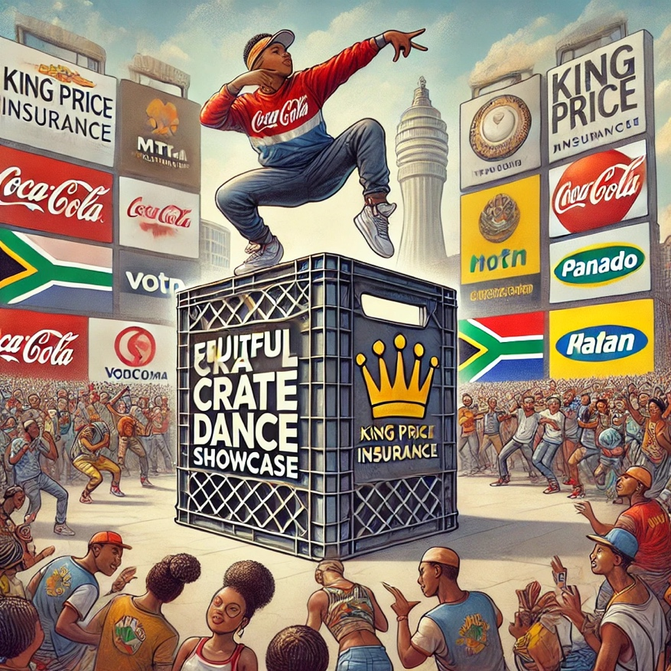
* **International Partnerships**: Collaboration with global venues and media outlets.
* **Charitable Component**: Proceeds supported local charities and community programs.

**Success Metrics**:

* Global Reach: Performed in over 25 countries.
* Social Impact: Raised significant funds for charitable causes.
* Sponsor ROI: High visibility in international markets.

**Relevance to Crate Dance Showcase**:  
This model emphasizes the potential of global sponsorships that tie cultural events to social impact.

#### **5. Case Study: Nike Dance Battle (Global)**

**Overview**:  
A Nike-sponsored dance competition focusing on street and urban dance styles, held in global urban centers.

**Key Features**:

* **Youth-Centric Branding**: Nike integrated its brand with youth-focused themes of self-expression and athleticism.
* **Digital Content**: Produced high-quality videos and livestreams for YouTube and Instagram.
* **Product Placement**: Participants wore Nike apparel and footwear exclusively.

**Success Metrics**:

* Audience Reach: Over 1 million livestream viewers globally.
* Sales Conversion: Increase in dance-related apparel and sneaker sales.
* Brand Perception: Boost in brand relevance among younger demographics.

**Relevance to Crate Dance Showcase**:  
This example highlights the effectiveness of sponsorships tied to product placement and digital content creation.

#### **6. Key Takeaways for Crate Dance Showcase**

1. **Exclusive Branding Opportunities**: Title sponsorships (e.g., Red Bull) should feature prominently with logo placement on stages, merchandise, and digital content.
2. **Local Engagement**: Like the Adidas Streetball Challenge, regional qualifiers and activations can drive community involvement.
3. **Digital Strategy**: Inspired by Red Bull BC One and Nike Dance Battle, a robust digital campaign with influencers and livestreams will expand the event's reach.
4. 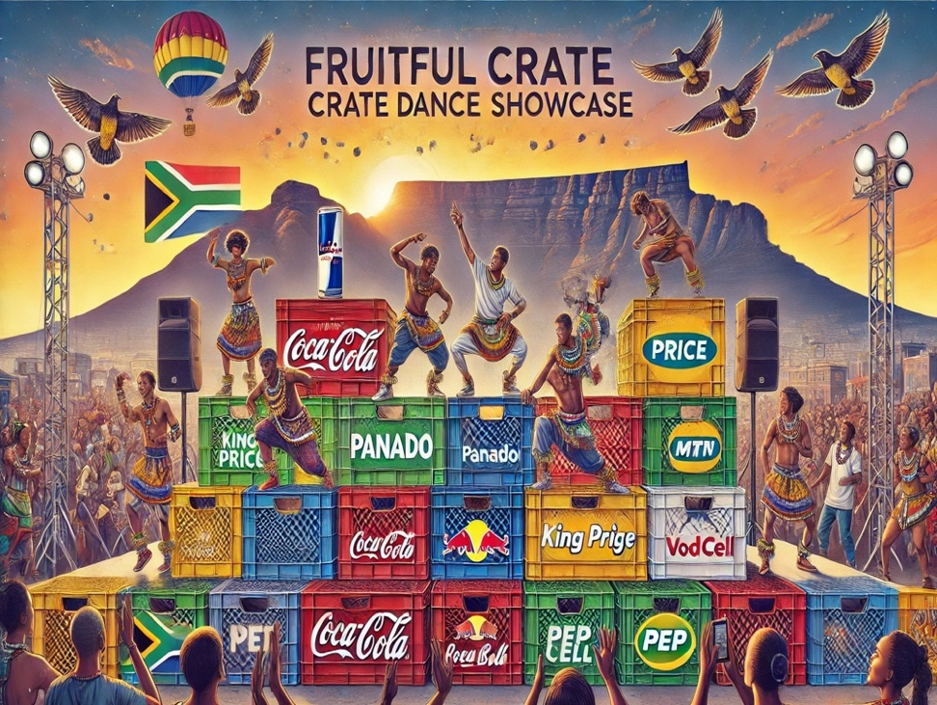**Multi-Tiered Sponsorships**: Incorporating diverse sponsors, as seen in the Cape Town International Jazz Festival, ensures a wider revenue base.
5. **Cultural and Social Impact**: Following the Soweto Gospel Choir’s model, tie the event to community outreach and social initiatives for broader appeal.

This comprehensive overview provides actionable insights into proven sponsorship models and event strategies, serving as a foundation for Fruitful Holdings to refine its approach for the Crate Dance Showcase.

#### **1. Goals of the Talent Development Framework**

The primary goals of the Talent Development Framework are:

* To identify and nurture raw talent within underserved communities.
* To provide professional development opportunities for dancers, choreographers, and event organizers.
* To create sustainable pathways for creative careers in dance, performance, and arts management.
* To contribute to the cultural and social development of communities through arts and mentorship.

#### **2. Key Components of the Framework**

**A. Talent Identification and Recruitment**

* **Community Outreach Programs**: **Partner with local schools, youth centers, and dance academies to scout untapped talent.**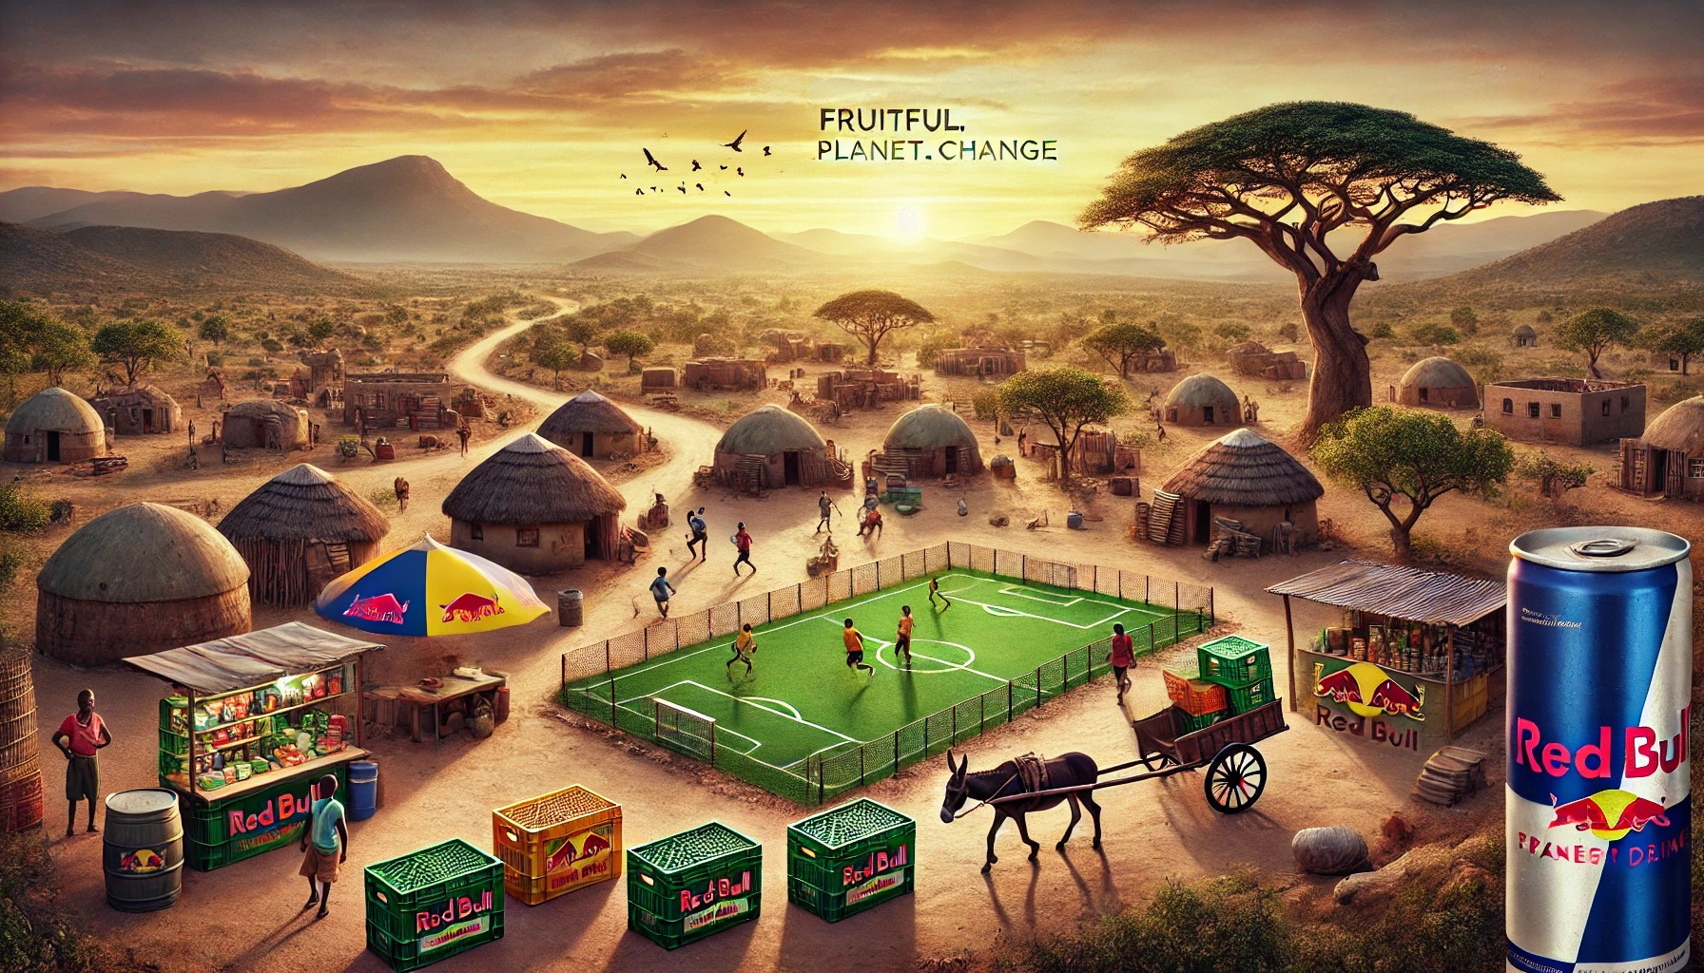
* **Open Auditions**: Organize regional auditions in partnership with local community centers to provide equal opportunities for participation.
* **Digital Submissions**: Allow dancers to submit audition videos through a user-friendly online platform, increasing accessibility.

**B. Mentorship and Training**

* **Workshops and Bootcamps**: Conduct intensive workshops led by industry professionals, focusing on technique, performance, and stage presence.
* **Mentorship Program**: Pair emerging dancers with seasoned professionals for one-on-one guidance in skill development and career planning.
* **Masterclasses**: Invite renowned international choreographers and performers to deliver specialized training sessions.

**C. Education and Career Development**

* **Entrepreneurship in Arts**: Provide training in branding, networking, and self-promotion to help artists build sustainable careers.
* **Certification Programs**: Offer accredited certifications in dance and performance, improving employability and recognition in the industry.
* **Job Placement Assistance**: Collaborate with production companies, performing arts organizations, and entertainment brands to create job placement opportunities for program graduates.

**D. Diversity and Inclusion**

* **Underrepresented Communities**: Prioritize recruitment from marginalized communities to ensure equal representation and opportunity.
* **Global Representation**: Celebrate and incorporate diverse dance styles and cultures, promoting inclusivity and cross-cultural understanding.

#### **3. Talent Development Program Phases**

The framework will be implemented in three phases to ensure thorough execution and scalability:

**Phase 1: Launch and Awareness**

* Establish partnerships with local organizations and schools.
* Organize talent recruitment campaigns, including open auditions and online submissions.
* Promote the program through social media, local radio, and community outreach.

**Phase 2: Training and Development**

* Execute workshops, bootcamps, and masterclasses in high-density areas.
* Roll out the mentorship program with expert pairings.
* Provide access to resources, such as rehearsal spaces, equipment, and online learning modules.

**Phase 3: Showcase and Career Progression**

* Host regional and national showcases to highlight developed talent.
* Assist participants in creating professional portfolios and demo reels.
* Facilitate partnerships with sponsors, event organizers, and brands for long-term engagement.

#### **4. Metrics for Measuring Success**

The success of the Talent Development Framework will be assessed through the following metrics:

* **Participation Rates**: Number of participants in auditions, workshops, and mentorship programs.
* **Retention Rates**: Percentage of participants who complete the program.
* **Skill Improvement**: Pre- and post-assessment of dance skills and knowledge.
* **Employment Outcomes**: Number of participants who secure jobs or contracts in the creative arts industry.
* **Community Impact**: Feedback from local organizations and communities regarding the program's influence.
* **Diversity Metrics**: Representation of underrepresented groups in program participation and outcomes.

#### **5. Partnerships and Stakeholders**

The success of this framework depends on collaboration with various stakeholders, including:

* **Local Schools and Community Centers**: To serve as recruitment hubs.
* **Professional Dance Organizations**: To provide mentorship and training expertise.
* **Corporate Sponsors**: To fund the program and offer brand partnerships.
* **Government and NGOs**: To align with national arts and cultural development goals.

#### **6. Expected Outcomes**

By implementing this Talent Development Framework, the Crate Dance Showcase will:

1. Empower thousands of young dancers with professional skills and career opportunities.
2. Establish Fruitful Holdings as a leader in youth empowerment and community development.
3. Create a sustainable pipeline of talent for the creative arts industry.
4. Foster cultural exchange and celebrate diversity through global representation.

### ****Appendix J: Community Engagement Reports and Surveys****

This appendix provides an overview of the methodologies, findings, and impacts of the community engagement initiatives associated with the Fruitful Holdings Crate Dance Showcase. It highlights the significance of community involvement in building long-term trust and fostering a positive social impact.

#### **1. Goals of Community Engagement**

The primary objectives of the community engagement efforts are:

* To ensure inclusivity by involving underserved and marginalized communities in the Crate Dance Showcase.
* To foster a sense of ownership and pride among local stakeholders.
* To create economic opportunities and social empowerment through event-related activities.
* To gather feedback for continuous improvement and deeper community impact.

#### **2. Community Engagement Methodology**

**A. Stakeholder Mapping**

* Identifying key community leaders, youth organizations, and cultural hubs within the regions of operation.
* Establishing partnerships with schools, local NGOs, and municipal offices to enhance outreach.

**B. Engagement Activities**

* **Community Information Sessions**: Hosting open forums to introduce the Crate Dance Showcase concept and explain its benefits to the community.
* **Workshops and Focus Groups**: Conducting sessions to gather insights on local needs, cultural nuances, and potential areas of collaboration.
* **Volunteer Programs**: Recruiting local residents as volunteers for event logistics, security, and hospitality roles.
* **Economic Empowerment Initiatives**: Partnering with local vendors for event catering, merchandise, and production needs.

**C. Surveys and Feedback Collection**

* Utilizing online surveys, on-site questionnaires, and interviews to gather participant opinions and measure community sentiment.
* Collecting qualitative feedback on inclusivity, cultural representation, and economic impact.

#### **3. Key Findings from Community Surveys**

**A. Survey Structure**

* **Respondent Demographics**: Age, gender, occupation, and location.
* **Themes Covered**: Accessibility, cultural relevance, economic opportunities, and overall satisfaction.
* **Participation Method**: Online, paper-based, and in-person surveys conducted across targeted regions.

**B. Highlights from the Data**

* **Accessibility**:
  + 87% of respondents appreciated the event’s focus on high-density areas, with free or low-cost entry.
  + 76% reported easy access to audition venues and workshop locations.
* **Cultural Relevance**:
  + 91% of respondents felt that the event celebrated local dance styles and cultural diversity.
  + Many expressed interest in expanding the showcase to include traditional dance forms.
* **Economic Impact**:
  + 68% of local vendors reported increased revenue from event-related activities.
  + Job creation for logistics, event setup, and hospitality was cited as a major benefit.
* **Satisfaction**:
  + 85% of participants rated the overall event experience as excellent or very good.
  + 89% of surveyed attendees expressed interest in attending future events.

#### **4. Social and Economic Impacts**

**A. Youth Empowerment**

* The showcase directly engaged over 5,000 youth across its pilot phase, providing them with skills and exposure.
* 65% of participants reported improved confidence and enhanced professional aspirations post-event.

**B. Local Economic Boost**

* The event generated an estimated R5 million in economic activity, with significant contributions to local businesses.
* Partnerships with over 200 vendors ensured broad-based economic participation.

**C. Community Sentiment**

* Positive reviews from community leaders highlighted the showcase as a transformative initiative that uplifted local talent and provided cultural recognition.
* 92% of respondents believed the event strengthened community cohesion.

#### **5. Recommendations for Improvement**

Based on survey data and feedback, the following recommendations have been made to enhance future community engagement efforts:

* **Expanded Outreach**: Increase awareness campaigns in remote and rural areas to ensure greater inclusivity.
* **Local Talent Spotlights**: Provide dedicated segments in the showcase to highlight traditional dance styles and local performers.
* **Enhanced Accessibility**: Offer transportation support for participants from underserved regions to ensure no one is excluded due to logistical challenges.
* **Capacity-Building Initiatives**: Introduce more training sessions for local volunteers and vendors to improve event management and service quality.
* **Continuous Feedback Mechanisms**: Implement real-time feedback systems during events for immediate insights and adaptive improvements.

#### **6. Partnerships and Collaborations**

Community engagement was made possible through collaboration with:

* Local municipalities and government agencies.
* Schools, universities, and community centers.
* NGOs focused on youth development, arts, and education.
* Corporate sponsors invested in social impact initiatives.

#### **7. Conclusion**

The community engagement efforts of the Fruitful Holdings Crate Dance Showcase have demonstrated a powerful ability to connect with and uplift diverse communities. Through continued focus on inclusivity, economic empowerment, and cultural celebration, the showcase is positioned to leave a lasting legacy of positive social change.

### ****Appendix K: Additional Supporting Documents****

This appendix consolidates supplementary materials that provide further evidence, context, and resources for the Fruitful Holdings Crate Dance Showcase business plan. These documents serve to strengthen the overall strategy, substantiate projections, and facilitate stakeholder understanding.

#### **1. Memorandums of Understanding (MOUs)**

* **Purpose**: MOUs formalize preliminary agreements with key partners and sponsors.
* **Included MOUs**:
  + Partnership agreement with Red Bull for exclusive sponsorship of global beverage rights.
  + MOU with Tupperware for logistical support and distribution center access in high-density areas.
  + Agreement with local government agencies for venue permissions and community engagement facilitation.
* **Relevance**: These agreements ensure operational feasibility and outline partner expectations.

#### **2. Legal Compliance Documents**

* **Licensing Agreements**:
  + Certification to operate large-scale events in identified regions.
  + Franchise licensing templates for future geographic expansions.
* **Permits**:
  + Approval documentation for noise regulation compliance.
  + Public gathering permits issued by municipal authorities.
* **Contractual Frameworks**:
  + Templates for sponsorship contracts and vendor agreements.

#### **3. Vendor and Supplier Agreements**

* **Sample Contracts**:
  + Contracts with local vendors for merchandise sales and catering services.
  + Agreements with media production teams for event coverage and digital streaming.
* **Scope of Work**:
  + Defined deliverables and timelines for event setup, branding, and logistics providers.

#### **4. Talent Recruitment and Development Framework**

* **Talent Audition Materials**:
  + Detailed audition guidelines distributed to participants.
  + Evaluation criteria for selecting top performers across regions.
* **Training Program Outlines**:
  + Schedules for skill enhancement workshops.
  + Modules focusing on professional development, media readiness, and performance improvement.
* **Partnerships with Talent Scouts**:
  + Collaboration agreements with national and international talent agencies to ensure seamless progression opportunities for top performers.

#### **5. Marketing Collateral**

* **Design Prototypes**:
  + Drafts of event posters, flyers, and digital ads showcasing the showcase branding.
  + Custom templates for sponsor integration in social media campaigns.
* **Event Schedule**:
  + Sample event day agenda with highlighted activities and sponsor activation times.
* **Influencer Briefs**:
  + Guidelines and expectations for influencers partnering with the event for promotion.

#### **6. Financial Audits and Verification**

* **Revenue and Cost Breakdowns**:
  + Verified financial summaries of projected sponsorship income and operational expenses.
  + Breakdown of anticipated revenue streams by sponsorship category (e.g., Title Sponsor, Media Partner).
* **Audit Reports**:
  + Independent reviews of financial projections to ensure feasibility and compliance with investor expectations.
  + Documentation demonstrating alignment with R391 million revenue targets.

#### **7. Community Feedback Reports**

* Summaries of focus group discussions with local stakeholders.
* Testimonials from community leaders, participants, and attendees.
* Graphs and charts illustrating engagement metrics from pilot community events.

#### **8. Risk Management Plan**

* **Comprehensive Risk Assessment**:
  + Identification of potential challenges, including weather disruptions, sponsor withdrawals, and technical failures.
* **Mitigation Strategies**:
  + Contingency plans for securing alternate venues.
  + Backup suppliers for essential services.
  + Insurance policies covering event cancellation and liability.

#### **9. Case Studies**

* 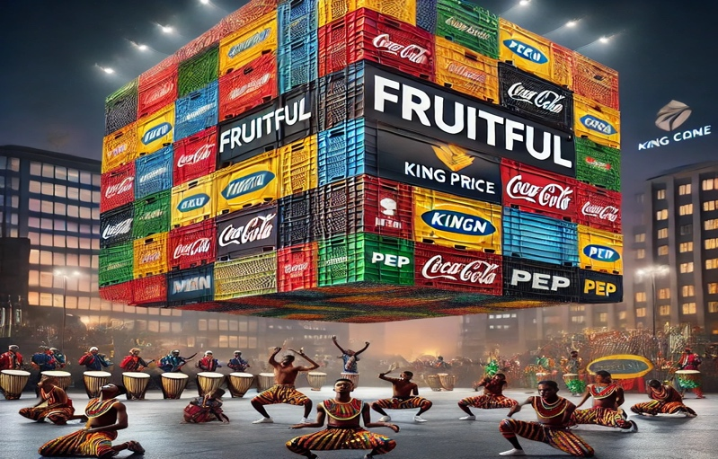**Comparative Event Analyses**:
  + Study of similar international events, including the Red Bull BC One and Urban Street Dance Festivals.
  + Lessons learned and best practices applied to the Crate Dance Showcase.
* **Sponsor Success Stories**:
  + Examples of sponsor ROI from comparable activations.
  + Brand visibility improvements for sponsors like Coca-Cola and Nike through cultural events.

#### **10. Reference Materials and Sources**

* List of external studies, reports, and benchmarks used to validate the Fruitful Holdings business plan.
* Links to publicly available data on market trends, audience demographics, and sponsorship effectiveness.

#### **11. Contact Information for Key Stakeholders**

* **Executive Committee Contacts**:
  + Names, titles, and contact details for Fruitful Holdings’ leadership team.
* **External Partners**:
  + 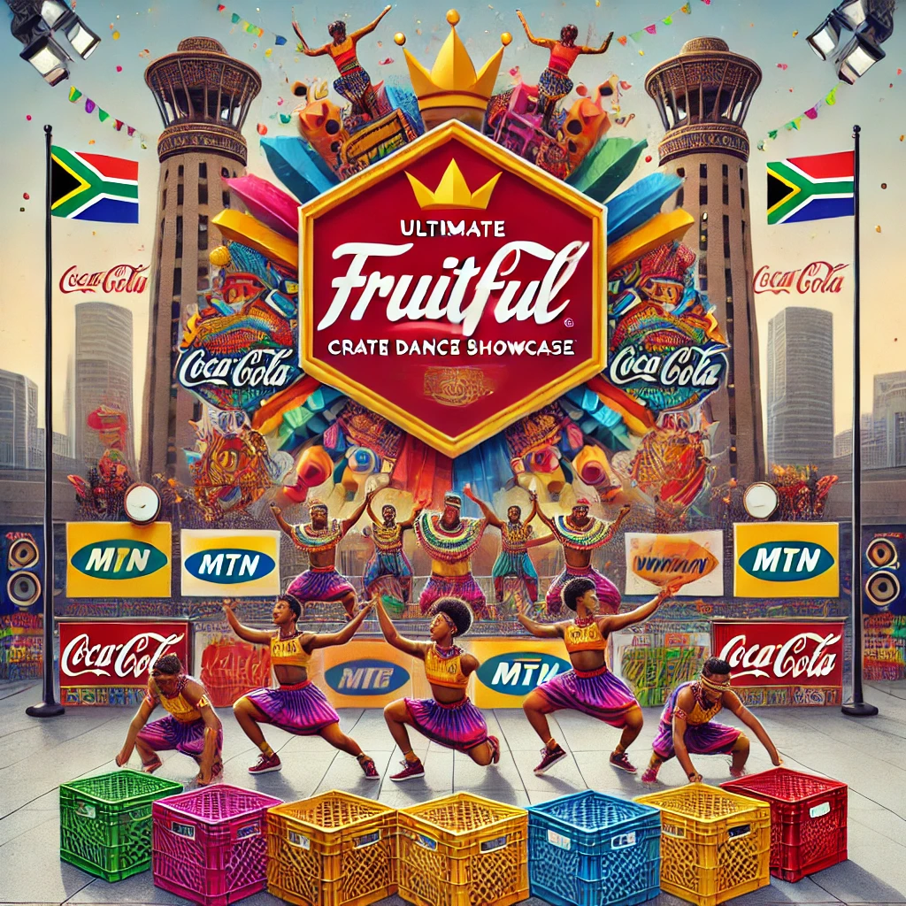Points of contact for major sponsors, collaborators, and service providers.

***Conclusion***

*The supporting documents included in this appendix provide a thorough foundation for the Crate Dance Showcase strategy. They reinforce the plan's credibility and offer tangible resources to ensure effective execution and stakeholder alignment.*

### *****Fruitful Holdings Business Plan Summary*****

#### **Executive Summary**

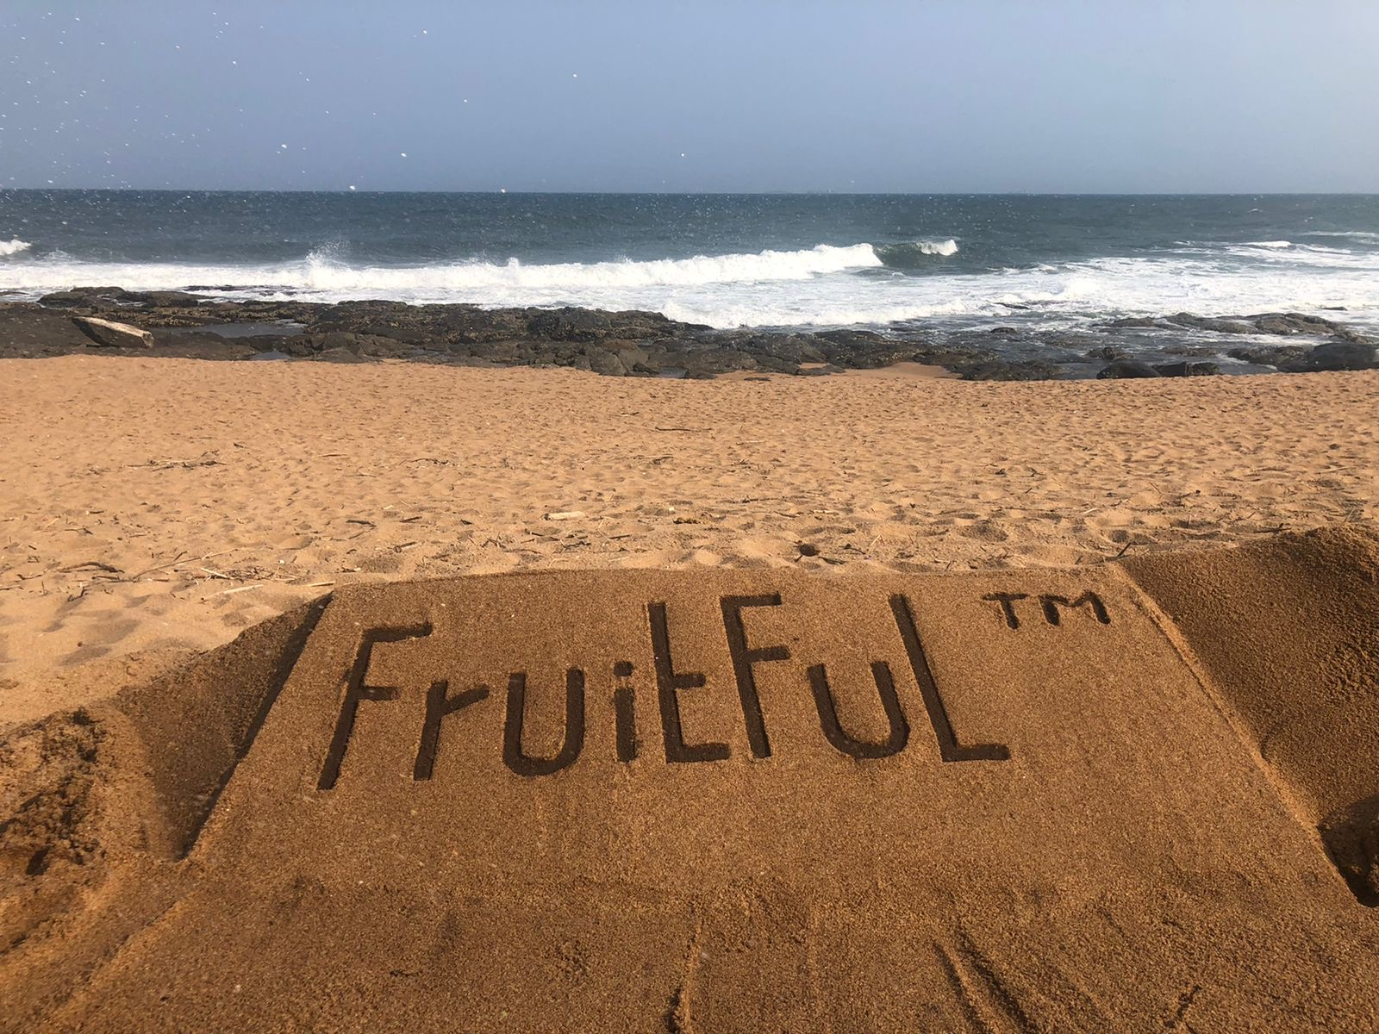Fruitful Holdings presents the **Crate Dance Showcase**, a first-of-its-kind global event platform celebrating youth culture through street dance, music, and community engagement. Designed to empower underserved communities, the showcase combines grassroots participation with corporate sponsorships and global brand visibility. This multi-layered model blends live events, digital engagement, and strategic partnerships to drive revenue and social impact. With a projected five-year revenue target of R391 million, the Crate Dance Showcase is positioned to become a cultural phenomenon.

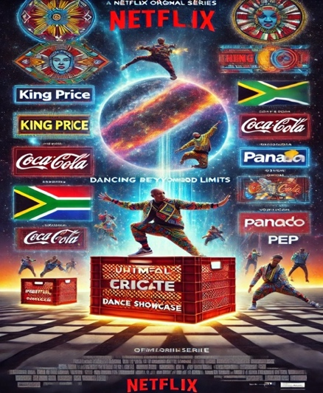

#### **Vision and Mission**

* **Vision**: To create a globally recognized platform that empowers youth through creativity and innovation while celebrating cultural diversity.
* **Mission**: To produce dynamic, inclusive events that amplify talent, foster economic growth, and inspire communities globally.

#### **Core Objectives**

1. Host an annual showcase starting in South Africa, expanding to other regions.
2. Secure long-term sponsorships and partnerships with global brands like Red Bull, Coca-Cola, and Nike.
3. Build a scalable revenue model through sponsorships, merchandise, ticket sales, and digital streaming.
4. Deliver measurable community impact through local engagement, talent development, and economic opportunities.

#### **Market Analysis**

* **Target Audience**: Youth aged 16-35, focused on urban and suburban areas, with active digital engagement.
* **Market Opportunity**: The global rise of street culture and youth-oriented events presents significant growth potential. South Africa’s high youth population (66% under 35) creates a prime launching ground.
* **Competition**: The event will differentiate itself with a unique blend of local authenticity and international appeal, leveraging global brands to elevate visibility.

#### **Revenue Model**

1. **Sponsorships** (70% of revenue): multi-tier packages offering branding, activation zones, and exclusivity by category.
2. **Ticket Sales** (15% of revenue): VIP, general admission, and group discounts for live events.
3. **Merchandise** (10% of revenue): Co-branded apparel, accessories, and collectibles.
4. **Digital Streams** (5% of revenue): Paid streaming content and ad revenue from platforms like YouTube, Showmax, and Red Bull TV.

#### **Geographic Expansion**

* **Phase 1 (Year 1-2)**: Host events in Johannesburg, Cape Town, Durban, and Port Elizabeth, targeting Tupperware DC regions for high-density community outreach.
* **Phase 2 (Year 3-5)**: Expand across Africa, focusing on countries with strong youth demographics like Nigeria, Kenya, and Ghana.
* **Phase 3 (Beyond Year 5)**: Launch global circuits in Europe, North America, and Asia.

#### **Sponsorship Strategy**

* 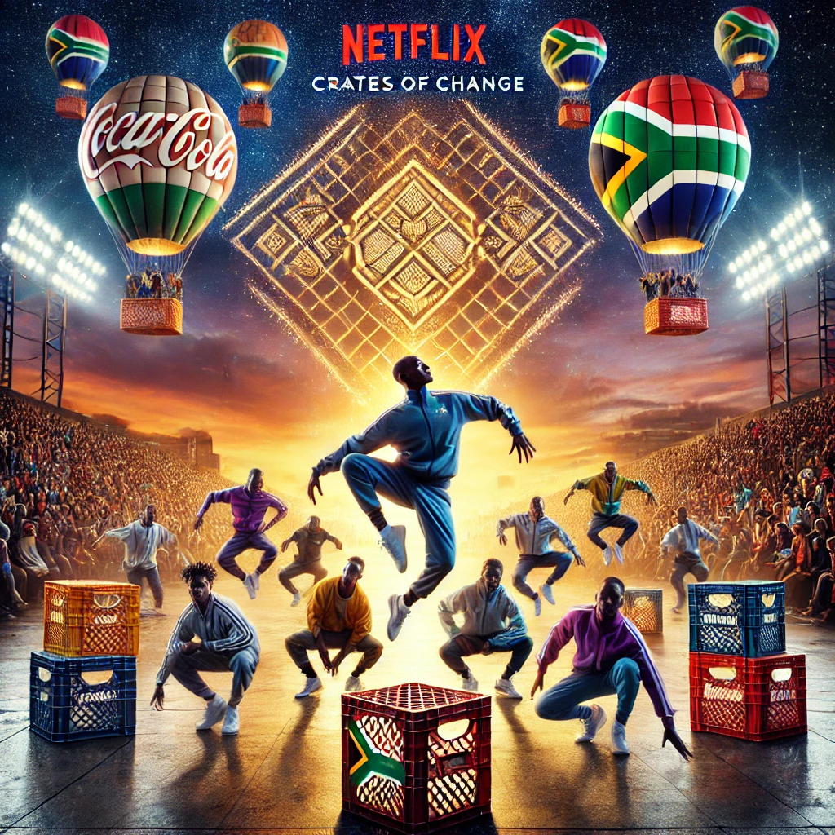**Title Sponsor**: Exclusive naming rights and premium brand integration (e.g., "Red Bull Crate Dance Showcase").
* **Gold/Silver/Bronze Tiers**: Scaled benefits, including branding, media exposure, and product sampling opportunities.
* **Exclusive Partners**: Category-specific sponsors (e.g., energy drink, telecom provider).
* **Product Sponsors**: Brands providing tangible goods and activation opportunities at the event.

#### **Marketing and Branding**

1. **Social media**: Collaborate with influencers and participants to drive pre-event hype.
2. **Digital Content**: Create short films, dance challenges, and behind-the-scenes content.
3. **Traditional Media**: Leverage partnerships with local radio, TV, and print to maximize outreach.
4. **Grassroots Engagement**: Run community auditions and workshops to ensure local participation.

#### **Community Impact**

* **Talent Development**: Host training workshops and mentorship programs for participants.
* **Local Economic Boost**: Employ local vendors, artists, and service providers for event production.
* **Social Responsibility**: Allocate a portion of event revenue to fund community upliftment initiatives.

#### **Technology and Innovation**

* Live streaming to reach global audiences.
* Event apps for ticketing, voting, and audience interaction.
* Data-driven insights for sponsor ROI and audience preferences.

#### **Financial Projections**

* **Year 1 Revenue**: R30 million from sponsorships, ticket sales, and merchandise.
* **Year 5 Revenue**: R130 million, driven by global expansion and higher sponsorship deals.
* **Break-Even Timeline**: Anticipated within the first 18 months.

#### **Next Steps**

1. Finalize sponsorship agreements with major partners.
2. Partner with event agencies to manage logistics and sponsorship activation.
3. Launch a pre-event digital marketing campaign to build momentum.
4. Host the inaugural Crate Dance Showcase in Johannesburg within six months.

#### **Conclusion**

The Crate Dance Showcase represents a transformative opportunity to blend cultural celebration with economic empowerment. By leveraging strategic partnerships, community engagement, and cutting-edge technology, Fruitful Holdings is well-positioned to deliver a globally impactful event series.

This concise business plan is suitable for general discussions with stakeholders, potential sponsors, and event partners. Let me know if you’d like further refinements!

**NON-DISCLOSURE AGREEMENT (NDA)**

This Non-Disclosure Agreement (the “Agreement”) is entered into as of [Insert Date] by and between:

1. **Disclosing Party**: [Your Name/Business Name], with a principal address at [Your Address].
2. **Receiving Party**: [Recipient Name/Business Name], with a principal address at [Recipient Address].

**1. Purpose**  
The purpose of this Agreement is to ensure that confidential and proprietary information disclosed by the Disclosing Party to the Receiving Party during discussions, reviews, or collaborations regarding [specific project or topic, e.g., "Fruitful Holdings Crate Dance Showcase"] is protected from unauthorized use or disclosure.

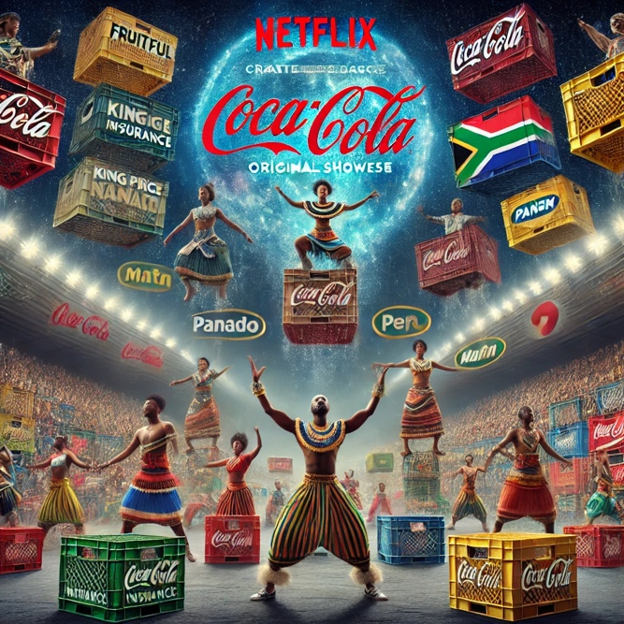**2. Definition of Confidential Information**  
Confidential Information includes but is not limited to:

* Business strategies, plans, and projections.
* Financial information, forecasts, and data.
* Marketing strategies and materials.
* Event concepts, designs, and operational details.
* Client and sponsor lists.
* Any other information explicitly marked as "Confidential" by the Disclosing Party.

Confidential Information does not include:

* Information that is or becomes publicly available through no breach of this Agreement.
* Information independently developed or discovered by the Receiving Party without reference to the Confidential Information.
* Information disclosed to the Receiving Party by a third party legally entitled to make such disclosure.

**3. Obligations of Receiving Party**  
The Receiving Party agrees to:

1. Maintain the confidentiality of the disclosed information and not disclose it to any third party without prior written consent from the Disclosing Party.
2. Use the Confidential Information solely for the purpose of evaluating or pursuing the project or collaboration outlined above.
3. Protect the Confidential Information using reasonable measures equivalent to those used to protect its own confidential information.

**4. Exceptions**  
Disclosure of Confidential Information is permissible if required by law or court order, provided the Receiving Party gives the Disclosing Party prompt notice to allow for protective measures or intervention.

**5. Term**  
This Agreement shall remain in effect for a period of [insert duration, e.g., "three (3) years"] from the date of execution unless extended by mutual agreement in writing.

**6. Return or Destruction of Information**  
Upon the Disclosing Party’s request, the Receiving Party shall promptly return or destroy all copies of the Confidential Information and certify such destruction in writing.

**7. No License**  
This Agreement does not grant any license or ownership rights to the Receiving Party in the Confidential Information.

**8. Governing Law**  
This Agreement shall be governed by and construed in accordance with the laws of [Insert Jurisdiction].

**9. Entire Agreement**  
This Agreement constitutes the entire understanding between the parties concerning the subject matter and supersedes all prior agreements, understandings, or communications.

**10. Signatures**  
By signing below, both parties acknowledge and agree to the terms of this Agreement.

**Disclosing Party**:  
Name: ___________________________  
Signature: ________________________  
Date: ____________________________

**Receiving Party**:  
Name: ___________________________  
Signature: ________________________  
Date: ____________________________

Let me know if you need adjustments or would like me to include additional clauses based on your specific needs!



### ****Email Index for Fruitful Holdings Outreach****

#### **1. Alicia Casselman - Trademark and Legal Filings**

Content: Introduction to the divisions, brands, and trademark strategy for Fruitful Holdings, including a breakdown of priority, secondary, and tertiary countries for trademark filings and brand classes.

#### **2. Red Bull Collaboration - Fruitful Crate Dance Showcase**

Content: Proposal for partnership opportunities with Red Bull, including sponsorship, brand co-activation, and global rollout plans.

#### **3. Adams & Adams - Legal Support for Intellectual Property**

Content: Request for legal counsel and strategic alignment on protecting intellectual property and licensing agreements across all Fruitful brands.

#### **4. Willie Prinsloo - Investment Opportunity**

Content: A detailed investment pitch highlighting Fruitful Holdings' vision, financial projections, and key revenue drivers to secure funding.

#### **5. Mettle Administration Solutions - Operational Collaboration**

Content: Proposal for handling financial administration, logistics, and operational support for the rollout of Fruitful Crate Dance Showcase and other initiatives.

#### **6. Prospective Artisans and Vendors - Fruitful Home and Decor**

Content: Outreach to local artisans to onboard them as suppliers for Fruitful Home and Decor, with details on distribution via Homemart.africa.

#### **7. Community Partners and NGOs - Social Impact Initiatives**

Content: Invitation to partner on community programs, emphasizing the social impact of Fruitful Kids and Sekelbos Tank initiatives.

#### **8. Tupperware International - Licensing and Brand Collaboration**

Content: Discussion of co-branding opportunities for Tupperware Going Fruitful initiative, including alignment with Fruitful Holdings’ sustainability goals.

### ****Content Breakdown Per Index****

#### **1. Alicia Casselman - Trademark and Legal Filings**

**Subject:** Trademark Filing Strategy for Fruitful Holdings

### **Email Content:** Instructions

**Subject:** Comprehensive Trademark Strategy for Fruitful Holdings and Global Expansion

Dear Alicia,

I hope this email finds you well.

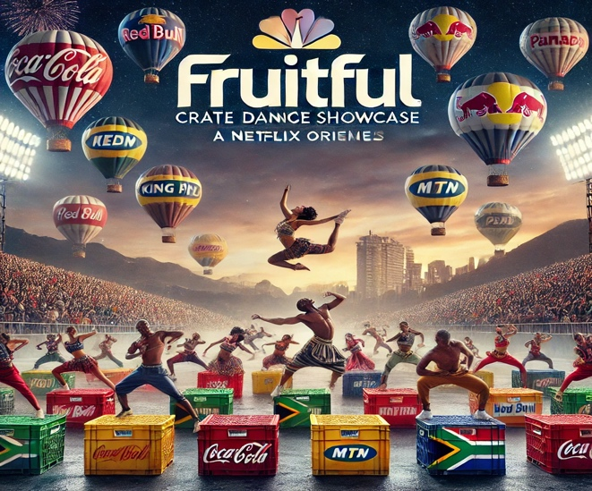It’s always a pleasure working with you, and I’m excited to share the next steps for Fruitful Holdings' ambitious trademark and intellectual property (IP) strategy. With our multiple divisions and global expansion on the horizon, I’m confident that your expertise will be instrumental in ensuring our brand is protected as we establish a strong international footprint.

#### Overview of Divisions and Brands

Fruitful Holdings is a diversified entity with multiple subdivisions that support creativity, entrepreneurship, and community empowerment. Below, I have outlined the key divisions and their focus areas for your understanding:

**1.Fruitful Crate Dance Showcase:**

* Focus: Youth-driven, innovative dance competitions leveraging crate structures, digital streaming, and live events.
* Scope: Entertainment, global street culture, and co-branded sponsorships.

**2.Fruitful Sekelbos Tank:**

* Focus: Empowering local artisans and small vendors by providing access to both local and international markets.
* Unique Angle: A vendor-driven marketplace prioritizing fair trade and handcrafted goods.

**3.Fruitful Home and Decor:**

* Focus: Retail of home goods, building materials, and decor, including support for private labeling and corporate standards.
* 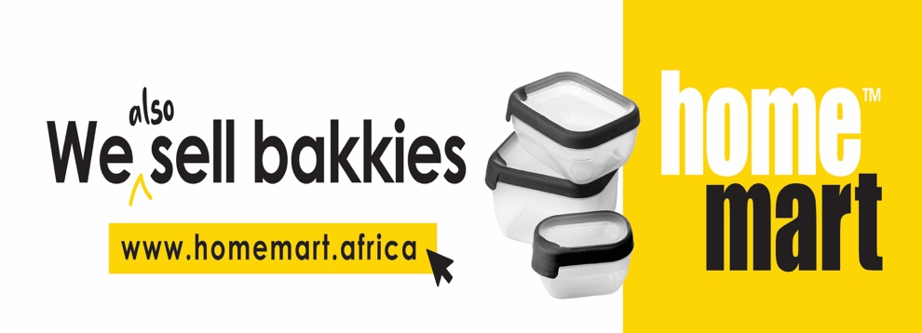Unique Proposition: Collaboration hubs for vendors, ensuring local artisan support alongside corporate-grade development.

**4.Homemart.africa:**

* Focus: Acting as the distribution arm for all Fruitful Home and Decor products, driving logistics and supply-chain excellence.
* Unique Proposition: Linking grassroots artisans to larger retailers nationwide and internationally.

**5.Fruitful Kids:**

* + - * + Focus: Promoting local artisans through unique, handmade products designed for children and corporate clients.
* Scope: International visibility and strong alignment with corporate gifting.

 **6.Tupperware Going Fruitful:**

* Focus: Engaging Tupperware consultants as agents for selling Fruitful products through intimate, community-based events.
* Unique Strategy: Merging direct sales with the visibility of the Crate Dance Showcase.

1. 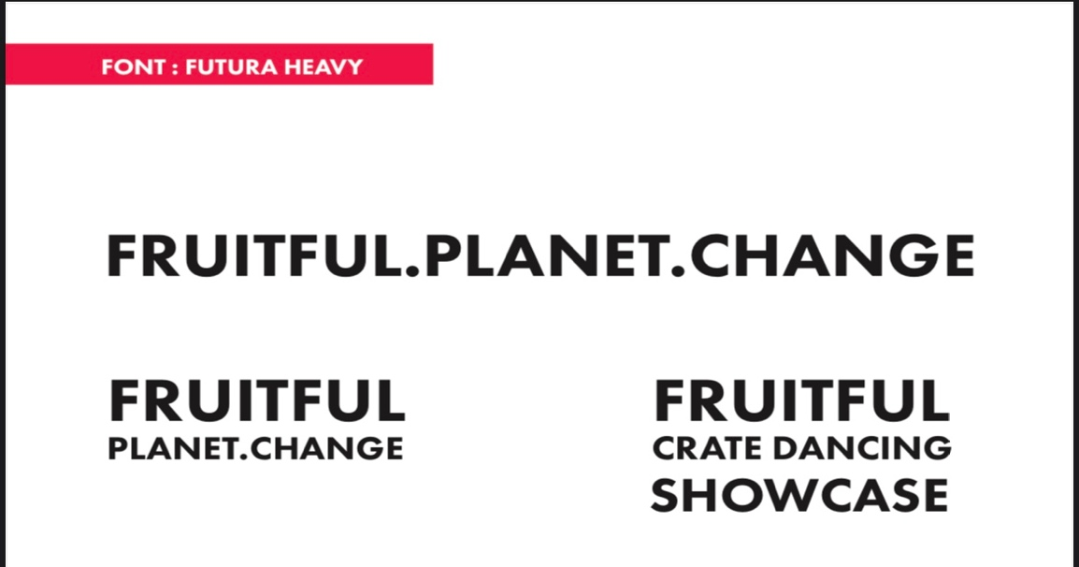**Fruitful.Planet.Change:**
   * 1. Focus: Advocacy for environmental sustainability through creative marketing and digital campaigns.
     2. Scope: Aligning sustainability with brand initiatives for impactful global outreach.

#### Trademark Filings Strategy and Details

We aim to prioritize countries based on their alignment with the core values of each division. Here is the detailed table organized by brand and country priority.

|  |  |  |  |
| --- | --- | --- | --- |
| **Brand** | **Priority Countries** | **Classes** | **Rationale** |
| Fruitful Crate Dance Showcase | South Africa, Zimbabwe, Kenya | Classes 41 (Entertainment), 9 (Digital) | Strong street culture, youth appeal, and partnerships. |
|  | USA, Brazil, UK, India,Nigeria | Classes 41, 35 | High demand for entertainment and market scalability. |
| Fruitful Sekelbos Tank | South Africa, Zimbabwe,Botswana, Malawi | Classes 35 (Retail), 41 (Artisan Development) | Local artisan empowerment and grassroots economic impact. |
| Fruitful Home and Decor | South Africa, Namibia, Zimbabwe | Classes 35 (Retail), 20 (Furniture) | Expanding visibility for artisanal home goods. |
| Homemart.africa | South Africa, Kenya, Nigeria | Classes 35, 39 (Logistics) | Core hub for distributing products and linking markets. |
| Fruitful Kids | South Africa, India, UK | Classes 35, 41 | Corporate gifting and international retail. |
| Tupperware Going Fruitful | South Africa, India, Zimbabwe | Classes 35 (Retail) | Leveraging existing Tupperware consultant networks. |
| Fruitful.Planet.Change | South Africa, Australia, USA | Classes 35, 42 (Sustainability) | Leading sustainability-focused initiatives globally. |

#### Actionable Steps

1. **Trademark Searches and Applications:**
   * Conduct availability searches for the listed brands across identified countries.
   * Proceed with filing trademark applications based on priority countries and classes.
2. **Franchise and Licensing Agreements:**
   * Draft tailored agreements for each division to support our global franchise and vendor operations.
3. **Strategic Focus on Youth Empowerment and Community Impact:**
   * Highlight how the Fruitful Crate Dance Showcase, Sekelbos Tank, and Fruitful Home divisions integrate social impact and fair trade.

#### Supporting Metrics for Country Prioritization

Based on youth demographics (ages 8–35), unemployment rates, and artisan potential, the following table offers insights into why these countries are critical for Fruitful Holdings:

|  |  |  |  |
| --- | --- | --- | --- |
| **Country** | **Youth Population** | **Unemployment**  **Rate** | **Strategic Rationale** |
| South Africa | 20M | 30% | Base market with high unemployment. |
| Zimbabwe | 8M | 35% | Regional synergy with strong cultural ties. |
| Kenya | 10M | 25% | Vibrant youth-driven markets. |
| USA | 40M | 10% | High scalability for events and franchises. |
| Brazil | 50M | 12% | Strong street dance culture. |

#### Concluding Remarks

Alicia, I trust this comprehensive overview aligns with our vision and strategy for Fruitful Holdings. I am confident that your expertise will guide us through the intricate trademark processes. Please let me know if you require additional information or specific details to move forward.

Looking forward to hearing your thoughts.

Warm regards,  
Heyns Schoeman  
CEO & Founder – Fruitful Holdings  
global@fruitfulholdings.com  
+27 72 414 0117

#### **2. Red Bull Collaboration - Fruitful Crate Dance Showcase**

**Subject:** Exciting Partnership Opportunity: Fruitful Crate Dance Showcase & Red Bull

### **Email Content:** Subject: Exciting Partnership Opportunity: Fruitful Crate Dance Showcase & Red Bull

Dear [Recipient's Name],

I trust this message finds you well. I am thrilled to reach out regarding a unique opportunity that aligns with Red Bull’s legacy of energizing culture, sport, and creativity. At Fruitful Holdings, we are proud to introduce the **Fruitful Crate Dance Showcase**, a vibrant, youth-driven platform with the potential to revolutionize the global dance and entertainment scene—starting right here in South Africa.

**About the Fruitful Crate Dance Showcase**

This is more than just a dance event; it is a celebration of creativity and grassroots talent that merges youth culture, technology, and community engagement. The Showcase transforms something as simple as crates into a stage for explosive performances, innovative choreography, and audience interaction.

It is a perfect fit for Red Bull's vision of pushing boundaries and championing extraordinary stories. The Showcase combines:

* **Dynamic street culture:** Rooted in authentic, local movements that resonate with youth demographics.
* **Global scalability:** A flexible model designed to expand seamlessly to other countries.
* **Technology integration:** Augmented reality (AR), livestream capabilities, and gamified engagement strategies to ensure immersive audience experiences.

**Why Red Bull?**

Red Bull’s longstanding presence in South Africa and across the globe makes it an ideal partner for this groundbreaking initiative. Together, we can create a platform that not only energizes communities but also inspires a global audience.

**Initial Rollout and Expansion Plan**

Our rollout plan begins in South Africa, including Lesotho and Zimbabwe, capitalizing on a strong grassroots culture and Red Bull’s existing market presence. From there, we envision growth into high-impact markets such as Kenya, Brazil, Nigeria, and India, building a worldwide movement.

**Partnership Opportunities**

We invite Red Bull to partner with us in several exciting capacities, including:

1. **Event Sponsorship:** Exclusive rights as the title sponsor for the inaugural Fruitful Crate Dance Showcase in South Africa.
2. **Brand Co-Activation:** Leverage your brand at the forefront of the event with product placement, interactive displays, and digital campaigns.
3. **Global Expansion Partner:** Be a strategic collaborator in bringing the Showcase to 30+ countries.

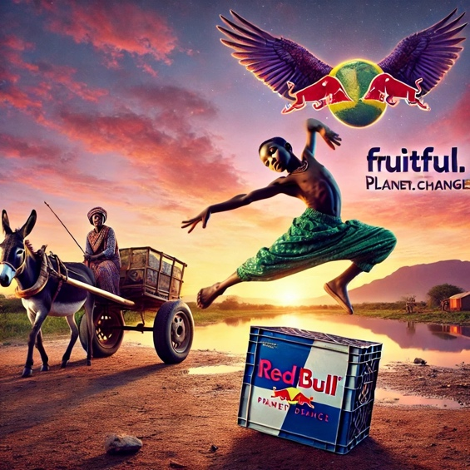**Next Steps**

We would love to discuss this vision further and explore how we can work together to redefine youth engagement through the Fruitful Crate Dance Showcase. Let me know a time that suits you to connect, or I can provide additional materials tailored to Red Bull’s interests.

Looking forward to creating something extraordinary with Red Bull.

Warm regards,  
[Your Full Name]  
CEO, Fruitful Holdings  
[Your Contact Information]

Let me know if this aligns with your goals for the email or if you’d like any adjustments!

#### **3. Adams & Adams - Legal Support for Intellectual Property**

**Subject:** Legal Counsel Request: Protecting Fruitful Holdings' Intellectual Property

**Email Content:**  
Dear [Recipient's Name],

I hope this message finds you well. Fruitful Holdings has an expansive vision to redefine youth culture, community engagement, and creative innovation through multiple brands and initiatives. To ensure we protect our intellectual property as we scale globally, we would like to enlist the expertise of Adams & Adams for:

1. Trademark filings in key markets, focusing on Fruitful Crate Dance Showcase and other pivotal brands.
2. Drafting and reviewing licensing agreements, particularly for our vendor networks and collaborations.
3. Guidance on compliance with international IP laws as we expand into regions like the USA, India, Brazil, and Nigeria.

Please let us know how we can proceed to formalize this engagement. I’m available to provide further information or arrange a meeting at your earliest convenience.

Warm regards,  
[Your Full Name

#### **4. Willie Prinsloo - Investment Opportunity**

**Subject:** Investment Opportunity: Fueling Fruitful Holdings’ Growth

**Email Content:**  
Dear Willie,

It was a pleasure connecting with you recently, and I’m excited to share more about Fruitful Holdings. Our vision is to empower communities and drive economic growth through initiatives like the Fruitful Crate Dance Showcase, Fruitful Home and Decor, and more.

With a clear roadmap and robust financial strategy, we project significant returns for investors while making a lasting social impact. I’d love to share our detailed business plan and discuss potential investment opportunities tailored to your interests.

Looking forward to your response.

Best regards,  
[Your Full Name]

#### **5. Mettle Administration Solutions - Operational Collaboration**

**Subject:** Partnership Opportunity: Operational Support for Fruitful Holdings

**Email Content:**  
Dear [Recipient's Name],

Fruitful Holdings is expanding rapidly, and we are seeking a trusted partner to provide financial administration and operational support as we scale our initiatives, particularly the Fruitful Crate Dance Showcase. Your expertise in managing complex logistics aligns perfectly with our needs.

We’d appreciate the opportunity to discuss this collaboration further. Let me know a suitable time for a meeting.

Best regards,  
[Your Full Name]

#### **6. Prospective Artisans and Vendors - Fruitful Home and Decor**

**Subject:** Join the Fruitful Home and Decor Artisan Network

**Email Content:**  
Dear [Artisan's Name],

Fruitful Home and Decor is on a mission to showcase the best of local craftsmanship. We are excited to invite you to join our artisan network, where your unique creations will reach a wider audience through our retail hubs and distribution via Homemart.africa.

Let’s work together to uplift communities and create exceptional products. Please get in touch to learn more about this opportunity.

Warm regards,  
[Your Full Name]

**7. Community Partners and NGOs - Social Impact Initiatives**

**Subject:** Partnering for Social Impact: Fruitful Holdings Initiatives

**Email Content:**  
Dear [NGO/Partner Name],

Fruitful Holdings is committed to making a difference. Through initiatives like Fruitful Kids and Sekelbos Tank, we aim to empower communities by creating opportunities for youth and local artisans.

We would love to partner with your organization to amplify our social impact. Please let us know how we can collaborate to bring meaningful change.

Warm regards,  
[Your Full Name]

#### **8. Tupperware Consultants and DC - Licensing and Brand Collaboration**

**Subject:** Licensing Opportunity: Tupperware Going Fruitful

**Email Content:**  
Dear [Recipient's Name],

Fruitful Holdings is excited to propose a collaboration with Tupperware Consultants and DC’s. Our Tupperware Going Fruitful initiative aligns perfectly with our sustainability goals, and we believe this partnership can redefine community engagement while expanding market reach.

Looking forward to exploring this opportunity further.

Warm regards,  
[Your Full Name]

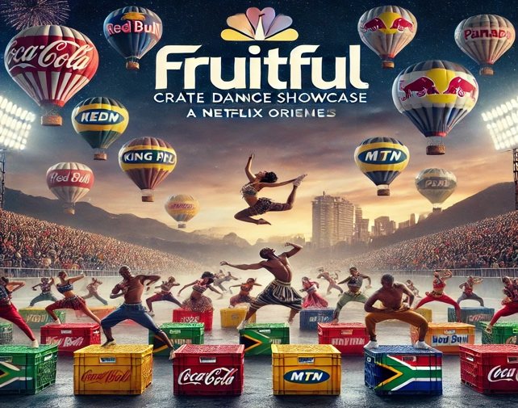

**Subject:** A Personal Invitation to Collaborate for Global Change

Dear Sir Richard Branson,

I hope this email finds you in great spirits. My name is Heyns Schoeman, CEO of Fruitful Holdings. As someone who has long admired your relentless pursuit of innovation and positive change, I write this message with both deep respect and sincere gratitude.

Fruitful Holdings acknowledges you and your phenomenal Virgin team as a beacon of real transformation. Your unwavering commitment to challenging norms, empowering communities, and creating unforgettable experiences continues to inspire us daily. It’s not just your remarkable business achievements that resonate with us, but the way you embody the principles of sustainability, inclusivity, and meaningful impact.

At Fruitful, we echo those same values in our mission to build a platform for **Fruitful.planet.change.** Whether through our **Fruitful Crate Dance Showcase**—a celebration of creativity and untapped talent—or through the various divisions of Fruitful Holdings aimed at empowering local artisans, uplifting communities, and fostering innovation, we are committed to leaving a legacy of change.

Today, we extend an invitation to Virgin to join hands with us. Not only do we wish to collaborate, but we humbly ask for your inspiration face-to-face, rather than only through the pages of your incredible achievements. We know that a conversation with you and your team could ignite a partnership that truly embodies the spirit of "listening to the call for change."

Together, we could reach untapped potential, amplify underrepresented voices, and ignite the same spark that Virgin has lit in millions. We envision the Fruitful and Virgin brands working side by side, driving the change we both believe in so deeply.

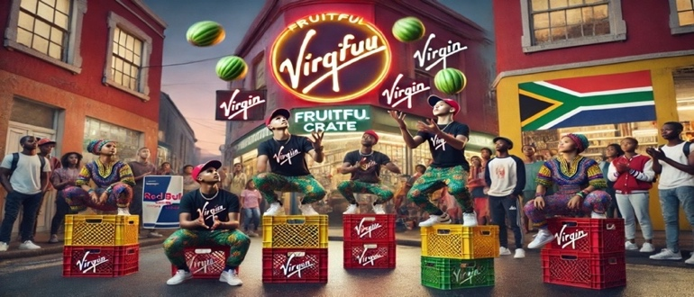Thank you for your time, Sir Richard, and for your contributions to making the world a better place. I look forward to the opportunity to meet with you or your team to share more about Fruitful Holdings and the vision we are building for the future.

Warm regards,

**Heyns Schoeman**  
CEO, Fruitful Holdings  
Fruitful.change.planet@gmail.com  
+27 (72) 414 0117

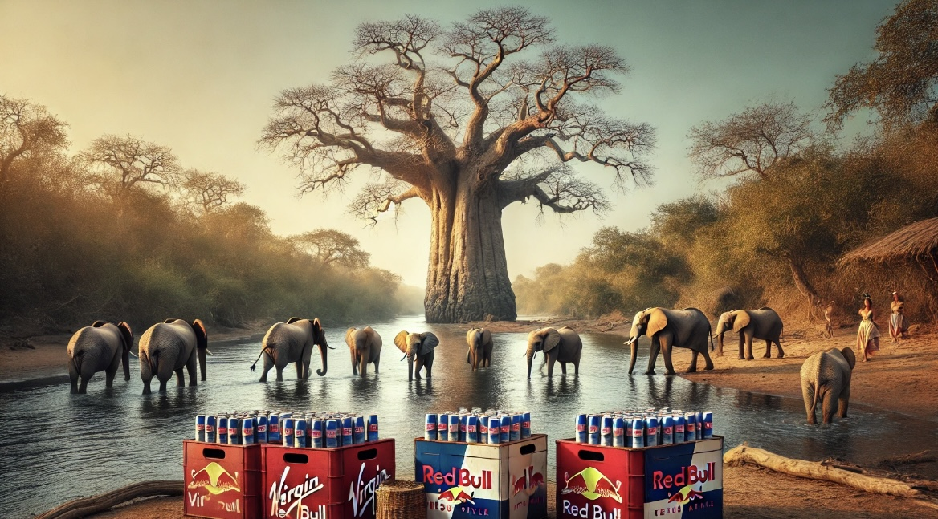

1.